Name |  | Date |  | Period
Lesson 5-6 · Session 1
Guided Practice
Drawing Nets of Solids
VOCABULARY read and say each word before you begin
net | A flat pattern that folds up into a solid. | unfolded box
face | One flat side of a solid shape. | a cube has 6 faces
pyramid  Spanish: pirámide | A solid with one base and triangular sides. | square base + 4 triangles
two-dimensional  Spanish: bidimensional | Flat: it has length and width only. | a net on paper
three-dimensional  Spanish: tridimensional | Solid: it has length, width, and height. | the folded box
EXPLORE TOGETHER Class Launch · 8–10 min
1. Paper Pyramid Model  Yuri is folding a paper model of a square pyramid. The square base is 6 in. on each side, and every triangular face has a height of 5 in.  a. Attributes. Base shape: __________ Triangular faces: ______ Total flat pieces: ______  b. Sketch. Draw the net: the square in the middle with a triangle on each side. Label 6 in.  c. Faces. Area of the square base: ______ in² Area of ONE triangle: ______ in²  d. Reasoning. Why are all four triangular faces the same size? __________ | e. Net. Draw the net on the grid below, label every face with its dimensions, and mark the matching pairs.​  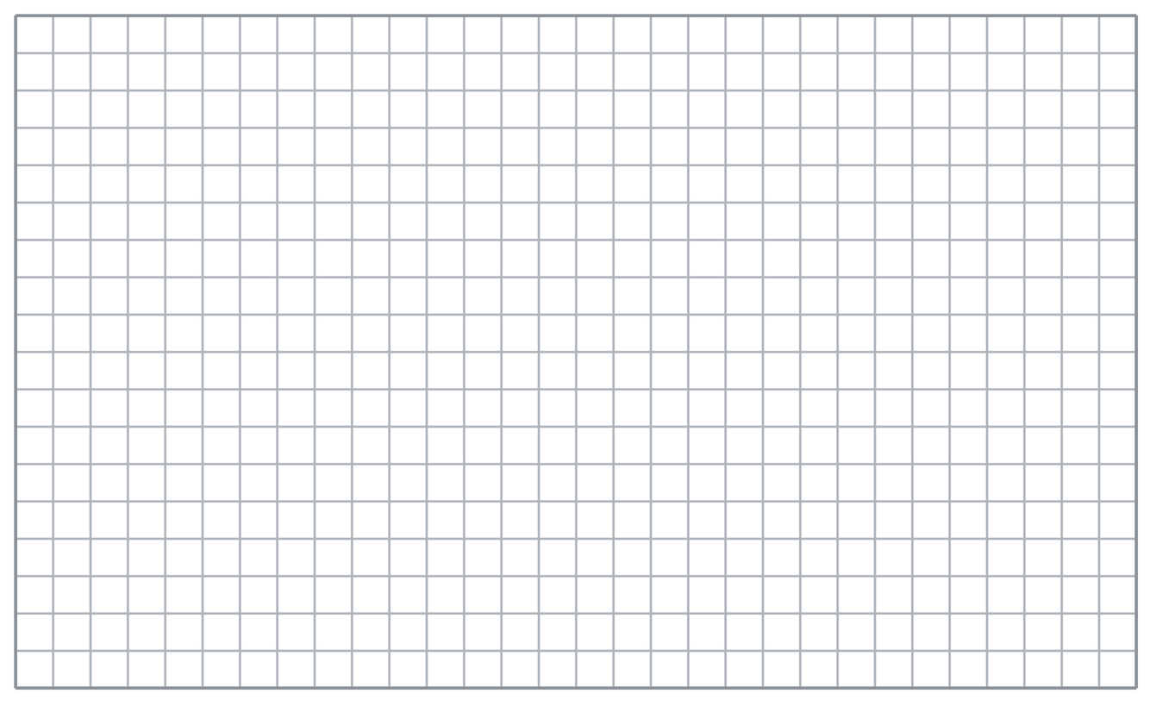
  TURN AND TALK
  How do a solid’s attributes tell you what its net has to look like?
PRACTICE WITH A PARTNER You Do Together · 10–12 min
2. Cereal Box. A cereal box is a rectangular prism 12 in. tall, 8 in. wide, and 2 in. deep.  a. Sketch the net. Rectangles in all __________  b. Area of the largest face __________ | c. Net. Draw the net on the grid below, label every face with its dimensions, and mark the matching pairs.​
  PARTNER TALK
  Which faces of this rectangular prism form congruent pairs? Explain.

3. Tent Net. A camping tent is a triangular prism. Each triangular end has a base of 7 ft and a height of 4 ft, and the tent is 10 ft long.  a. Sketch the net. Triangle pieces __________  b. Area of ONE triangular end __________ | c. Net. Draw the net on the grid below, label every face with its dimensions, and mark the matching pairs.​
  PARTNER TALK
  Where would you fold this net to build the tent? Describe the folds to your partner.

4. Juice Carton. A juice carton is a rectangular prism 6 cm long, 4 cm wide, and 15 cm tall.
a. Rectangles in the net __________
b. Area of the largest face __________
PARTNER TALK
How can you tell from your net which rectangles fold onto each other?

PRACTICE ON YOUR OWN You Do · 8 problems · 18–20 min
5. Gift Box. A gift box is a cube with edges of 9 cm.  Draw a net for the cube, then find the number of faces and the area of one face.  Hint A cube’s faces are identical squares. Try a row of four with one above and one below.  Answer number of faces and area of one face | Net. Draw the net on the grid below, label every face with its dimensions, and mark the matching pairs.​
  Show your work.

6. Display Pyramid. A store display is a square pyramid. Its base is 14 in. on each side and each triangular face has a height of 11 in.  Draw the net, then find the area of one triangular face.  Hint The base of each triangle is a side of the square. Use the triangle formula on just one face.  Answer area of one triangular face in in² | Net. Draw the net on the grid below, label every face with its dimensions, and mark the matching pairs.​
  Show your work.

7. Maya’s Net. Maya drew a net made of 5 squares that are all the same size. She says it folds into a cube.
Justify or correct Maya’s net.
Hint Count the flat faces a cube shows when you turn it and look from every direction.
Answer does it fold into a cube? (Why?)

8. Pencil Case. A pencil case is a rectangular prism 18 cm long, 8 cm wide, and 5 cm tall.  Draw a net for the case, then find the area of the largest face  Hint Each face uses two of the three edges. Pair the two longest edges for the largest face.  Answer area of the largest face in cm² | Net. Draw the net on the grid below, label every face with its dimensions, and mark the matching pairs.​
  Show your work.

9. Museum Pyramid. A museum model is a square pyramid with a base 10 in. on each side. Each triangular face has a slant height of 7 in.  Draw the net, then find the area of one triangular face  Hint The base of each triangle is a side of the square, so use the triangle formula on just one face.  Answer area of one triangular face in in² | Net. Draw the net on the grid below, label every face with its dimensions, and mark the matching pairs.​
  Show your work.

10. Square Pyramid. A square pyramid has a square base and 4 triangular faces. Describe the net you would draw.  Hint One square with a triangle attached to each of its sides.  Answer your description | 11. Rectangular Prism. A rectangular prism is 6 cm by 4 cm by 3 cm. How many rectangles does its net contain, and which ones match?  Hint Opposite faces of a prism are identical.  Answer count and matching pairs

12. Count the Faces. A triangular prism has two triangular ends and three rectangular sides.
a. How many faces does the solid have? __________
b. How many shapes are in its net? __________
Hint A net has one shape per face.
Answer a and b
ANALYZE THE ERROR 5 min
13. Read the work below. Explain the mistake, then show the correct reasoning.
CALEB’S WORK

Caleb drew a net for a square pyramid: one square with three triangles attached to three of its sides. He says it will fold up correctly.
a. Explain the mistake. Count the sides of the square base. How many triangles does the net need? | b. Show correct work  Correct answer
  Show the correct work.
STRETCH YOUR THINKING multi-step reasoning · 8 min
14. Gift Box. A gift box is a rectangular prism 10 in. long, 5 in. wide, and 4 in. tall.
a. List the six rectangles in its net with their dimensions.
b. Name the three matching pairs.
c. Explain how a net makes it easier to plan how much wrapping paper is needed.
Answer the rectangles, the pairs, and your explanation
TEST PRACTICE multiple choice · fill one box · 6 min
15. A net is a flat pattern that folds into a — | 16. A cube’s net contains how many squares?
  □ A. point | □ B. line | □ C. solid | □ D. circle
  □ A. 12 | □ B. 4 | □ C. 8 | □ D. 6

17. A square pyramid’s net contains — | 18. The number of shapes in a net equals the number of —
  □ A. 1 square, 4 triangles | □ B. 4 squares, 1 triangle | □ C. 6 squares | □ D. 2 triangles, 3 rectangles
  □ A. edges | □ B. faces | □ C. vertices | □ D. corners
SPIRAL REVIEW earlier skills · keep them sharp · 6 min
19. From Lesson 5-5 Session 2. A prism has volume 180 cm³, length 6 cm, and width 5 cm. Find its height.  Answer | 20. From Lesson 5-5 Session 1. A prism is 4 in. by 3 in. by 5 in. Find its volume.  Answer

21. From Lesson 4-4 Session 1. Find 60% of 150.  Answer | 22. From Lesson 3-6 Session 1. Convert 48 ounces to pounds.  Answer
CHECK YOUR UNDERSTANDING 5 min
23. Jewelry Box Net. A jewelry box is a rectangular prism 10 cm long, 7 cm wide, and 3 cm tall.  a. Sketch a net for the box and label the edges. Rectangles __________  b. Area of the top face __________  Hint Opposite faces of a prism match, so every rectangle in your net has a twin somewhere in it.  Answer | c. Net. Draw the net on the grid below, label every face with its dimensions, and mark the matching pairs.​
  Show your work.

□ 4 — Can teach it | □ 3 — Got it | □ 2 — Need hint | □ 1 — Need help
Circle your confidence. Star one problem that shows your learning.

