Name |  | Date |  | Period
Lesson 5-6 · Session 2
Guided Practice
Reading Nets and Solids
VOCABULARY read and say each word before you begin
EXPLORE TOGETHER Class Launch · 8–10 min
1. Mystery Net on the Board
A net on the board shows 6 identical squares, each 4 cm on a side, joined edge to edge with no pieces overlapping.
a. Describe. Shape of the pieces: __________ How many? ______ All the same? ______
b. Name It. Folded solid: __________ How do you know? __________
c. Count. Faces: ______ Edges: ______ Vertices: ______
d. Area. Area of ONE face: ______ cm² Area of all the faces together: ______ cm²
TURN AND TALK
How can a net tell you the name of a solid before anyone folds it?

PRACTICE WITH A PARTNER You Do Together · 10–12 min
2. Fold the Net. A net holds 2 rectangles that are 9 in. by 5 in., 2 rectangles that are 9 in. by 3 in., and 2 rectangles that are 5 in. by 3 in.  a. Folded solid __________  b. Which faces land opposite each other? __________ | 3. Prism or Pyramid. Net A is made of 2 hexagons and 6 rectangles. Net B is made of 1 hexagon and 6 triangles.  a. Net A folds into a __________  b. Number of faces on each solid: A __________
  PARTNER TALK
  Why does every rectangle in this net have an exact partner somewhere in it?
  PARTNER TALK
  What part of a net tells you prism versus pyramid? Explain your reasoning.

4. Game Box. A net holds 2 rectangles that are 12 in. by 12 in. and 4 rectangles that are 12 in. by 3 in.
a. Folded solid __________
b. Total area of all six faces __________
PARTNER TALK
How does a square base change this net from an ordinary box net?

PRACTICE ON YOUR OWN You Do · 8 problems · 18–20 min
5. Cube Count. A storage cube has edges of 7 cm.
Find the number of faces, edges, and vertices, then find the area of one face.
Hint Turn a real box in your mind. Faces are flat, edges are the lines, vertices are the corners.
Answer faces, edges, vertices, area of one face

6. Unfolding a Prism. A rectangular prism is 11 in. long, 6 in. wide, and 2 in. tall.  Sketch a net for the prism, then find the area of each different-sized face.  Hint A rectangular prism has three different face sizes, and each size shows up twice in the net.  Answer the three different face areas | Net. Draw the net on the grid below, label every face with its dimensions, and mark the matching pairs.​  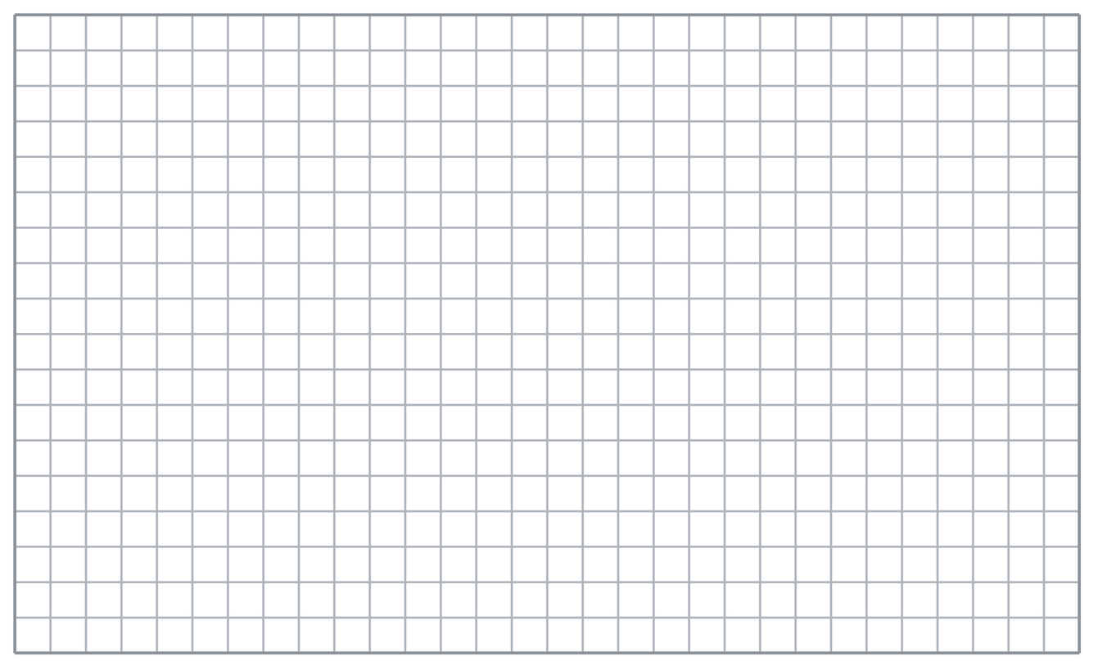
  Show your work.

7. Ravi’s Claim. Ravi sees a net made of 1 square and 4 triangles. He says it folds into a triangular prism.  Justify or correct Ravi’s answer.  Hint Count how many bases the net contains. Prisms and pyramids differ on exactly that point.  Answer correct solid name (Is Ravi right?) | 8. Candle Box. A net is made of 2 identical octagons and 8 rectangles joined edge to edge.  Name the solid, then give its number of faces  Hint Two matching bases point to a prism, and the base shape gives the solid its name.  Answer solid name and number of faces

9. Ornament Net. A net is made of 1 triangle base with 3 triangles around it. Each of the 3 outer triangles has a base of 9 cm and a height of 8 cm.  Name the solid, then find the area of one outer triangle  Hint Only one base means a pyramid. Use the triangle formula on a single outer face.  Answer solid name and area of one outer triangle | 10. Name the Solid. A net is made of 2 identical triangles and 3 rectangles joined edge to edge. Name the solid.  Hint Two matching ends plus rectangles means a prism.  Answer the solid

11. Pyramid or Prism? A net has 1 square and 4 triangles. Name the solid and explain how you know.  Hint One base plus triangles means a pyramid.  Answer the solid and why | 12. Two Nets. Net A has 6 identical squares. Net B has 2 hexagons and 6 rectangles.  a. Name the solid from Net A. __________  b. Name the solid from Net B. __________  Hint Identical end polygons plus rectangles means a prism.  Answer a and b
ANALYZE THE ERROR 5 min
13. Read the work below. Explain the mistake, then show the correct reasoning.
NADIA’S WORK

Nadia says a cube has 6 faces, 6 edges, and 6 vertices, because everything about a cube comes in sixes.
a. Explain the mistake. Trace one face of a box with your finger. How many lines and corners do you pass? | b. Show correct work  Correct answer
  Show the correct work.
STRETCH YOUR THINKING multi-step reasoning · 8 min
14. Three Nets. Net 1: 2 triangles and 3 rectangles. Net 2: 1 square and 4 triangles. Net 3: 2 rectangles and 4 other rectangles.
a. Name the solid each net makes.
b. Explain the rule you used to tell a prism from a pyramid.
c. Explain why counting the shapes alone is not always enough.
Answer all three solids and both explanations
TEST PRACTICE multiple choice · fill one box · 6 min
15. A net with 2 pentagons and 5 rectangles makes a — | 16. A net with 1 triangle and 3 triangles makes a —
  □ A. pentagonal prism | □ B. pentagonal pyramid | □ C. cube | □ D. triangular prism
  □ A. triangular prism | □ B. triangular pyramid | □ C. cube | □ D. rectangular prism

17. A prism is named for the shape of its — | 18. A net with 6 identical squares makes a —
  □ A. longest edge | □ B. rectangles | □ C. two identical ends | □ D. top point
  □ A. triangular prism | □ B. square pyramid | □ C. rectangular prism | □ D. cube
SPIRAL REVIEW earlier skills · keep them sharp · 6 min
19. From Lesson 5-6 Session 1. How many shapes are in the net of a rectangular prism?  Answer | 20. From Lesson 5-5 Session 1. A prism is 8 m by 2 m by 3 m. Find its volume.  Answer

21. From Lesson 4-5 Session 1. If 30 is 60% of a number, find the number.  Answer | 22. From Lesson 3-2 Session 2. Which is the better buy: 4 lb for $10.00 or 6 lb for $14.40?  Answer
CHECK YOUR UNDERSTANDING 5 min
23. Two Nets. Net P is made of 2 identical pentagons and 5 rectangles. Net Q is made of 1 square that is 8 cm on a side plus 4 triangles.
a. Net P folds into a __________
b. Net Q folds into a __________
Hint Two matching bases point to one family of solids; a single base points to the other one.
Answer

□ 4 — Can teach it | □ 3 — Got it | □ 2 — Need hint | □ 1 — Need help
Circle your confidence. Star one problem that shows your learning.

