Name Date Period
Lesson 6-2 · Homework Packet · Sheet 1 of 2
Dividing a Fraction by a Fraction
Maryland Standard 6.NS.A.1 · Learning target — I can divide a fraction by another fraction using the reciprocal.

REMEMBER  • To divide by a fraction, multiply by its reciprocal: 3/4 ÷ 3/8 = 3/4 × 8/3.  • Keep the first fraction, change ÷ to ×, and flip only the second fraction.  • Check: quotient × divisor = dividend. 2 × 3/8 = 6/8 = 3/4. | WORKED EXAMPLE  How many 3/8-cup servings are in 3/4 cup of yogurt?  Step 1 Write the division: 3/4 ÷ 3/8  Step 2 Multiply by the reciprocal: 3/4 × 8/3 = 24/12  Step 3 Simplify: 24/12 = 2  Answer 2 servings
PRACTICE show your work · label units
1. The bar is 1 whole. The shaded part is 4/5 of the bar. How many 1/10 pieces fit in 4/5? Write the division and the quotient.
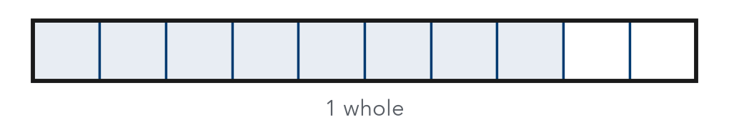
Division

2. Divide. Write each quotient in simplest form.
a. 3/4 ÷ 1/8 = | b. 2/3 ÷ 2/9 = | c. 5/6 ÷ 1/3 =
d. 7/10 ÷ 2/5 = | e. 1/2 ÷ 3/4 = | f. 8/9 ÷ 4/9 =

3. Pancakes. A pancake recipe needs 2/3 cup of milk. Rosa has only 1/2 cup of milk. What fraction of the recipe can she make?

Show your work.
Answer of the recipe

4. Bookmarks. Jae has 5/6 yard of ribbon. Each bookmark needs 5/12 yard. How many bookmarks can Jae make?
Answer bookmarks

5. Find the Error. Imani wrote 4/5 ÷ 2/3 = 4/5 × 2/3 = 8/15. Explain her mistake. Then find the correct quotient.

CHECK YOURSELF | □ I can do this on my own | □ I need a little help | □ I have a question about #
AT HOME With a measuring cup, show someone at home how many 1/4-cup scoops are in 3/4 cup.
Name Date Period
Lesson 6-2 · Homework Packet · Sheet 2 of 2
Dividing with Mixed Numbers
Maryland Standard 6.NS.A.1 · Learning target — I can divide mixed numbers by writing them as improper fractions first.

REMEMBER  • Write each mixed number as an improper fraction: 2 3/4 = 11/4.  • Then multiply by the reciprocal of the divisor.  • Simplify. Write an improper answer as a mixed number. | WORKED EXAMPLE  A board is 5 1/4 feet long. How many 3/4-foot pieces can be cut?  Step 1 5 1/4 = 21/4, so 21/4 ÷ 3/4 = 21/4 × 4/3  Step 2 Multiply and simplify: 84/12 = 7  Answer 7 pieces
PRACTICE show your work · label units
1. Divide. Write each quotient in simplest form.
a. 4 1/2 ÷ 3/4 = | b. 3 1/3 ÷ 5/6 = | c. 2 1/4 ÷ 1 1/2 =
d. 6 ÷ 1 1/3 = | e. 5 5/6 ÷ 1 1/6 = | f. 1 7/8 ÷ 2 1/2 =

2. Write each mixed number as an improper fraction.
a. 3 2/5 = | b. 4 5/6 =

3. Soup Bowls. A pot holds 8 3/4 cups of soup. Each bowl holds 1 1/2 cups. How many bowls can be filled completely? How much soup is left over?

Show your work.
Answer

4. Hiking. A trail is 7 1/2 miles long. Kenji hikes 1 1/4 miles each hour. How many hours will it take him to hike the whole trail?
Answer hours

5. Reason. Without dividing, decide: is 6 1/2 ÷ 1 1/4 greater than or less than 6 1/2?
□ greater than 6 1/2 | □ less than 6 1/2

TEST PRACTICE choose the best answer
6. What is 3 1/2 ÷ 1 3/4?
A 1/2 | B 2 | C 3 2/3 | D 6 1/8

7. A rope is 6 2/3 feet long. It is cut into pieces that are each 5/6 foot long. How many pieces are there?
A 1/8 | B 5 5/9 | C 8 | D 12

CHECK YOURSELF | □ I can do this on my own | □ I need a little help | □ I have a question about #
AT HOME Measure 1 1/2 cups of water with a 1/4-cup scoop. Does the number of scoops match 1 1/2 ÷ 1/4?

