Name Date Period
Lesson 6-6 · Homework Packet · Sheet 1 of 2
Simplifying to Show Equivalence
Maryland Standard 6.EE.A.3 · Learning target — I can simplify an expression by combining like terms to test whether two expressions are equivalent.

REMEMBER  • Like terms have the same variable part: 4x and 9x are like terms. 4x and 4 are not.  • Combine like terms by adding or subtracting coefficients: 4x + 9x = 13x. A lone x is 1x.  • Expressions are equivalent if they simplify to the same expression. | WORKED EXAMPLE  Are 5m + 8 + 2m − 3 and 7m + 5 equivalent?  Step 1 Combine the m terms: 5m + 2m = 7m  Step 2 Combine the constants: 8 − 3 = 5  Step 3 The first simplifies to 7m + 5, the same as the second.  Answer Yes, they are equivalent.
PRACTICE show your work · label units
1. Simplify each expression.
a. 6a + 3a = | b. 10y − 4y =
c. x + 5x + 2 = | d. 7 + 3n + 4 =
e. 8b + 6 − 3b + 1 = | f. 2p + 9q + 5p =
g. 4m + 2 + m + 9 = | h. 12z − z =

2. Perimeter. The side lengths of the triangle are in centimeters. Write and simplify an expression for its perimeter.  Answer cm | 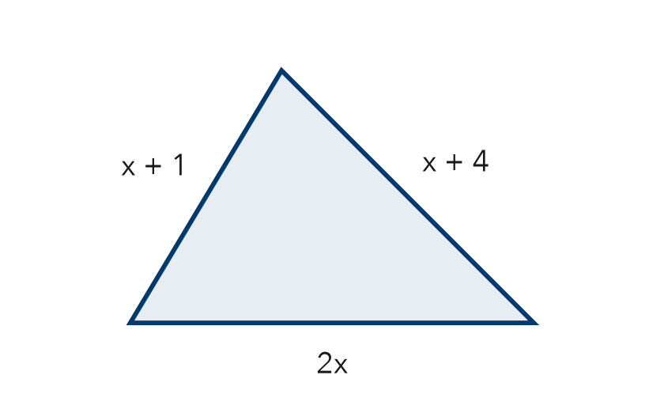
  Show your work.

3. Are 3w + 3w and 6w² equivalent?
□ Yes | □ No

4. Which expression is equivalent to 5x + 3 + 2x?
□ 10x | □ 7x + 3 | □ 5x + 5

5. Find the Error. Elena simplified 7x + 4 − 2x and wrote 9x. Explain her mistake. Then simplify correctly.

CHECK YOURSELF | □ I can do this on my own | □ I need a little help | □ I have a question about #
AT HOME Explain to someone at home why 4x + 4 cannot be written as 8x.
Name Date Period
Lesson 6-6 · Homework Packet · Sheet 2 of 2
Testing and Justifying Equivalence
Maryland Standard 6.EE.A.4 · Learning target — I can test whether two expressions are equivalent by substituting values and by reasoning.

REMEMBER  • Equivalent expressions have the same value for every value of the variable.  • Test with the same value in both. One value that gives different results proves they are not equivalent.  • Matching values do not prove it. Justify with properties, like the distributive property. | WORKED EXAMPLE  Are 4(n + 3) and 4n + 3 equivalent?  Step 1 Test n = 2: 4(2 + 3) = 20 and 4 × 2 + 3 = 11  Step 2 20 ≠ 11. Distributing shows 4(n + 3) = 4n + 12.  Answer Not equivalent
PRACTICE show your work · label units
1. Evaluate each expression when x = 5. Which two might be equivalent?
a. 3(x + 4) = | b. 3x + 12 = | c. 3x + 4 =

2. Write E if the expressions are equivalent or N if they are not.
a. 2(a + 5) and 2a + 10 | b. 6b + 1 and 7b
c. c + c + c and c³ | d. 8 + 4m − m and 3m + 8

3. Counterexample. Nate says n² and 2n are equivalent because both equal 4 when n = 2. Find a value of n that shows he is wrong.

Show your work.
Value and results

4. Reason. 3x and x + 6 are both 9 when x = 3. Which value of x shows they are not equivalent?
□ x = 3 | □ x = 4

5. Which property shows that 5(m + 2) = 5m + 10?
□ Commutative | □ Associative | □ Distributive

TEST PRACTICE choose the best answer
6. Which expression is equivalent to 7(p + 3)?
A 7p + 3 | B 7p + 21 | C p + 21 | D 10p

7. Which expression is not equivalent to 4y + 8?
A 4(y + 2) | B 2(2y + 4) | C 8 + 4y | D 4(y + 8)

CHECK YOURSELF | □ I can do this on my own | □ I need a little help | □ I have a question about #
AT HOME Pick a number with someone at home. Do 2(x + 3) and 2x + 6 give the same value? Try another number.

