Name |  | Date |  | Period
Lesson 7-5 · Session 2 · Version 2
Guided Practice · Version 2
Reflecting Points Across the Axes
VOCABULARY read and say each word before you begin
reflection  Spanish: reflexión | A mirror image flipped across a line. | (4, 1) (4, −1)
x-axis | The horizontal line through the origin. | runs left and right
y-axis | The vertical line through the origin. | runs up and down
opposite  Spanish: opuesto | A number and its negative; equally far from 0. Zero is its own opposite. | 1 and −1 are opposites
quadrant  Spanish: cuadrante | One of the four parts of the grid, I to IV. | Quadrant IV is lower right
EXPLORE TOGETHER Class Launch · 8–10 min
1. Mirror Room Floor Plan  Ms. Rivera’s floor plan puts a reading lamp at (4, 7). One mirror lies along the x-axis and a second mirror lies along the y-axis.  a. Plot. Plot the reading lamp on the coordinate plane below and mark both mirror lines.  b. Reflect. Reading lamp reflected across the x-axis: ( ______ , ______ ) Quadrant ______  c. Reflect. Reading lamp reflected across the y-axis: ( ______ , ______ ) Quadrant ______ | d. Pattern. For each mirror line, identify the coordinate that changes sign and the coordinate that stays the same. __________  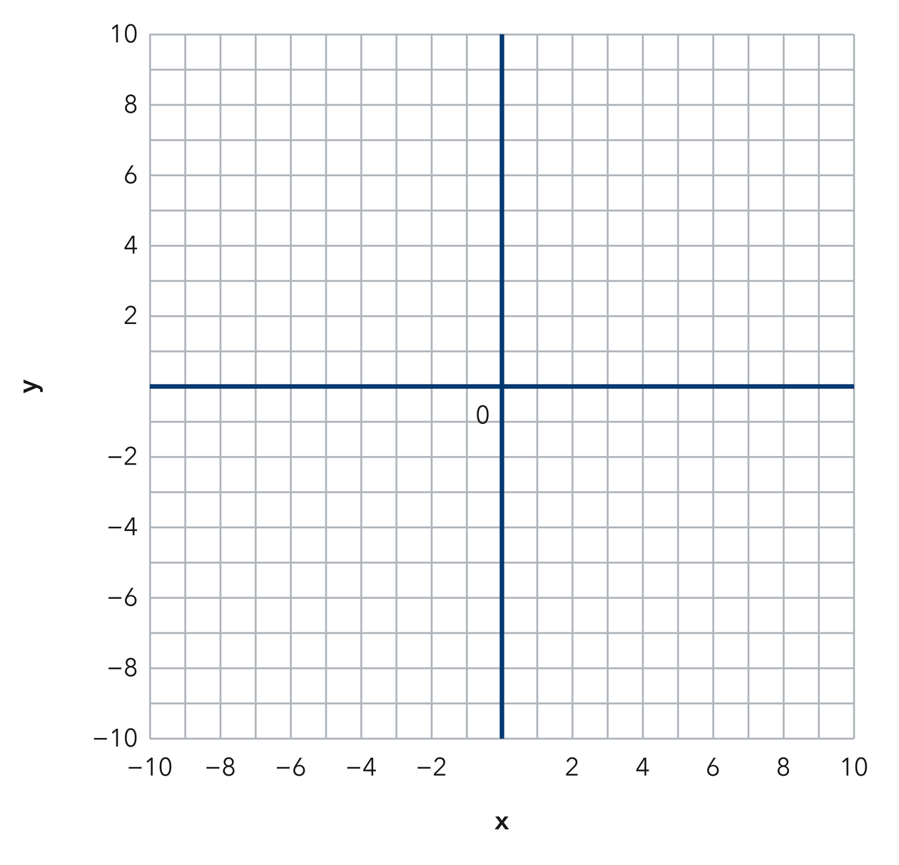​
  TURN AND TALK
  Why does only one coordinate change sign when a point reflects across an axis?
PRACTICE WITH A PARTNER You Do Together · 10–12 min
2. Two Kites. Kite A flies over the point (−6, 3). Kite B is the reflection of Kite A across the y-axis.  a. Write the ordered pair for Omar’s Kite B: ( __________  b. What is the left-right distance between Maya’s and Omar’s kites? __________ | c. Coordinate plane. Plot Maya’s Kite A, then plot Omar’s Kite B across the y-axis.
  PARTNER TALK
  How does the mirror line help you predict the new point before you plot anything?

3. Double Flip. A marker sits at (5, −8). It reflects across the x-axis, and then that image reflects across the y-axis.  a. Write both images of Theo’s marker. First ( __________  b. Name the quadrant containing the marker’s final image. __________ | c. Coordinate plane. Plot Theo’s marker, then plot its first and second images in order.
  PARTNER TALK
  How does the final image compare with the point you started from?

4. Stage Lights. A stage light hangs over the point (−8, 12). A second light is the reflection of the first one across the x-axis.
a. Write the ordered pair for the second lantern: ( __________
b. How far apart are the two lanterns in the up-down direction? __________
PARTNER TALK
How can you name the image before you plot a single point on the grid?

PRACTICE ON YOUR OWN You Do · 8 problems · 18–20 min
5. One Mirror. Point M sits at (−9, −4) on a coordinate grid.  Write the reflection of T across the x-axis and name the quadrant it lands in.  Hint Across the x-axis, keep the x-coordinate and change the sign of the y-coordinate.  Answer image of T and its quadrant | 6. Which Mirror. Point P is at (2, −7) and point Q is at (2, 7). Determine which axis these two points reflect across, and explain how the coordinates prove it.  Hint Compare the x-coordinates, then the y-coordinates. Which coordinate stays the same, and which changes sign?  Answer the axis of reflection and evidence from the coordinates

7. Ben’s Image. Ben says reflecting (−3, 6) across the y-axis gives (−3, −6). Explain what he mixed up, then write the correct image.  Hint For a reflection across the y-axis, decide which coordinate stays the same and which changes sign.  Answer correct image and explanation: Aisha changed the ______-coordinate, but she should have changed the ______-coordinate. | 8. Mirror Wall. Point W sits at (11, −6) on a coordinate grid.  Write the reflection of F across the y-axis and name the quadrant it lands in  Hint Across the y-axis, change the sign of the x-coordinate and keep the y-coordinate.  Answer image of F and its quadrant

9. Back to Start. Point Z sits at (−7, 5). It reflects across the x-axis, and then that image reflects across the x-axis again.  Write both images of D, then explain why the second image matches the drone’s starting point  Hint Track the sign of the y-coordinate through both reflections. What happens when its sign changes twice?  Answer first image, second image, and why the drone returns to its starting point | 10. Two Reflections. Point R sits at (3.25, −5.5). Find its reflection across the x-axis and across the y-axis.  Hint Across the x-axis, change the sign of y. Across the y-axis, change the sign of x.  Answer both reflected coordinates

11. Name the Axis. Point P(−4, 7) is reflected to (−4, −7).
a. Which axis served as the mirror line? __________
b. Explain which coordinate stayed the same and which changed sign. __________
Hint Compare the signs of the original and reflected coordinates.
Answer a and b

12. Both Axes. Reflect the point (6, 2) across the x-axis, then reflect the result across the y-axis.  Hint Use the first reflected point as the starting point for the second reflection.  Answer the coordinates of the final point | Coordinate plane. Plot (6, 2), followed by the first reflected point and then the final reflected point.​
  Show your work.
ANALYZE THE ERROR 5 min
13. Read the work below. Explain the mistake, then show the correct reasoning.
MATEO’S WORK

Reflecting the point (−1, 8) across the x-axis, Lucia flipped both signs and wrote the image as (1, −8).
a. Explain Mateo’s mistake. Mateo says that reflecting (−7, 2) across the x-axis gives (7, −2). Complete the frame: Only the _____-coordinate should change sign; the _____-coordinate should stay the same. | b. Show correct work for reflecting (−7, 2) across the x-axis.  Correct answer
  Show the correct work.
STRETCH YOUR THINKING multi-step reasoning · 8 min
14. Design Symmetry. A designer places a shape’s corner at A(3, 4) and wants matching corners in the other three quadrants.  a. Find and name the point that matches A after a reflection across the y-axis.  b. Find and name the point that matches A after a reflection across the x-axis.  c. Give the coordinates of the fourth corner and explain the reflections you used to find it.  Answer all three matching points and your explanation | d. Coordinate plane. Plot A and each of the three matching corners.​
  Show your work.
TEST PRACTICE multiple choice · fill one box · 6 min
15. Reflecting (5, 3) across the x-axis gives — | 16. Reflecting (−2, 8) across the y-axis gives —
  □ A. (−5, 3) | □ B. (5, −3) | □ C. (−5, −3) | □ D. (3, 5)
  □ A. (2, −8) | □ B. (−2, −8) | □ C. (2, 8) | □ D. (8, −2)

17. Reflecting across the y-axis changes the sign of the — | 18. Reflecting (4, −6) across the x-axis gives —
  □ A. neither | □ B. y-coordinate | □ C. both | □ D. x-coordinate
  □ A. (4, 6) | □ B. (−4, −6) | □ C. (−4, 6) | □ D. (−6, 4)
SPIRAL REVIEW earlier skills · keep them sharp · 6 min
19. From Lesson 7-5 Session 1. Name the quadrant of (−8, 3).  Answer | 20. From Lesson 7-3 Session 2. Find the distance from −7 to 5.  Answer

21. From Lesson 6-6 Session 1. Simplify 5n + 8 + 4n.  Answer | 22. From Lesson 4-1 Session 1. Write 10 out of 25 as a percent.  Answer
CHECK YOUR UNDERSTANDING 5 min
23. Sensor Mirrors. A sensor sits at (−10, 5) on a grid marked from −10 to 10 on both axes.  a. Reflection across the x-axis: ( __________  b. Reflection across the y-axis: ( __________  Hint For each mirror line, keep the coordinate along that axis unchanged and change the sign of the other coordinate.  Answer | c. Coordinate plane. Mark the sensor’s position and its reflected position across each axis.​
  Show your work.

□ 4 — Can teach it | □ 3 — Got it | □ 2 — Need hint | □ 1 — Need help
Circle your confidence. Star one problem that shows your learning.

