Name |  | Date |  | Period
Lesson 7-5 · Session 2
Guided Practice
Reflecting Points Across the Axes
VOCABULARY read and say each word before you begin
reflection  Spanish: reflexión | A mirror image flipped across a line. | (4, 1) (4, −1)
x-axis | The horizontal line through the origin. | runs left and right
y-axis | The vertical line through the origin. | runs up and down
opposite  Spanish: opuesto | A number and its negative; equally far from 0. Zero is its own opposite. | 1 and −1 are opposites
quadrant  Spanish: cuadrante | One of the four parts of the grid, I to IV. | Quadrant IV is lower right
EXPLORE TOGETHER Class Launch · 8–10 min
1. Mirror Room Floor Plan  A floor plan puts a lamp at (4, 7). One mirror lies along the x-axis and a second mirror lies along the y-axis.  a. Plot. Plot the lamp on the coordinate plane below and mark both mirror lines.  b. Reflect. Lamp reflected across the x-axis: ( ______ , ______ ) Quadrant ______  c. Reflect. Lamp reflected across the y-axis: ( ______ , ______ ) Quadrant ______ | d. Pattern. Which coordinate changes in each reflection, and which one stays? __________  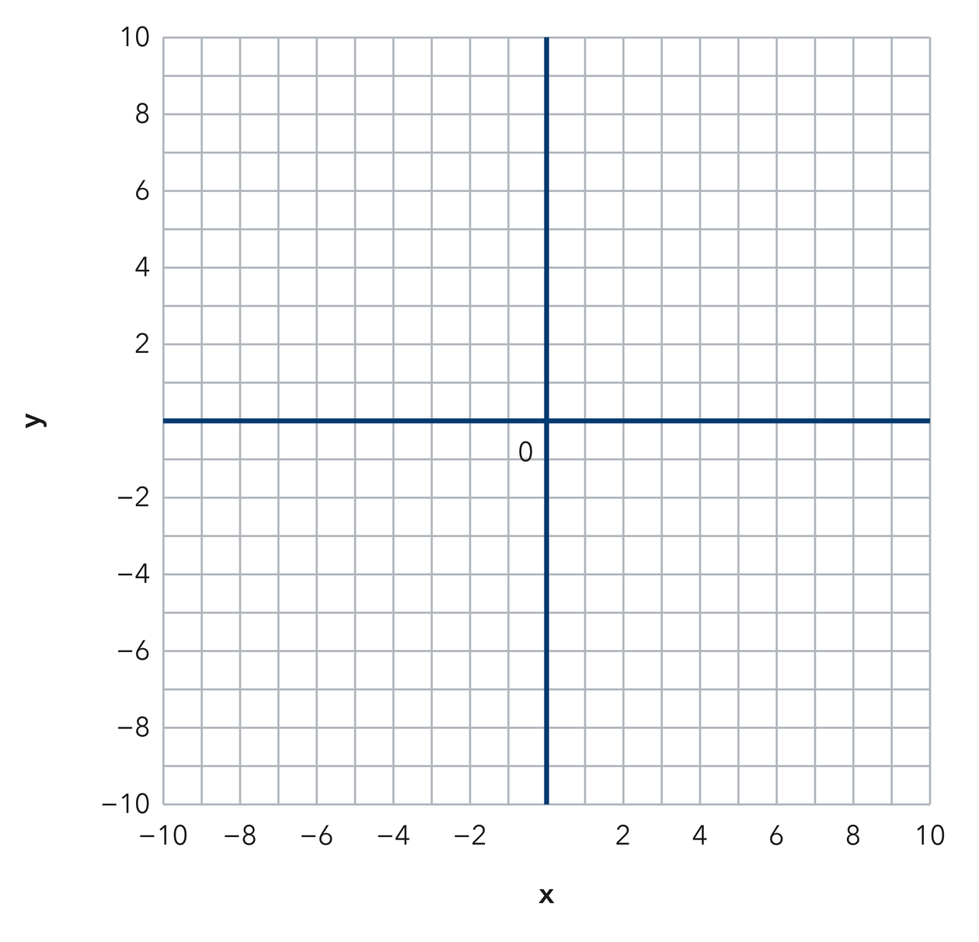​
  TURN AND TALK
  Why does only one coordinate change sign when a point reflects across an axis?
PRACTICE WITH A PARTNER You Do Together · 10–12 min
2. Two Kites. Kite A flies over the point (−6, 3). Kite B is the reflection of Kite A across the y-axis.  a. Write the ordered pair for Kite B: ( __________  b. How far apart are the two kites in the left-right direction? __________ | c. Coordinate plane. Plot Kite A, then its reflection across the y-axis.​
  PARTNER TALK
  How does the mirror line help you predict the new point before you plot anything?

3. Double Flip. A marker sits at (5, −8). It reflects across the x-axis, and then that image reflects across the y-axis.  a. Write both images. First ( __________  b. Which quadrant holds the final image? __________ | c. Coordinate plane. Plot the marker, then each image in turn.​
  PARTNER TALK
  How does the final image compare with the point you started from?

4. Stage Lights. A stage light hangs over the point (−8, 12). A second light is the reflection of the first one across the x-axis.
a. Write the ordered pair for the second light: ( __________
b. How far apart are the two lights in the up-down direction? __________
PARTNER TALK
How can you name the image before you plot a single point on the grid?

PRACTICE ON YOUR OWN You Do · 8 problems · 18–20 min
5. One Mirror. Point M sits at (−9, −4) on a coordinate grid.  Write the reflection of M across the x-axis and name the quadrant it lands in.  Hint A reflection across the x-axis leaves the left-right move alone and flips the up-down move.  Answer image of M and its quadrant | 6. Which Mirror. Point P is at (2, −7) and point Q is at (2, 7). Determine which axis these two points reflect across, and explain how the coordinates prove it.  Hint Compare the pairs one coordinate at a time. The coordinate that stays put names the mirror.  Answer the mirror line and the reason

7. Ben’s Image. Ben says reflecting (−3, 6) across the y-axis gives (−3, −6). Explain what he mixed up, then write the correct image.  Hint Name the mirror first, then decide which coordinate that mirror leaves unchanged.  Answer correct image (What did Ben mix up?) | 8. Mirror Wall. Point W sits at (11, −6) on a coordinate grid.  Write the reflection of W across the y-axis and name the quadrant it lands in  Hint A reflection across the y-axis flips the left-right move and leaves the up-down move alone.  Answer image of W and its quadrant

9. Back to Start. Point Z sits at (−7, 5). It reflects across the x-axis, and then that image reflects across the x-axis again.  Write both images, then explain why the second one matches the starting point  Hint Each reflection flips the same coordinate, so two flips undo each other.  Answer two images and the reason | 10. Two Reflections. Point R sits at (3.25, −5.5). Find its reflection across the x-axis and across the y-axis.  Hint One reflection flips y; the other flips x.  Answer both reflections

11. Name the Axis. Point P(−4, 7) is reflected to (−4, −7).
a. Which axis was the reflection across? __________
b. Explain how the coordinates show it. __________
Hint Look at which coordinate changed sign.
Answer a and b

12. Both Axes. Reflect the point (6, 2) across the x-axis, then reflect the result across the y-axis.  Hint Apply one rule, then the other.  Answer the final point | Coordinate plane. Plot (6, 2), then each reflection in turn.​
  Show your work.
ANALYZE THE ERROR 5 min
13. Read the work below. Explain the mistake, then show the correct reasoning.
LUCIA’S WORK

Reflecting the point (−1, 8) across the x-axis, Lucia flipped both signs and wrote the image as (1, −8).
a. Explain the mistake. Which single coordinate should a reflection across the x-axis change? Check the other one. | b. Show correct work  Correct answer
  Show the correct work.
STRETCH YOUR THINKING multi-step reasoning · 8 min
14. Design Symmetry. A designer places a shape’s corner at A(3, 4) and wants matching corners in the other three quadrants.  a. Reflect A across the y-axis and name the new point.  b. Reflect A across the x-axis and name the new point.  c. Name the fourth corner and explain how you found it.  Answer all three points and your explanation | d. Coordinate plane. Plot A, then the three matching corners.​
  Show your work.
TEST PRACTICE multiple choice · fill one box · 6 min
15. Reflecting (5, 3) across the x-axis gives — | 16. Reflecting (−2, 8) across the y-axis gives —
  □ A. (−5, 3) | □ B. (5, −3) | □ C. (−5, −3) | □ D. (3, 5)
  □ A. (2, −8) | □ B. (−2, −8) | □ C. (2, 8) | □ D. (8, −2)

17. Reflecting across the y-axis changes the sign of the — | 18. Reflecting (4, −6) across the x-axis gives —
  □ A. neither | □ B. y-coordinate | □ C. both | □ D. x-coordinate
  □ A. (4, 6) | □ B. (−4, −6) | □ C. (−4, 6) | □ D. (−6, 4)
SPIRAL REVIEW earlier skills · keep them sharp · 6 min
19. From Lesson 7-5 Session 1. Name the quadrant of (−8, 3).  Answer | 20. From Lesson 7-3 Session 2. Find the distance from −7 to 5.  Answer

21. From Lesson 6-6 Session 1. Simplify 5n + 8 + 4n.  Answer | 22. From Lesson 4-1 Session 1. Write 10 out of 25 as a percent.  Answer
CHECK YOUR UNDERSTANDING 5 min
23. Sensor Mirrors. A sensor sits at (−10, 5) on a grid marked from −10 to 10 on both axes.  a. Reflection across the x-axis: ( __________  b. Reflection across the y-axis: ( __________  Hint Name the mirror line first; the coordinate measured along that line stays where it is.  Answer | c. Coordinate plane. Plot the sensor and both of its reflections.​
  Show your work.

□ 4 — Can teach it | □ 3 — Got it | □ 2 — Need hint | □ 1 — Need help
Circle your confidence. Star one problem that shows your learning.

