Name |  | Date |  | Period

Lesson 7-6 · Session 1
Homework
Distance Between Points on a Grid
Maryland Standard 6.NS.C.8 · Learning target — I can find the distance between two points that share a coordinate.
Show a model, calculation, or explanation for each exercise. Label units and answer every part.
Exercises 1–12 earn 1 point for a correct response and 1 for supporting work. Spiral Review and Test Practice earn 1 point each.
REMEMBER review this before you start
• When two points share the same x-coordinate or same y-coordinate, find the distance using the difference (absolute value) between the other coordinates.
• Count grid squares to check your answer.
• Watch out — distance uses the coordinate that changes, not the one that stays the same.
• Check it — count the units on a sketch to confirm your arithmetic.
WORKED EXAMPLE the same steps you practiced in class
Finding the Distance Between Two Points on a Vertical Line On a map where each unit is one kilometer, find the distance from J(−4.5, 8.5) to K(−4.5, −3.5).
Step 1 The x-coordinates match, so both points sit on one vertical line.
Step 2 The y-coordinates have different signs, so the trip crosses the x-axis.
Step 3 Distance from 0 for each y-coordinate: |8.5| = 8.5 and |−3.5| = 3.5
Step 4 Join the two distances: 8.5 + 3.5 = 12
Answer The points are 12 units apart, so the trip is 12 kilometers straight up and down.
EXERCISES 12 exercises · 24 points
1. Find the distance between (2, 3) and (2, −5) (same x-coordinate).

Show your work.
Answer
2. Find the distance between (−4, 1) and (6, 1) (same y-coordinate).

Show your work.
Answer
3. Plot both pairs of points from problems 1 and 2 and count the grid squares to check your answers.

Coordinate plane. Plot and label the points on the plane below. Then count the grid squares between each pair.​
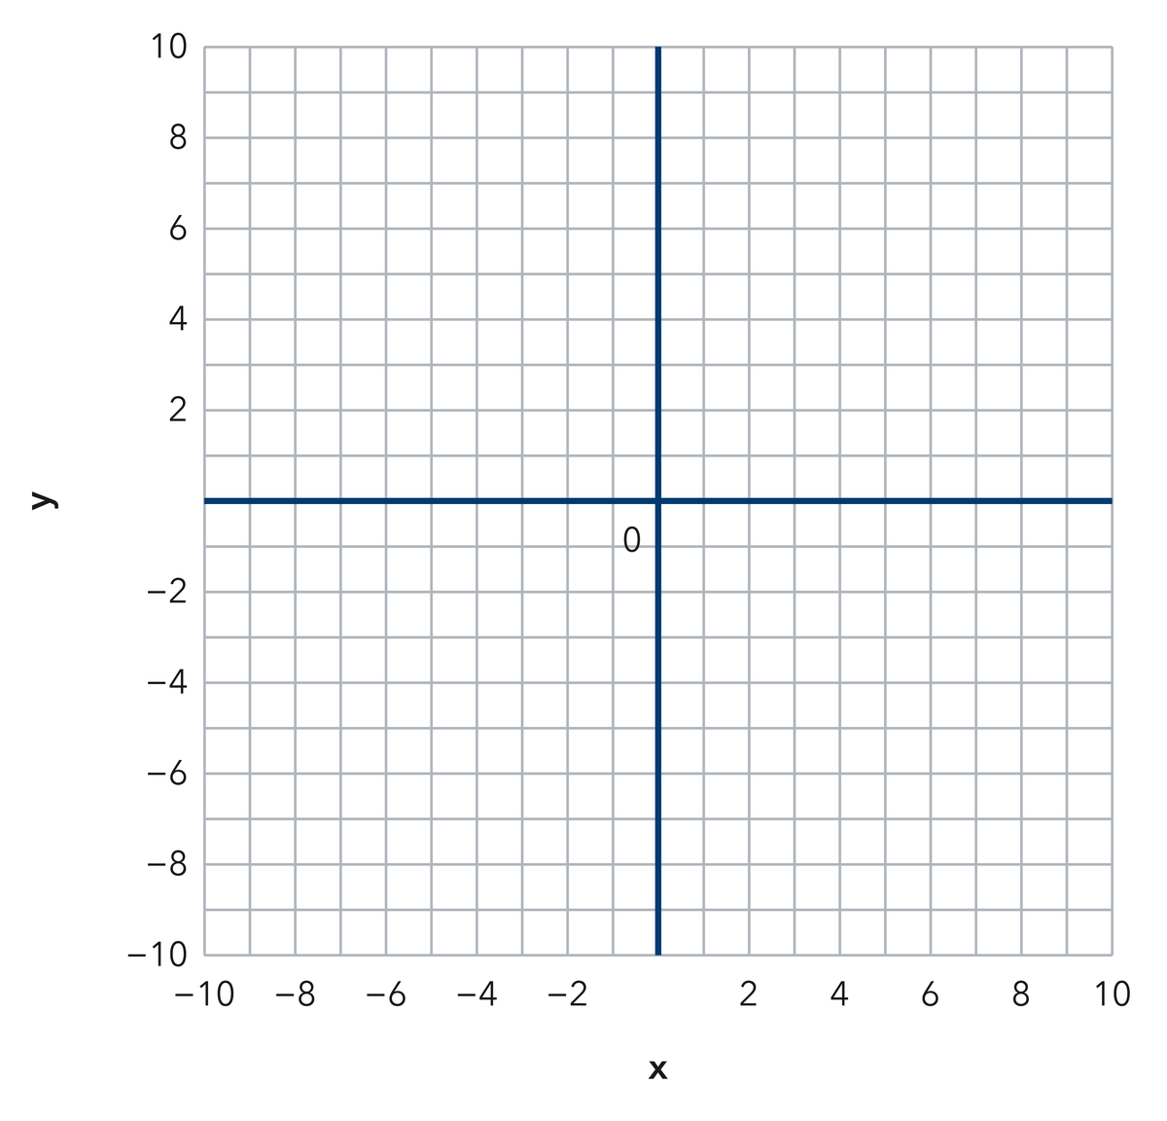
Show your work.
Answer
4. Write each distance on the line.
a. Distance between (5, 9) and (5, −3): ______
b. Distance between (−7, 2) and (8, 2): ______
c. Distance between (−1, −4) and (−1, −16): ______
d. |−11| + |6| = ______
e. Distance between (3, 7) and (3, 20): ______

Answer
5. Two Hydrants. Two hydrants sit at (−9, 4) and (−9, −10) on a city grid where each unit is one meter. Find the distance between them.

Show your work.

Answer
6. Straight Walk. Malia walks straight from (−12, 6) to (7, 6). Each unit is one block. Find how far she walks, then tell which coordinates you used.

Show your work.

Answer
7. Missing Corner. Point R sits at (−5, 11). Point S sits 18 units directly below R. Write the coordinates of point S.

Show your work.

Answer
8. Andre found the distance from (4, −8) to (4, 5) by subtracting 5 from 8 and writing 3 units. Explain the mistake, then show the correct distance.

Show your work.

Answer
9. Find the distance from (7, 1) to (7, 12).

Show your work.
Answer units
10. Find the distance from (−8, 3) to (4, 3).

Show your work.
Answer units
11. Same Side. Find the distance from (−5, −2) to (−5, −11).

Show your work.
Answer units
12. Find the Mistake. For (2, 6) to (2, −4), Tom wrote 2 units. Explain the mistake.

Show your work.
Answer the mistake and the distance
SPIRAL REVIEW earlier skills · 1 point each
13. From Lesson 7-5 Session 2. Reflect (−2, 7) across the y-axis.
Answer
14. From Lesson 6-8 Session 1. Simplify 6(m + 1) + 2m.
Answer
15. From Lesson 4-4 Session 1. Find 85% of 200.
Answer
TEST PRACTICE multiple choice · fill one box · 1 point each
16. The distance from (0, 5) to (0, −5) is —
□ A. 5 | □ B. 0 | □ C. 10 | □ D. 25
17. Two points with the same y-value lie on a —
□ A. circle | □ B. vertical line | □ C. diagonal | □ D. horizontal line
18. The distance from (−9, 2) to (−3, 2) is —
□ A. 6 | □ B. 12 | □ C. −6 | □ D. 27
CHECK YOURSELF Score: ______ / 30
□ Solved on my own | □ Needed a hint | □ Need help on Question # ______
Check signs, scale, and labels. Use a number line or coordinate grid to verify one response.

