Name |  | Date |  | Period
Lesson 7-6 · Session 1 · Version 2
Guided Practice · Version 2
Distance Between Points on a Grid
VOCABULARY read and say each word before you begin
distance  Spanish: distancia | How far apart two points are. | zero or a positive length
absolute value  Spanish: valor absoluto | How far a number is from zero. | |−7| = 7
horizontal distance | How far apart two points are left to right. | uses the x-coordinates
vertical distance | How far apart two points are up and down. | uses the y-coordinates
coordinate plane  Spanish: plano de coordenadas | A grid made by a horizontal and a vertical line. | x-axis across, y-axis up
EXPLORE TOGETHER Class Launch · 8–10 min
1. Town Map Walk  Sofia uses a town map where each unit is one kilometer: Library (−8, 5), Pool (7, 5), Clinic (−8, −6), and Depot (7, −6).  a. Plot. Help Sofia plot and label all four town places on the coordinate plane below.  b. Horizontal. Sofia walks from Library to Pool: ______ km Which coordinates did you use? __________  c. Vertical. Sofia walks from Library to Clinic: ______ km Did you add or subtract the distances? ______ | d. Reason. For each trip, explain whether Sofia should add or subtract the absolute values. _________  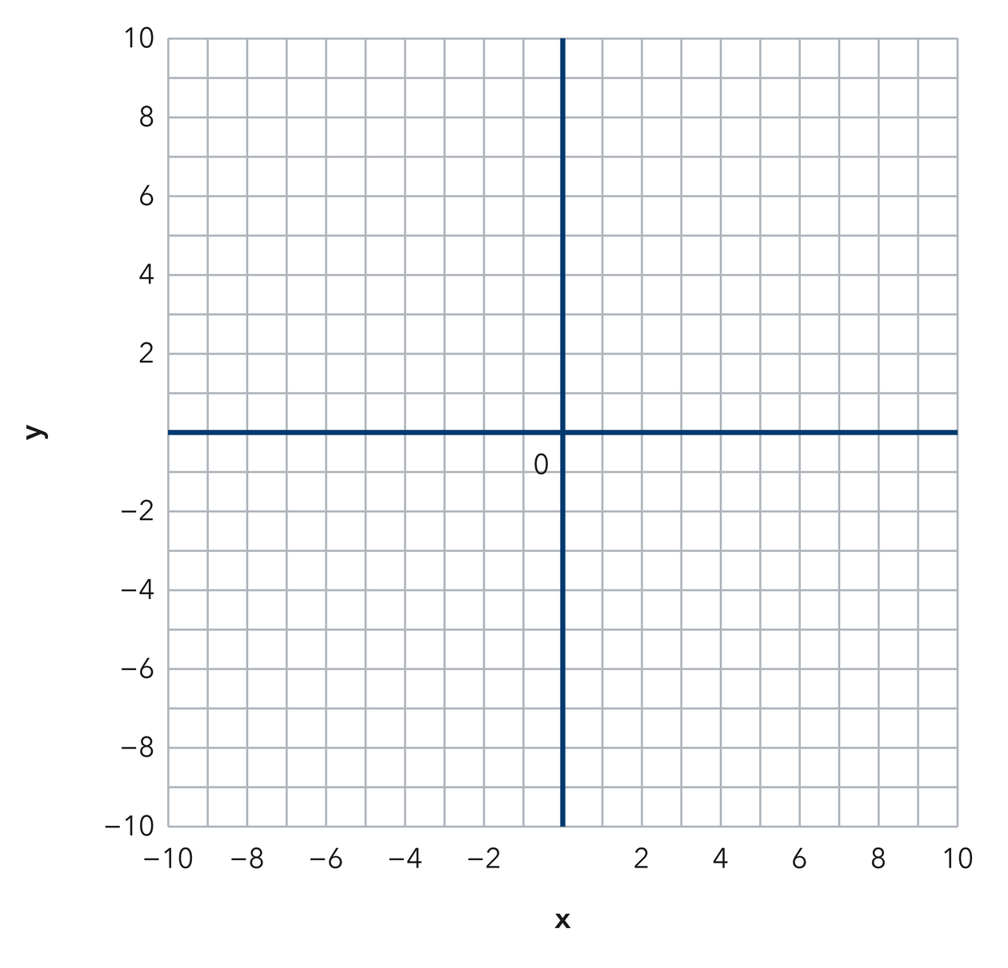​
  TURN AND TALK
  How can the coordinates alone tell you whether a trip runs across or up and down?
PRACTICE WITH A PARTNER You Do Together · 10–12 min
2. Two Buoys. Two buoys float at (3, 14) and (3, 4) on a lake grid where each unit is one meter.  a. Which coordinate do the two garden posts share? __________  b. Distance between the garden posts __________ | 3. Two Towers. Two radio towers stand at (−11, 2) and (6, 2) on a map grid.  a. Write the absolute value of each x-coordinate. __________  b. Distance between the food stands __________
  PARTNER TALK
  Why do two points on the same side of an axis call for subtraction instead?
  PARTNER TALK
  How does crossing the y-axis change the way you combine the two distances?

4. Two Flagpoles. Two flagpoles stand at (−13, 9) and (−13, −6) on a campus grid where each unit is one meter.
a. Which coordinate do the two benches share? __________
b. Distance between the benches __________
PARTNER TALK
Why does a trip that crosses the x-axis join the two distances instead of taking one away?

PRACTICE ON YOUR OWN You Do · 8 problems · 18–20 min
5. Drone Flight. A drone flies straight from (−5, 13) to (−5, −4) on a grid where each unit is one meter.  Find the distance the robot travels and explain why you used the y-coordinates.  Hint The robot's x-coordinates match, so its trip is vertical. Decide whether the trip crosses the x-axis.  Answer distance traveled, in meters | 6. One Quadrant. Find the distance from the point (−16, −7) to the point (−16, −20) on a coordinate grid.  Hint Both y-coordinates are negative, so Jasper's trip stays below the x-axis.  Answer distance walked, in units

7. Missing Point. Point G sits at (10, −3). Point H sits 15 units directly to the left of point G.  Write the coordinates of point Q and explain how the distance gave you its x-coordinate.  Hint Moving left changes only the x-coordinate. Count 19 units left from point P.  Answer coordinates of point Q | 8. Bus Route. A bus runs straight from (−17, −4) to (12, −4) on a city grid where each unit is one block.  Find the distance Omar rides, then explain why you used the x-coordinates.  Hint Omar's y-coordinates match, so he travels horizontally. Decide whether his route crosses the y-axis.  Answer distance ridden, in blocks

9. Window Washer. A window washer moves from (21, 18) to (21, 7) on a building grid where each unit is one foot.  Find the distance the stage lift moves, then explain why you subtracted the two absolute values.  Hint Both y-coordinates are positive, so the stage lift stays above the x-axis.  Answer distance the lift moved, in feet | 10. Vertical Line. On a map where each unit is one kilometre, find the distance from (3, 8) to (3, −2).  Hint The x-values match, so use the y-values: 9 and −4 are on opposite sides of zero.  Answer distance traveled, in kilometres

11. Horizontal Line. Find the distance from (−6, 4) to (5, 4).  Hint Both points have the same y-value. Use their x-values to find the distance.  Answer distance, in units | Coordinate plane. Plot and label Adrian's two points, then draw the segment between them.​
  Show your work.

12. Same Side. Find the distance from (2, −9) to (2, −3).  a. Which coordinate do you use to find Vivian's distance? __________  b. Find the distance between Vivian's points. __________  Hint Both y-values are negative. Subtract the smaller absolute value from the larger absolute value.  Answer responses to a and b | c. Coordinate plane. Plot and label Adrian's two points, then draw the segment between them.​
  Show your work.
ANALYZE THE ERROR 5 min
13. Read the work below. Explain the mistake, then show the correct reasoning.
AMINA’S WORK

To find the distance from (2, −9) to (2, 6), Malik subtracted and wrote 3 units, saying nine minus six is three.
a. Explain the mistake. Check the signs of Amina's two y-coordinates. Does the trip cross the x-axis? Complete: Amina should _____ the absolute values because _____. | b. Show correct work for Amina's problem.  Correct answer
  Show the correct work.
STRETCH YOUR THINKING multi-step reasoning · 8 min
14. City Grid. On a map with one unit per block, a library sits at (−4, 6), a school at (5, 6), and a park at (5, −3).  a. Find how many blocks Daniel walks from the library to the school.  b. Find how many blocks Daniel walks from the school to the park.  c. Find Daniel's total walking distance from the library to the park by way of the school.  Answer both walking distances and the total | d. Coordinate plane. Plot the library, the school and the park, then draw Daniel's walking route.​
  Show your work.
TEST PRACTICE multiple choice · fill one box · 6 min
15. The distance from (4, 2) to (4, 9) is — | 16. Two points with the same x-value lie on a —
  □ A. 5 | □ B. 11 | □ C. 7 | □ D. 13
  □ A. circle | □ B. horizontal line | □ C. diagonal | □ D. vertical line

17. The distance from (−3, 5) to (6, 5) is — | 18. The distance from (1, −4) to (1, −10) is —
  □ A. 9 | □ B. 3 | □ C. 11 | □ D. 30
  □ A. 14 | □ B. 6 | □ C. −6 | □ D. 40
SPIRAL REVIEW earlier skills · keep them sharp · 6 min
19. From Lesson 7-5 Session 2. Reflect (4, 3) across the x-axis.  Answer | 20. From Lesson 7-4 Session 2. Order −2, −11, and 3 from least to greatest.  Answer

21. From Lesson 6-7 Session 2. Find the LCM of 6 and 14.  Answer | 22. From Lesson 5-5 Session 1. A prism is 8 cm by 5 cm by 2 cm. Find its volume.  Answer
CHECK YOUR UNDERSTANDING 5 min
23. Trail Markers. Two trail markers sit at (−14, 8) and (19, 8) on a park grid where each unit is one meter.
a. Distance between the two picnic tables __________
b. Did you add or subtract the absolute values of the x-coordinates? __________
Hint The picnic tables have matching y-coordinates. Their horizontal connecting segment crosses the y-axis.
Answer

□ 4 — Can teach it | □ 3 — Got it | □ 2 — Need hint | □ 1 — Need help
Circle your confidence. Star one problem that shows your learning.

