Name |  | Date |  | Period
Lesson 7-6 · Session 1
Guided Practice
Distance Between Points on a Grid
VOCABULARY read and say each word before you begin
distance  Spanish: distancia | How far apart two points are. | zero or a positive length
absolute value  Spanish: valor absoluto | How far a number is from zero. | |−7| = 7
horizontal distance | How far apart two points are left to right. | uses the x-coordinates
vertical distance | How far apart two points are up and down. | uses the y-coordinates
coordinate plane  Spanish: plano de coordenadas | A grid made by a horizontal and a vertical line. | x-axis across, y-axis up
EXPLORE TOGETHER Class Launch · 8–10 min
1. Town Map Walk  On a town map each unit is one kilometer: Library (−8, 5), Pool (7, 5), Clinic (−8, −6), and Depot (7, −6).  a. Plot. Plot and label all four town places on the coordinate plane below.  b. Horizontal. Library to Pool: ______ km Which coordinates did you use? __________  c. Vertical. Library to Clinic: ______ km Did you add or subtract the distances? ______ | d. Reason. Why does one trip add the absolute values and the other one subtract? _________  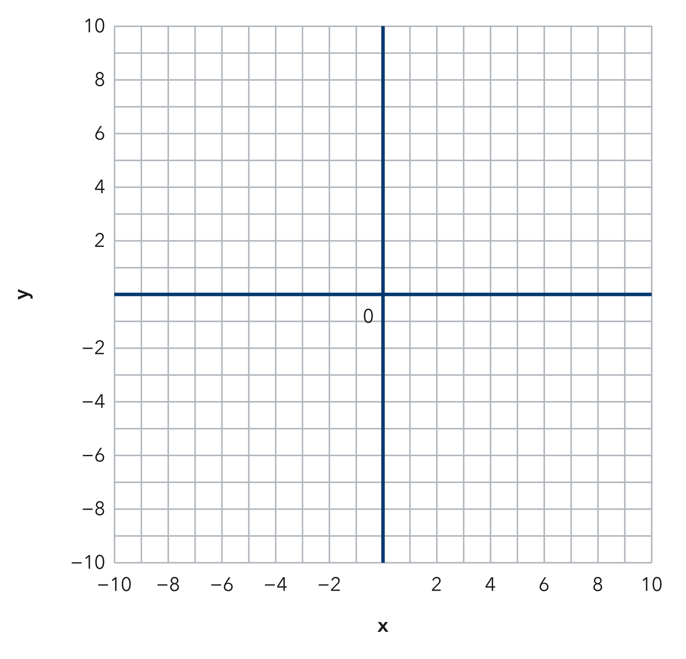​
  TURN AND TALK
  How can the coordinates alone tell you whether a trip runs across or up and down?
PRACTICE WITH A PARTNER You Do Together · 10–12 min
2. Two Buoys. Two buoys float at (3, 14) and (3, 4) on a lake grid where each unit is one meter.  a. Which coordinate do the two buoys share? __________  b. Distance between the buoys __________ | 3. Two Towers. Two radio towers stand at (−11, 2) and (6, 2) on a map grid.  a. Absolute value of each x-coordinate __________  b. Distance between the towers __________
  PARTNER TALK
  Why do two points on the same side of an axis call for subtraction instead?
  PARTNER TALK
  How does crossing the y-axis change the way you combine the two distances?

4. Two Flagpoles. Two flagpoles stand at (−13, 9) and (−13, −6) on a campus grid where each unit is one meter.
a. Which coordinate do the two poles share? __________
b. Distance between the poles __________
PARTNER TALK
Why does a trip that crosses the x-axis join the two distances instead of taking one away?

PRACTICE ON YOUR OWN You Do · 8 problems · 18–20 min
5. Drone Flight. A drone flies straight from (−5, 13) to (−5, −4) on a grid where each unit is one meter.  Find the distance the drone travels and explain why you used the y-coordinates.  Hint Matching x-coordinates make this a vertical trip. Check whether it crosses the x-axis.  Answer distance flown, in meters | 6. One Quadrant. Find the distance from the point (−16, −7) to the point (−16, −20) on a coordinate grid.  Hint Both y-coordinates sit below the x-axis, so this trip stays on one side of that axis.  Answer distance, in units

7. Missing Point. Point G sits at (10, −3). Point H sits 15 units directly to the left of point G.  Write the coordinates of point H and explain how the distance gave you its x-coordinate.  Hint Moving left changes only the x-coordinate. Count the units back from where G sits.  Answer coordinates of point H | 8. Bus Route. A bus runs straight from (−17, −4) to (12, −4) on a city grid where each unit is one block.  Find the distance the bus travels, then explain why you used the x-coordinates  Hint Matching y-coordinates make this a left-right trip. Check whether it crosses the y-axis.  Answer distance traveled, in blocks

9. Window Washer. A window washer moves from (21, 18) to (21, 7) on a building grid where each unit is one foot.  Find the distance the washer moves, then explain why you subtracted the two absolute values  Hint Both y-coordinates sit above the x-axis, so the trip never crosses that axis.  Answer distance moved, in feet | 10. Vertical Line. On a map where each unit is one kilometre, find the distance from (3, 8) to (3, −2).  Hint The x-values match, so use the y-values: 8 and −2 are on opposite sides of zero.  Answer kilometres

11. Horizontal Line. Find the distance from (−6, 4) to (5, 4).  Hint The y-values match, so use the x-values.  Answer units | Coordinate plane. Plot both points and draw the segment between them.​
  Show your work.

12. Same Side. Find the distance from (2, −9) to (2, −3).  a. Which coordinate do you use? __________  b. Find the distance. __________  Hint Both y-values are negative, so subtract the absolute values.  Answer a and b | c. Coordinate plane. Plot both points and draw the segment between them.​
  Show your work.
ANALYZE THE ERROR 5 min
13. Read the work below. Explain the mistake, then show the correct reasoning.
MALIK’S WORK

To find the distance from (2, −9) to (2, 6), Malik subtracted and wrote 3 units, saying nine minus six is three.
a. Explain the mistake. Check the signs of the two y-coordinates. Does this trip cross the x-axis? | b. Show correct work  Correct answer
  Show the correct work.
STRETCH YOUR THINKING multi-step reasoning · 8 min
14. City Grid. On a map with one unit per block, a library sits at (−4, 6), a school at (5, 6), and a park at (5, −3).  a. Find the distance from the library to the school.  b. Find the distance from the school to the park.  c. Find the total walking distance from the library to the park by way of the school.  Answer both distances and the total | d. Coordinate plane. Plot the library, the school and the park, then draw the walking route.​
  Show your work.
TEST PRACTICE multiple choice · fill one box · 6 min
15. The distance from (4, 2) to (4, 9) is — | 16. Two points with the same x-value lie on a —
  □ A. 5 | □ B. 11 | □ C. 7 | □ D. 13
  □ A. circle | □ B. horizontal line | □ C. diagonal | □ D. vertical line

17. The distance from (−3, 5) to (6, 5) is — | 18. The distance from (1, −4) to (1, −10) is —
  □ A. 9 | □ B. 3 | □ C. 11 | □ D. 30
  □ A. 14 | □ B. 6 | □ C. −6 | □ D. 40
SPIRAL REVIEW earlier skills · keep them sharp · 6 min
19. From Lesson 7-5 Session 2. Reflect (4, 3) across the x-axis.  Answer | 20. From Lesson 7-4 Session 2. Order −2, −11, and 3 from least to greatest.  Answer

21. From Lesson 6-7 Session 2. Find the LCM of 6 and 14.  Answer | 22. From Lesson 5-5 Session 1. A prism is 8 cm by 5 cm by 2 cm. Find its volume.  Answer
CHECK YOUR UNDERSTANDING 5 min
23. Trail Markers. Two trail markers sit at (−14, 8) and (19, 8) on a park grid where each unit is one meter.
a. Distance between the two markers __________
b. Did you add or subtract the absolute values? __________
Hint Matching y-coordinates make this a left-right trip; check whether it crosses the y-axis.
Answer

□ 4 — Can teach it | □ 3 — Got it | □ 2 — Need hint | □ 1 — Need help
Circle your confidence. Star one problem that shows your learning.

