Name |  | Date |  | Period
Lesson 7-6 · Session 2
Guided Practice
Comparing Distances on the Plane
VOCABULARY read and say each word before you begin
distance  Spanish: distancia | How far apart two points are. | zero or a positive length
absolute value  Spanish: valor absoluto | How far a number is from zero. | |−7| = 7
quadrant  Spanish: cuadrante | One of the four parts of the grid, I to IV. | same quadrant = same signs
compare  Spanish: comparar | To decide which amount is greater or less. | which trip is longer?
vertical distance | How far apart two points are up and down. | uses the y-coordinates
EXPLORE TOGETHER Class Launch · 8–10 min
1. Campus Map Distances
Each unit is one kilometer on a campus map: Gym (−6, 4), Lab (−6, 17), Field (8, 4), and Office (−6, −2).
a. Plot. Draw a grid from −10 to 20 on both axes. Plot and label all four campus spots.
b. Same Side. Gym to Lab: ______ km Did you add or subtract the absolute values? ______
c. Across. Gym to Field: ______ km Which two absolute values did you combine? ________
d. Compare. Longer trip, Gym to Lab or Gym to Office? ______ By how many km? ______
TURN AND TALK
How do the signs of the changing coordinates tell you whether to add or to subtract?

PRACTICE WITH A PARTNER You Do Together · 10–12 min
2. Two Errands. From home at (5, −3), Rae rides to the bank at (5, −15) and later to the gym at (5, 10).  a. Home to the bank __________  b. Home to the gym __________ | 3. Two Routes. A courier starts at (−12, 7) and may travel either to (4, 7) or to (−12, −5).  a. Length of each route __________  b. Shorter route __________
  PARTNER TALK
  Why does one of these trips cross the x-axis while the other one does not?
  PARTNER TALK
  How can you compare two routes without drawing either one of them first?

4. Two Riders. From the rec center at (−9, 5), Tariq rides to (−9, −8) and Jada rides to (6, 5). Each unit is one block.
a. Length of each ride. Tariq __________
b. Who rides farther? __________
PARTNER TALK
How can the coordinates alone tell you which ride crosses an axis?

PRACTICE ON YOUR OWN You Do · 8 problems · 18–20 min
5. Who Walks Farther. Jo walks from (−3, 10) to (−3, 2). Sam walks from (6, −8) to (−7, −8). Each unit is one block.  Find both distances, then determine who walks farther.  Hint Check which coordinate stays put in each walk, then look at the signs of the other one.  Answer two distances and who walks farther | 6. Add or Subtract. Explain when you add the absolute values of two coordinates to find a distance and when you subtract them. Give one grid example of each case.  Hint Ask whether the segment crosses an axis. That one question settles the operation.  Answer rule plus two examples

7. Partner Point. Point T sits at (−4, 16). Point U shares the x-coordinate of T and lies 22 units directly below it.  Write the coordinates of point U and show how absolute value helped you place it.  Hint Moving down changes only the y-coordinate. Count to the x-axis first, then keep going.  Answer coordinates of point U | 8. Two Hikes. Kendra hikes from (−11, 12) to (−11, 3). Owen hikes from (−2, −15) to (10, −15). Each unit is one kilometer.  Find both distances, then determine who hikes farther  Hint Check which coordinate stays put in each hike, then look at the signs of the other one.  Answer two distances and who hikes farther

9. Place the Stop. Point N sits at (13, −5). Point M shares the y-coordinate of N and lies 20 units directly to the left of it.  Write the coordinates of point M, then show how absolute value checked your answer  Hint Moving left changes only the x-coordinate. Count back to the y-axis first, then keep going.  Answer coordinates of point M | 10. Two Walks. From the hub H(4.25, 5.75), Ana walks to A(4.25, −3.25) and Ben walks to B(4.25, 9.75). Find both distances and say who walks farther.  Hint All three points share the same x-value.  Answer both distances and the farther walk

11. Add or Subtract? Decide the operation and find each distance.
a. From (−2, 3) to (7, 3). __________
b. From (5, 3) to (12, 3). __________
Hint Check whether the two x-values are on the same side of zero.
Answer a and b

12. Which Is Closer? A store sits at (0, 0). Home A is at (0, −7) and Home B is at (0, 5).  a. Find each distance to the store. __________  b. Which home is closer? __________  Hint Distance from zero is absolute value.  Answer a and b | c. Coordinate plane. Plot the store, Home A and Home B, then compare the two distances.​  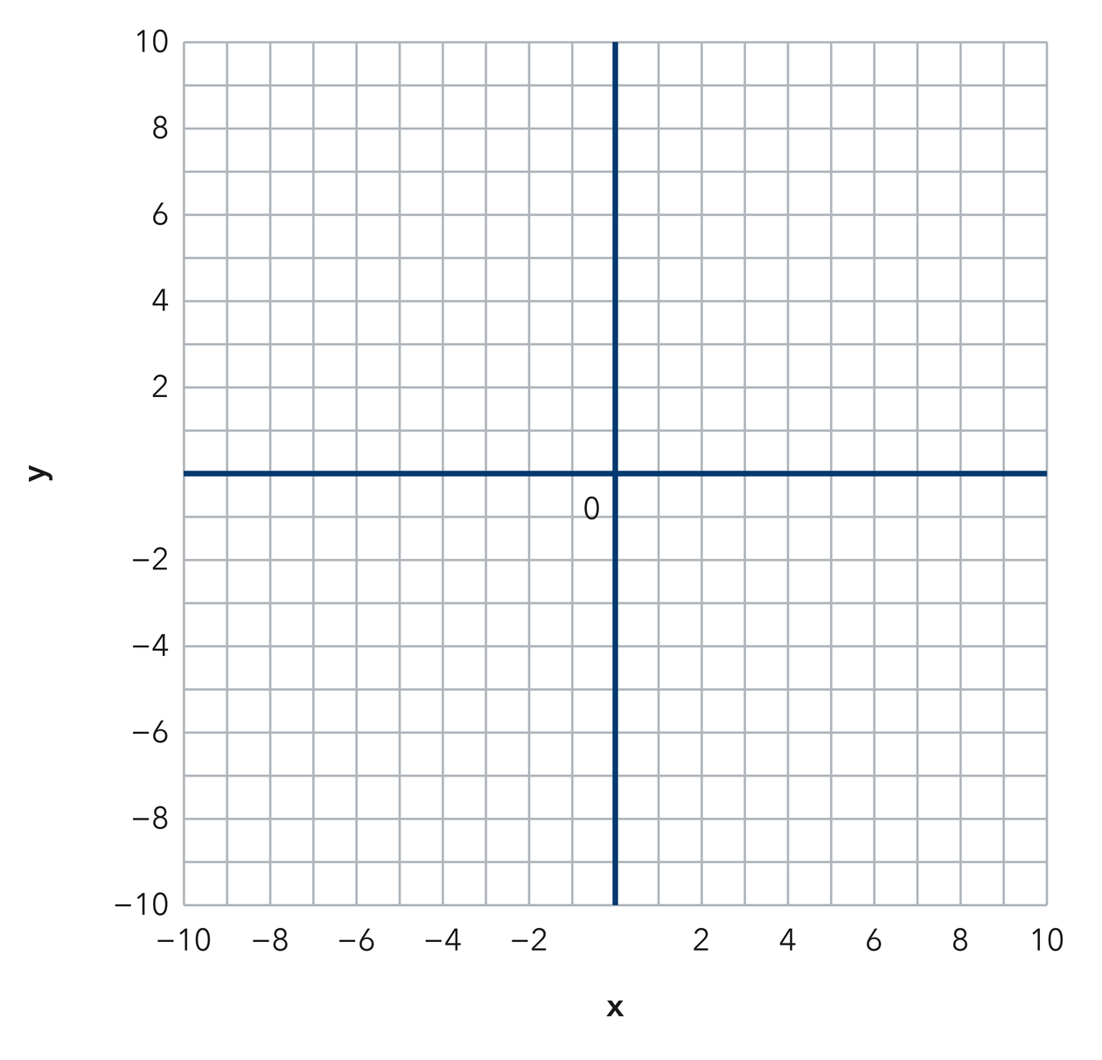
  Show your work.
ANALYZE THE ERROR 5 min
13. Read the work below. Explain the mistake, then show the correct reasoning.
INES’S WORK

Finding the distance from (−8, 3) to (4, 3), Ines subtracted and wrote 4 units, saying eight minus four is four.
a. Explain the mistake. Do these two points sit on the same side of the y-axis? Check that before choosing an operation. | b. Show correct work  Correct answer
  Show the correct work.
STRETCH YOUR THINKING multi-step reasoning · 8 min
14. Delivery Routes. A depot sits at (0, 0). Stop 1 is at (0, 12), Stop 2 is at (0, −9), and Stop 3 is at (0, 4).  a. Find the distance from the depot to each stop.  b. Order the stops from closest to farthest.  c. Find the distance from Stop 1 to Stop 2 and explain your operation.  Answer all three distances, the order, and the final distance | d. Coordinate plane. Plot the depot and all three stops on the y-axis.​  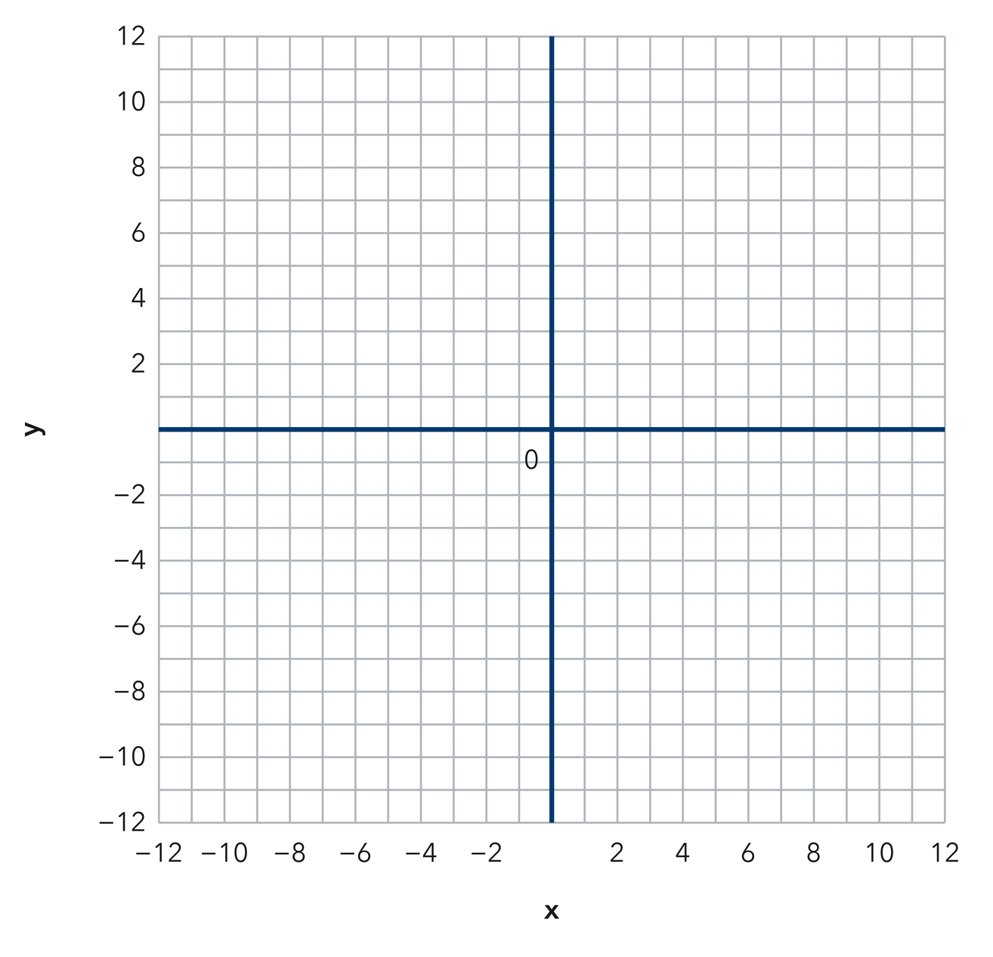
  Show your work.
TEST PRACTICE multiple choice · fill one box · 6 min
15. From (−4, 1) to (6, 1) the distance is — | 16. Two coordinates on the same side of zero call for —
  □ A. 10 | □ B. 2 | □ C. −10 | □ D. 24
  □ A. addition | □ B. subtraction | □ C. multiplication | □ D. division

17. From (3, −8) to (3, −2) the distance is — | 18. A distance can never be —
  □ A. −6 | □ B. 10 | □ C. 6 | □ D. 16
  □ A. zero | □ B. a decimal | □ C. a whole number | □ D. negative
SPIRAL REVIEW earlier skills · keep them sharp · 6 min
19. From Lesson 7-6 Session 1. Find the distance from (5, 2) to (5, 11).  Answer | 20. From Lesson 7-5 Session 1. Name the quadrant of (−7, −1).  Answer

21. From Lesson 6-6 Session 1. Simplify 3p + 12 + 7p.  Answer | 22. From Lesson 4-2 Session 1. Write 0.05 as a percent.  Answer
CHECK YOUR UNDERSTANDING 5 min
23. Two Deliveries. A driver starts at (2, −6). Stop A sits at (2, 15) and Stop B sits at (−18, −6). Each unit is one block.
a. Distance to Stop A __________
b. Which stop is farther from the start? __________
Hint Each trip holds one coordinate fixed. Use the signs of the other coordinate to pick your move.
Answer

□ 4 — Can teach it | □ 3 — Got it | □ 2 — Need hint | □ 1 — Need help
Circle your confidence. Star one problem that shows your learning.

