Name Date Period
Lesson 7-7 · Homework Packet · Sheet 1 of 2
Polygons and Perimeter on the Plane
Maryland Standard 6.G.A.3 · Learning target — I can find the perimeter and area of a polygon drawn on the coordinate plane.

REMEMBER  • Plot the vertices in order. Connect them to draw the polygon.  • Find each horizontal or vertical side from the coordinates.  • Perimeter = sum of all sides. Area of a rectangle = length × width. | WORKED EXAMPLE  Find the perimeter and area of the rectangle with vertices (−3, 2), (4, 2), (4, −1), (−3, −1).  Step 1 Top: 3 + 4 = 7 units. Side: 2 + 1 = 3 units.  Step 2 P = 7 + 3 + 7 + 3 = 20 units. A = 7 × 3 = 21 square units.  Answer P = 20 units, A = 21 square units
PRACTICE show your work · label units

1. Use the rectangle on the grid.  a. Length of AB units  b. Length of BC units  c. Perimeter units  d. Area sq. units | 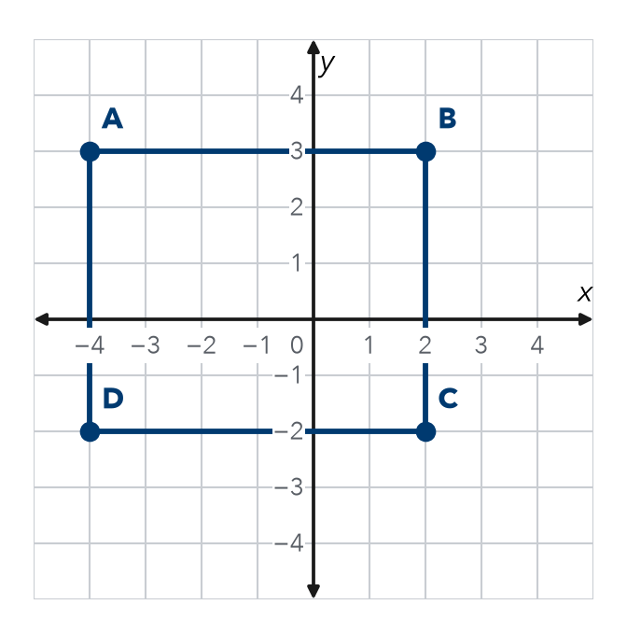

2. Plot A(−3, −2), B(4, −2), and C(−3, 4). Connect them to make a right triangle.  a. Base AB units  b. Height AC units  c. Area sq. units | 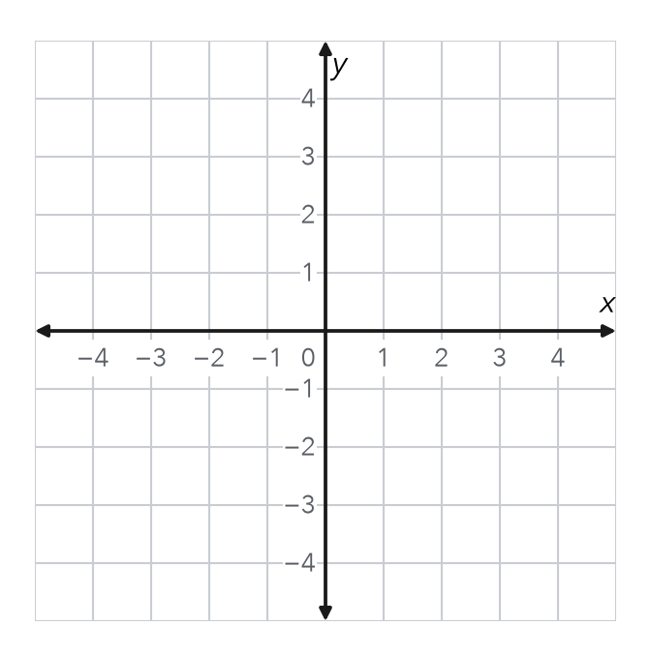

3. Garden Fence. A garden has corners at (−5, 3), (6, 3), (6, −4), and (−5, −4). Each unit is 1 meter. How much fence goes around it?
Answer m

4. Square. A square has vertices (−3, 1), (2, 1), (2, −4), and (−3, −4). Find its perimeter.
Answer units

5. Reasoning. Three corners of a rectangle are (−2, 5), (3, 5), and (3, −1). Name the fourth corner.
Answer

CHECK YOURSELF | □ I can do this on my own | □ I need a little help | □ I have a question about #
Name Date Period
Lesson 7-7 · Homework Packet · Sheet 2 of 2
Designing Polygons with Scale
Maryland Standard 6.G.A.3 · Learning target — I can use a scale to find a missing dimension of a figure on the coordinate plane.

REMEMBER  • A scale tells what 1 grid unit stands for, like 1 unit = 5 ft.  • Real length = grid units × scale.  • Missing side = area ÷ known side. | WORKED EXAMPLE  1 unit = 5 ft. A rectangle’s sides run from (−2, 3) to (4, 3) and from (4, 3) to (4, −1). Find its real size.  Step 1 Top: 2 + 4 = 6 units. 6 × 5 = 30 ft.  Step 2 Side: 3 + 1 = 4 units. 4 × 5 = 20 ft.  Answer 30 ft by 20 ft
PRACTICE show your work · label units

1. Court Plan. On this plan, 1 unit = 5 ft. Side AB of a court is drawn. The court must cover 1,200 ft².  a. AB in grid units units  b. AB in feet ft  c. Other side in feet ft  d. Other side in grid units units | 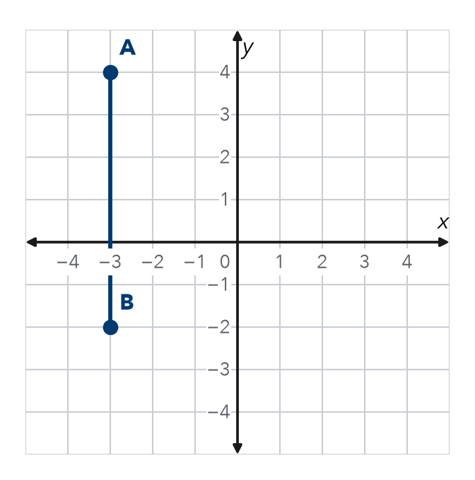

2. On a map, 1 grid unit = 4 meters.
a. 7 units = m | b. 36 m = units

3. Patio. A patio on a plan is 7 units by 5 units. 1 unit = 2 ft. Find the real area.
Answer ft²

4. Bedroom. On a plan, 1 unit = 3 ft. A room has corners at (−2, 4), (2, 4), (2, −1), and (−2, −1). Find its real perimeter.
Answer ft

5. Find the Error. If 1 unit = 3 ft, Lily says (−4, 1) to (5, 1) is 3 ft. Explain her error. Fix it.

TEST PRACTICE choose the best answer
6. A plan uses 1 unit = 6 m. A side is 5 units long. How long is the real side?
A 11 m | B 30 m | C 1 m | D 56 m

7. A rectangle has an area of 480 ft². One side is 24 ft. How long is the other side?
A 20 ft | B 456 ft | C 40 ft | D 504 ft

CHECK YOURSELF | □ I can do this on my own | □ I need a little help | □ I have a question about #

