Name |  | Date |  | Period
Lesson 7-7 · Session 1
Guided Practice
Polygons and Perimeter on the Plane
VOCABULARY read and say each word before you begin
vertex  Spanish: vértice | A corner point of a polygon. | named by an ordered pair
polygon  Spanish: polígono | A closed figure made of line segments. | triangle, rectangle, square
perimeter  Spanish: perímetro | The total distance around a polygon. | add every side length
side length | The distance between two joined vertices. | found with absolute value
scale  Spanish: escala | What one grid unit stands for in real life. | 1 unit = 1 meter
EXPLORE TOGETHER Class Launch · 8–10 min
1. Community Garden Plot  A garden plot has corners at (−4, 6), (9, 6), (9, −3), and (−4, −3). Each grid unit stands for one meter.  a. Draw. Plot the corners on the coordinate plane below and connect them in order.  b. Sides. Length of the top side: ______ m Length of the left side: ______ m  c. Perimeter. Perimeter of the plot: ______ m How did you combine the sides? __________ | d. Shape. What polygon did you draw? ______ How do the coordinates prove it? __________  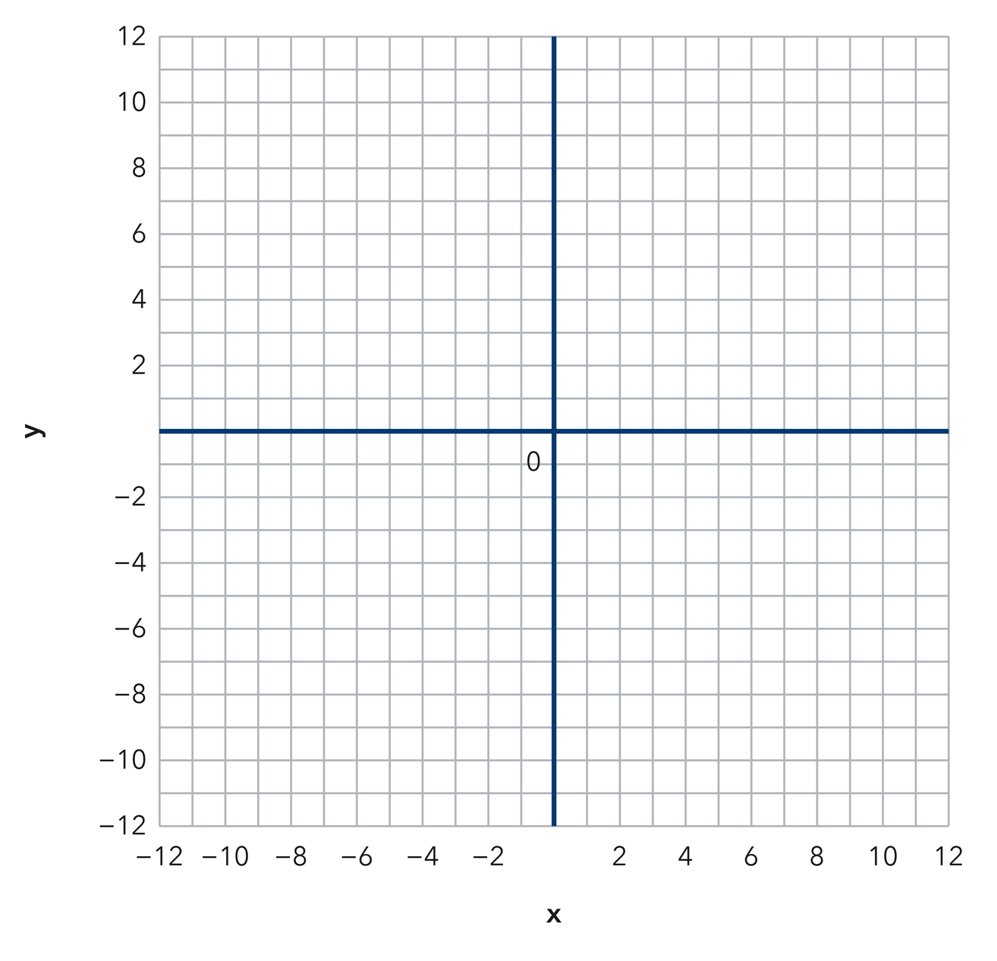​
  TURN AND TALK
  How do matching coordinates tell you which sides run across and which run up and down?
PRACTICE WITH A PARTNER You Do Together · 10–12 min
2. Animal Pen. A pen has vertices at (2, 8), (2, −4), (−10, −4), and (−10, 8) on a grid where each unit is one meter.  a. Length of one side __________  b. Perimeter __________ | c. Coordinate plane. Plot the four vertices and draw the pen.​
  PARTNER TALK
  How can the coordinates alone show you that a shape is a square?

3. Right Triangle. A right triangle has vertices at (−5, 2), (7, 2), and (7, −6) on a coordinate grid.  a. Horizontal leg __________  b. Which two vertices share a coordinate, and which coordinate is it? __________ | c. Coordinate plane. Plot the three vertices and draw the triangle.​
  PARTNER TALK
  Why can you count grid units for only two of this triangle’s three sides?

4. Dog Run. A dog run has vertices at (−7, 10), (11, 10), (11, −1), and (−7, −1) on a grid where each unit is one meter.
a. Length of the top side and the left side __________
b. Perimeter of the dog run __________
PARTNER TALK
Why does finding only two side lengths give you the whole perimeter of a rectangle?

PRACTICE ON YOUR OWN You Do · 8 problems · 18–20 min
5. Deck Outline. A rectangle has vertices at (−9, 5), (6, 5), (6, −7), and (−9, −7). Each unit is one foot.
Find both side lengths and the perimeter of the rectangle.
Hint Each side joins two vertices that share a coordinate; the other coordinate gives its length.
Answer side lengths and perimeter, in feet

6. Missing Vertex. Three corners of a rectangle sit at (−2, 9), (8, 9), and (8, 1). Find the fourth vertex, then find the perimeter.  Hint In a rectangle, opposite corners share coordinates. Match the pairs that are already given.  Answer fourth vertex and perimeter | Coordinate plane. Plot the three given corners; the fourth one is where the sides meet.​
  Show your work.

7. Deck Area. A rectangular deck has vertices at (−6, −2), (7, −2), (7, −9), and (−6, −9). Each unit is one yard.  Find the area of the deck and explain how the coordinates gave you each dimension.  Hint Find the two side lengths first. Area of a rectangle multiplies length by width.  Answer area, in square yards | 8. Square Check. A polygon has vertices at (−5, 8), (9, 8), (9, −6), and (−5, −6) on a grid where each unit is one yard.  Find the side lengths, name the polygon, and find its perimeter  Hint Compare the across length with the up-and-down length before you name the shape.  Answer side lengths, shape name, and perimeter

9. Mural Outline. A mural outline has vertices at (−6, 5), (6, 5), (6, −1), (1, −1), (1, −7), and (−6, −7) on a grid where each unit is one foot.  Find the length of every side, then find the perimeter of the outline  Hint Take the sides in order around the figure; each pair of joined vertices shares one coordinate.  Answer perimeter, in feet | Coordinate plane. Plot all six vertices and draw the mural outline.​
  Show your work.

10. Rectangle Perimeter. A rectangle has vertices at (−8.5, 7.5), (5.5, 7.5), (5.5, −2.5), and (−8.5, −2.5). Find its perimeter.  Hint Length is 8.5 + 5.5; width is 7.5 + 2.5.  Answer units | 11. Rectangle Area. For the same rectangle, find the area.  Hint Multiply the length by the width.  Answer square units

12. Find the Sides. A rectangle has vertices at (−3, 4), (6, 4), (6, −2), and (−3, −2).
a. Find the length of a horizontal side. __________
b. Find the length of a vertical side. __________
Hint Use the x-values for horizontal sides, the y-values for vertical ones.
Answer a and b
ANALYZE THE ERROR 5 min
13. Read the work below. Explain the mistake, then show the correct reasoning.
JORGE’S WORK

For a rectangle side joining (−5, 4) and (3, 4), Jorge wrote the length as 2 units, saying five minus three is two.
a. Explain the mistake. Do those two corners sit on the same side of the y-axis? Check that before subtracting. | b. Show correct work  Correct answer
  Show the correct work.
STRETCH YOUR THINKING multi-step reasoning · 8 min
14. Garden Plot. A rectangular plot has vertices at (−6, 5), (9, 5), (9, −4), and (−6, −4). Fencing costs $7 per unit and sod costs $2 per square unit.  a. Find the length and the width of the plot.  b. Find the perimeter and the cost of fencing.  c. Find the area and the cost of sod.  Answer the dimensions, the fencing cost, and the sod cost | d. Coordinate plane. Draw the plot, then label the sides you will fence.​
  Show your work.
TEST PRACTICE multiple choice · fill one box · 6 min
15. A rectangle with sides 8 and 5 has a perimeter of — | 16. A rectangle with sides 8 and 5 has an area of —
  □ A. 40 | □ B. 26 | □ C. 13 | □ D. 18
  □ A. 13 | □ B. 26 | □ C. 40 | □ D. 80

17. The distance from (−2, 0) to (7, 0) is — | 18. Perimeter is found by —
  □ A. −9 | □ B. 5 | □ C. 14 | □ D. 9
  □ A. adding all sides | □ B. multiplying sides | □ C. halving the area | □ D. counting vertices
SPIRAL REVIEW earlier skills · keep them sharp · 6 min
19. From Lesson 7-6 Session 2. Find the distance from (−3, 6) to (8, 6).  Answer | 20. From Lesson 7-5 Session 2. Reflect (5, −2) across the x-axis.  Answer

21. From Lesson 6-8 Session 2. Factor 24n + 36.  Answer | 22. From Lesson 5-1 Session 1. A parallelogram has base 13 cm and height 4 cm. Find its area.  Answer
CHECK YOUR UNDERSTANDING 5 min
23. Flag Outline. A flag outline has vertices at (−4, 7), (8, 7), (8, −5), and (−4, −5). Each unit is one inch.  a. Side lengths __________  b. Perimeter __________  Hint Take one side that runs across and one that runs up, then decide what equal lengths mean.  Answer | c. Coordinate plane. Plot the four vertices and draw the flag outline.​
  Show your work.

□ 4 — Can teach it | □ 3 — Got it | □ 2 — Need hint | □ 1 — Need help
Circle your confidence. Star one problem that shows your learning.

