Name |  | Date |  | Period
Lesson 7-7 · Session 2 · Version 2
Guided Practice · Version 2
Designing Polygons with a Scale
VOCABULARY read and say each word before you begin
scale  Spanish: escala | What one grid unit stands for in real life. | 1 unit = 25 feet
area  Spanish: área | The amount of space inside a flat figure. | length × width
dimensions  Spanish: dimensiones | The length and the width of a figure. | 24 ft by 16 ft
vertex  Spanish: vértice | A corner point of a polygon. | named by an ordered pair
perimeter  Spanish: perímetro | The total distance around a polygon. | add every side length
EXPLORE TOGETHER Class Launch · 8–10 min
1. School Courtyard Design  Ms. Rivera’s class is designing a rectangular courtyard. Three corners sit at (−5, 6), (6, 6), and (6, −3). Each grid unit stands for 10 feet.  a. Draw. Plot the three given courtyard corners on the coordinate plane below, then plot the missing corner.  b. Vertex. Write the missing courtyard corner: ( ______ , ______ )  c. Scale. Courtyard width: ______ units = ______ ft Courtyard height: ______ units = ______ ft | d. Area. Find the courtyard’s area: ______ square feet Show your work: __________  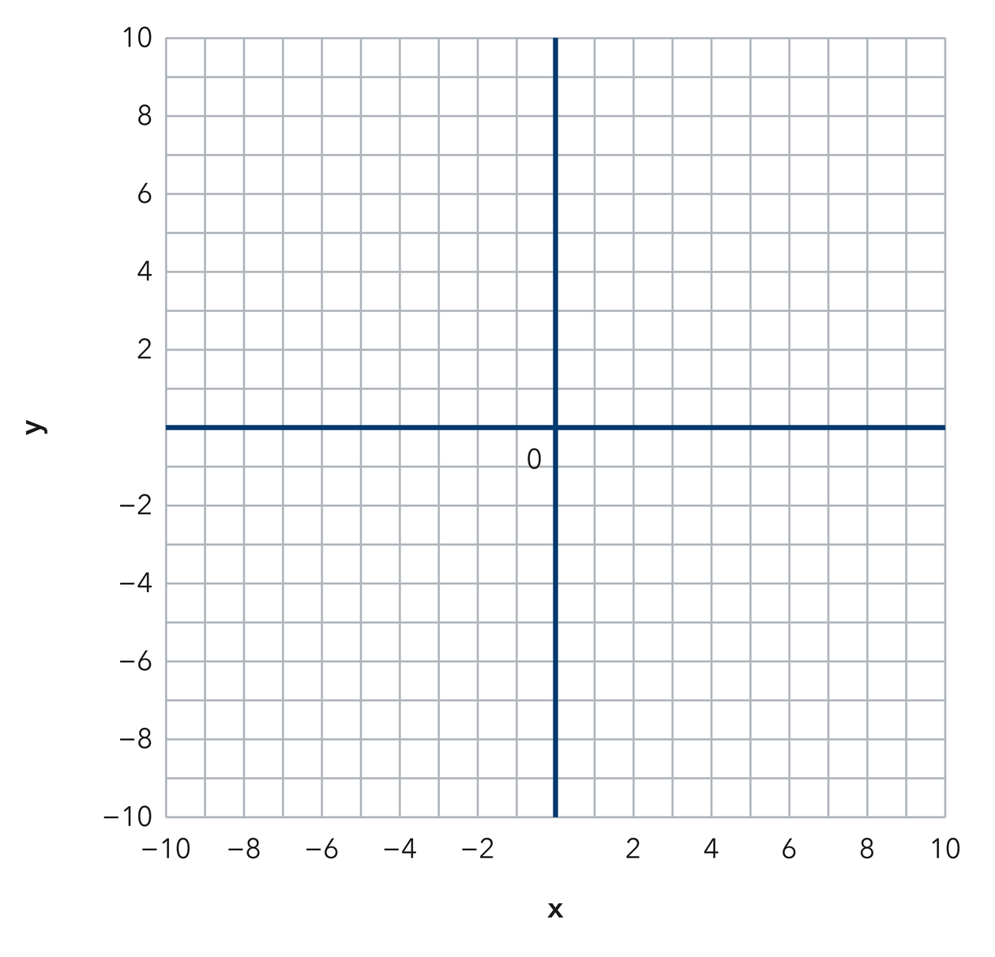​
  TURN AND TALK
  How does the scale change your answer even though the drawing stays the same size?
PRACTICE WITH A PARTNER You Do Together · 10–12 min
2. Garden Bed. A bed has corners at (−3, 2), (9, 2), (9, −6), and (−3, −6). Each grid unit stands for 2 feet.  a. Find both side lengths in grid units. __________  b. Find the garden bed’s perimeter in feet. __________ | c. Coordinate plane. Plot the garden bed’s corners and connect them, then convert each side length using the scale.
  PARTNER TALK
  Why does changing the scale change the perimeter but never change the shape?

3. Triangular Sign. A triangular sign has vertices at (−4, 8), (−4, −4), and (11, −4). Each grid unit is one foot.  a. Find the length of each perpendicular leg in feet. __________  b. Find the sign’s area in square feet. __________ | c. Coordinate plane. Plot the three sign vertices, then connect them to form the triangle.  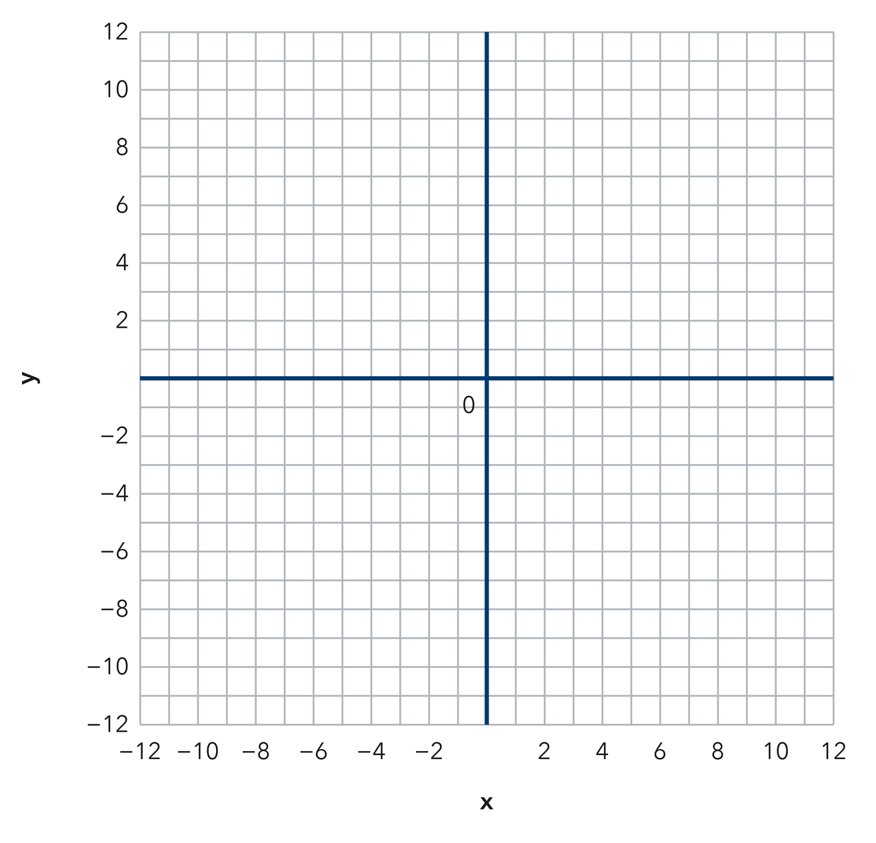
  PARTNER TALK
  How do you decide which two sides of this triangle act as the base and the height?

4. Parking Pad. A parking pad has corners at (−7, 5), (5, 5), (5, −4), and (−7, −4). Each grid unit stands for 3 feet.
a. Find the stage’s side lengths in grid units and in feet. __________
b. Find the stage’s area in square feet. __________
PARTNER TALK
Why does the drawing stay the same size while the real measurements change with the scale?

PRACTICE ON YOUR OWN You Do · 8 problems · 18–20 min
5. Missing Corners. Two corners of a rectangle sit at (−6, 3) and (8, 3). The rectangle extends 11 units downward from that side.  Write Elena’s two missing vertices, then calculate the rectangle’s perimeter in grid units.  Hint Subtract 11 from each given y-coordinate to move downward. Keep each x-coordinate unchanged.  Answer missing vertices and perimeter in grid units | Coordinate plane. Plot Elena’s two given corners, then draw the opposite side 11 units below them.
  Show your work.

6. Tile Budget. A floor has corners at (−2, 5), (10, 5), (10, −4), and (−2, −4). Each grid unit is 2 feet, and tile costs 2 dollars per square foot.  Find the reading room’s area in square feet, then find the total cost of the carpet.  Hint Multiply each side length in grid units by 3 to convert to feet. Find the area, then multiply by the carpet price per square foot.  Answer reading room area and total carpet cost | 7. Pen Design. Mara wants a rectangular pen with an area of 384 square feet. One side runs from (−4, 6) to (8, 6), and each grid unit is 2 feet.  Find the patio’s other side length in feet.  Hint Find the known side’s length in grid units and convert it to feet. Divide the patio’s area by that length.  Answer patio’s other side length, in feet

8. Storage Slab. A rectangular slab needs an area of 10,800 square feet. Two of its corners sit at (−3, 7) and (−3, −5). Each grid unit stands for 15 feet.
Find both dimensions of the festival tent in feet and in grid units.
Hint Convert the known side length to feet. Divide the tent’s area by that length to find the other dimension, then divide by 20 to convert it to grid units.
Answer both tent dimensions, in feet and in grid units

9. Fence Cost. A yard has corners at (−4, 3), (8, 3), (8, −5), and (−4, −5). Each grid unit stands for 4 feet, and fencing costs 6 dollars per foot.  Find Nia’s yard perimeter in feet, then calculate the total cost to fence the yard.  Hint Convert each side length to feet, find the total fencing length, then multiply by the price per foot.  Answer the yard’s perimeter and total fencing cost | Coordinate plane. Sketch the yard and mark each side that needs fencing.​
  Show your work.

10. Missing Dimension. A rectangular lot needs an area of 30,000 square feet. Two of its sides measure 150 feet. Find the other dimension.  Hint Divide 24,000 by 120.  Answer the missing dimension in feet | 11. Using the Scale. On a plan, 1 grid unit represents 25 feet. A rectangle measures 6 units by 4 units.  a. Find the real length and width of the picnic area. __________  b. Find the real area of the picnic area. __________  Hint Multiply each grid measure by 20 before finding the area.  Answer a and b, including units

12. Work Backward. A plan uses 1 unit for 10 meters. A rectangular field must cover 2,400 square meters and is 4 units wide on the plan.
Hint The real width is 40 m; divide 1,920 by 40.
Answer the orchard’s real length and its length on the plan
ANALYZE THE ERROR 5 min
13. Read the work below. Explain the mistake, then show the correct reasoning.
MATEO’S WORK

A plot runs from (−3, 4) to (9, 4), and each grid unit stands for 6 feet. Talia wrote the side length as 12 feet.
a. Explain the mistake. Mateo’s garden plan measures 5 units by 3 units, and 1 unit represents 4 meters. He wrote that the real area is 15 square meters. What did he forget to do with the scale? Complete: Mateo forgot to __________. | b. Show correct work. Convert both garden dimensions to meters, then calculate the real area.  Correct answer
  Show the correct work.
STRETCH YOUR THINKING multi-step reasoning · 8 min
14. Playground Design. A plan uses 1 grid unit for 15 feet. A playground must cover 5,400 square feet. On the plan it is 8 units wide.
a. Find the real width of the outdoor classroom.
b. Find the real length needed for the outdoor classroom.
c. Find the outdoor classroom’s plan length in grid units, then find its real perimeter.
Answer the real width, the real length, the plan length, and the real perimeter
TEST PRACTICE multiple choice · fill one box · 6 min
15. An area of 1,200 ft² with one side of 40 ft has another side of — | 16. If 1 unit represents 20 feet, then 5 units represent —
  □ A. 60 ft | □ B. 48,000 ft | □ C. 1,160 ft | □ D. 30 ft
  □ A. 100 feet | □ B. 25 feet | □ C. 4 feet | □ D. 20 feet

17. A scale tells you how many real units one grid unit — | 18. An area of 900 m² with one side of 30 m has another side of —
  □ A. adds | □ B. represents | □ C. subtracts | □ D. divides
  □ A. 27,000 m | □ B. 870 m | □ C. 30 m | □ D. 60 m
SPIRAL REVIEW earlier skills · keep them sharp · 6 min
19. From Lesson 7-7 Session 1. A rectangle with sides 9 and 4 has what perimeter?  Answer | 20. From Lesson 7-6 Session 2. Find the distance from (0, 9) to (0, −3).  Answer

21. From Lesson 5-1 Session 1. A parallelogram has base 12 m and height 5 m. Find its area.  Answer | 22. From Lesson 4-4 Session 1. Find 25% of 480.  Answer
CHECK YOUR UNDERSTANDING 5 min
23. Court Design. Three corners of a rectangular court sit at (−6, 2), (6, 2), and (6, −8). Each grid unit stands for 5 feet.  a. Fourth corner of Coach Rivera’s court: ( __________  b. Perimeter of Coach Rivera’s court __________  Hint Count the grid units along each side, then multiply each side length by 5 feet per unit.  Answer | c. Coordinate plane. Plot Coach Rivera’s three court corners, complete the rectangle, then use the scale to label its side lengths in feet.​
  Show your work.

□ 4 — Can teach it | □ 3 — Got it | □ 2 — Need hint | □ 1 — Need help
Circle your confidence. Star one problem that shows your learning.

