Name |  | Date |  | Period
Lesson 7-7 · Session 2
Guided Practice
Designing Polygons with a Scale
VOCABULARY read and say each word before you begin
scale  Spanish: escala | What one grid unit stands for in real life. | 1 unit = 25 feet
area  Spanish: área | The amount of space inside a flat figure. | length × width
dimensions  Spanish: dimensiones | The length and the width of a figure. | 24 ft by 16 ft
vertex  Spanish: vértice | A corner point of a polygon. | named by an ordered pair
perimeter  Spanish: perímetro | The total distance around a polygon. | add every side length
EXPLORE TOGETHER Class Launch · 8–10 min
1. School Courtyard Design  Three corners of a rectangular courtyard sit at (−5, 6), (6, 6), and (6, −3). Each grid unit stands for 10 feet.  a. Draw. Plot the three corners on the coordinate plane below, then the missing one.  b. Vertex. Ordered pair for the missing corner: ( ______ , ______ )  c. Scale. Width: ______ units = ______ ft Height: ______ units = ______ ft | d. Area. Area of the courtyard: ______ square feet Show your work: __________  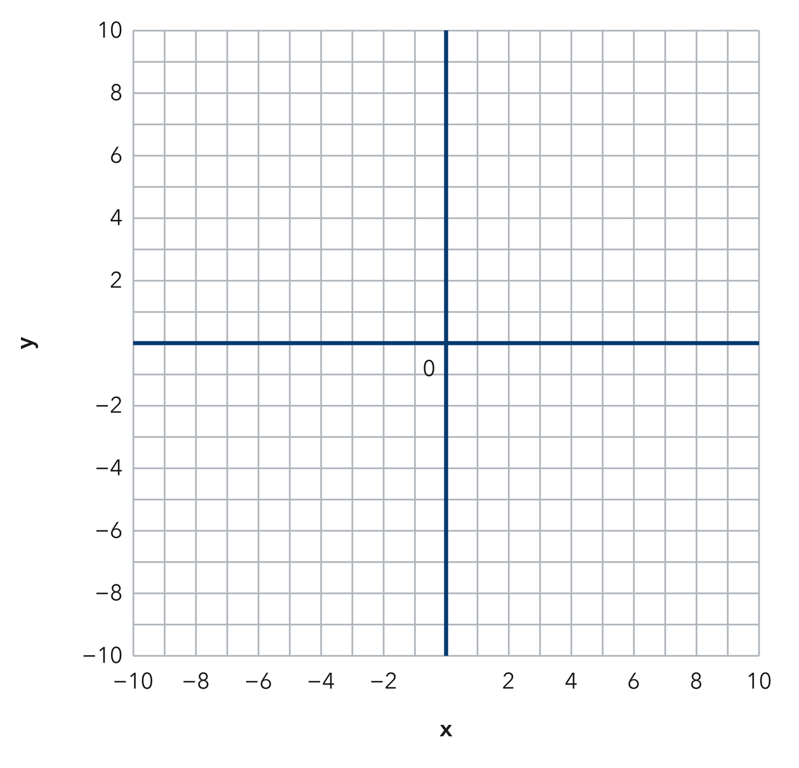​
  TURN AND TALK
  How does the scale change your answer even though the drawing stays the same size?
PRACTICE WITH A PARTNER You Do Together · 10–12 min
2. Garden Bed. A bed has corners at (−3, 2), (9, 2), (9, −6), and (−3, −6). Each grid unit stands for 2 feet.  a. Side lengths in units __________  b. Perimeter __________ | c. Coordinate plane. Draw the bed, then convert each side using the scale.​
  PARTNER TALK
  Why does changing the scale change the perimeter but never change the shape?

3. Triangular Sign. A triangular sign has vertices at (−4, 8), (−4, −4), and (11, −4). Each grid unit is one foot.  a. Length of each leg __________  b. Area of the sign __________ | c. Coordinate plane. Plot the three vertices and draw the sign.​  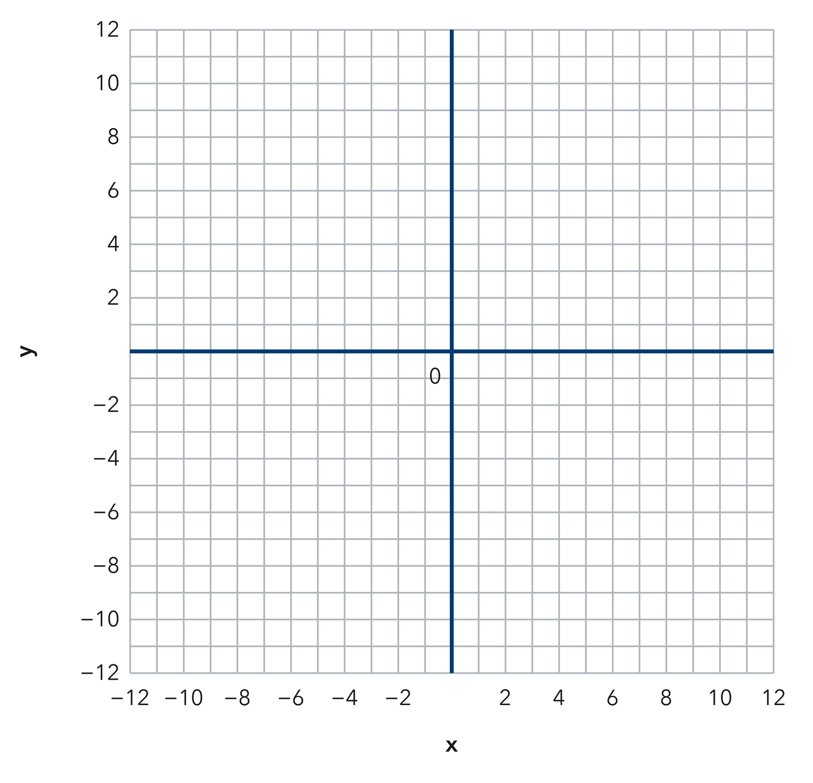
  PARTNER TALK
  How do you decide which two sides of this triangle act as the base and the height?

4. Parking Pad. A parking pad has corners at (−7, 5), (5, 5), (5, −4), and (−7, −4). Each grid unit stands for 3 feet.
a. Side lengths in grid units and in feet __________
b. Area of the pad in square feet __________
PARTNER TALK
Why does the drawing stay the same size while the real measurements change with the scale?

PRACTICE ON YOUR OWN You Do · 8 problems · 18–20 min
5. Missing Corners. Two corners of a rectangle sit at (−6, 3) and (8, 3). The rectangle extends 11 units downward from that side.  Write the other two vertices, then find the perimeter in grid units.  Hint Extending downward lowers the y-coordinate. Leave the x-coordinates exactly where they are.  Answer two vertices and the perimeter | Coordinate plane. Plot the two given corners, then drop the other side 11 units.​
  Show your work.

6. Tile Budget. A floor has corners at (−2, 5), (10, 5), (10, −4), and (−2, −4). Each grid unit is 2 feet, and tile costs 2 dollars per square foot.  Find the area of the floor in square feet, then find the total cost of the tile.  Hint Change both side lengths into feet before multiplying, then apply the price per square foot.  Answer area and total cost | 7. Pen Design. Mara wants a rectangular pen with an area of 384 square feet. One side runs from (−4, 6) to (8, 6), and each grid unit is 2 feet.  Find the length of the other side in feet.  Hint Turn the known side into feet first, then use the area to work back to the missing side.  Answer other side length, in feet

8. Storage Slab. A rectangular slab needs an area of 10,800 square feet. Two of its corners sit at (−3, 7) and (−3, −5). Each grid unit stands for 15 feet.
Find both dimensions of the slab in feet and in grid units
Hint Turn the known side into feet first, then divide the area by it and change the result back into units.
Answer both dimensions, in feet and in grid units

9. Fence Cost. A yard has corners at (−4, 3), (8, 3), (8, −5), and (−4, −5). Each grid unit stands for 4 feet, and fencing costs 6 dollars per foot.  Find the perimeter of the yard in feet, then find the total cost of the fence  Hint Change both side lengths into feet before you add them, then apply the price per foot.  Answer perimeter and total cost | Coordinate plane. Draw the yard, then label the sides you will fence.​
  Show your work.

10. Missing Dimension. A rectangular lot needs an area of 30,000 square feet. Two of its sides measure 150 feet. Find the other dimension.  Hint Divide 30,000 by 150.  Answer feet | 11. Using the Scale. On a plan, 1 grid unit represents 25 feet. A rectangle measures 6 units by 4 units.  a. Find the real length and width. __________  b. Find the real area. __________  Hint Multiply each grid measure by 25 before finding the area.  Answer a and b

12. Work Backward. A plan uses 1 unit for 10 meters. A rectangular field must cover 2,400 square meters and is 4 units wide on the plan.
Hint The real width is 40 m; divide 2,400 by 40.
Answer the real length and the plan length
ANALYZE THE ERROR 5 min
13. Read the work below. Explain the mistake, then show the correct reasoning.
TALIA’S WORK

A plot runs from (−3, 4) to (9, 4), and each grid unit stands for 6 feet. Talia wrote the side length as 12 feet.
a. Explain the mistake. Talia counted the grid units correctly. What did she forget to do with the scale? | b. Show correct work  Correct answer
  Show the correct work.
STRETCH YOUR THINKING multi-step reasoning · 8 min
14. Playground Design. A plan uses 1 grid unit for 15 feet. A playground must cover 5,400 square feet. On the plan it is 8 units wide.
a. Find the real width of the playground.
b. Find the real length needed.
c. Find the plan length in grid units, then find the real perimeter.
Answer the width, the length, the plan length, and the perimeter
TEST PRACTICE multiple choice · fill one box · 6 min
15. An area of 1,200 ft² with one side of 40 ft has another side of — | 16. If 1 unit represents 20 feet, then 5 units represent —
  □ A. 60 ft | □ B. 48,000 ft | □ C. 1,160 ft | □ D. 30 ft
  □ A. 100 feet | □ B. 25 feet | □ C. 4 feet | □ D. 20 feet

17. A scale tells you how many real units one grid unit — | 18. An area of 900 m² with one side of 30 m has another side of —
  □ A. adds | □ B. represents | □ C. subtracts | □ D. divides
  □ A. 27,000 m | □ B. 870 m | □ C. 30 m | □ D. 60 m
SPIRAL REVIEW earlier skills · keep them sharp · 6 min
19. From Lesson 7-7 Session 1. A rectangle with sides 9 and 4 has what perimeter?  Answer | 20. From Lesson 7-6 Session 2. Find the distance from (0, 9) to (0, −3).  Answer

21. From Lesson 5-1 Session 1. A parallelogram has base 12 m and height 5 m. Find its area.  Answer | 22. From Lesson 4-4 Session 1. Find 25% of 480.  Answer
CHECK YOUR UNDERSTANDING 5 min
23. Court Design. Three corners of a rectangular court sit at (−6, 2), (6, 2), and (6, −8). Each grid unit stands for 5 feet.  a. Fourth corner: ( __________  b. Perimeter of the court __________  Hint Find the side lengths in grid units first, then let the scale turn each unit into feet.  Answer | c. Coordinate plane. Plot the three corners, find the fourth, then apply the scale.​
  Show your work.

□ 4 — Can teach it | □ 3 — Got it | □ 2 — Need hint | □ 1 — Need help
Circle your confidence. Star one problem that shows your learning.

