Name Date Period
Lesson 8-3 · Homework Packet · Sheet 1 of 2
Multiplication Equations
Maryland Standard 6.EE.B.7 · Learning target — I can solve a multiplication equation by dividing both sides by the same number.

REMEMBER  • In 6x, the coefficient 6 means 6 × x.  • To solve ax = b, divide both sides by a. Division undoes multiplication.  • Check: the coefficient times your solution should equal the right side. | WORKED EXAMPLE  Solve 8p = 96.  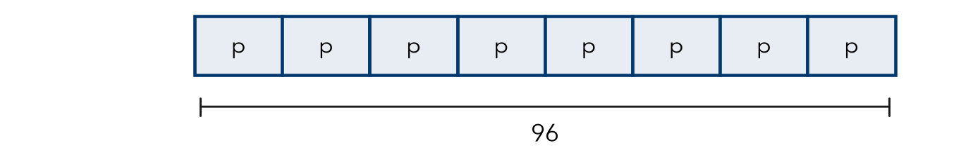  Step 1 Divide both sides by 8: p = 96 ÷ 8 = 12  Step 2 Check: 8 × 12 = 96, so it checks.  Answer p = 12
PRACTICE show your work · label units
1. Solve each equation.
a. 4x = 36 | b. 7n = 56 | c. 9y = 108
d. 12k = 84 | e. 5m = 85 | f. 3w = 4.5

2. Write a multiplication equation for the tape diagram. Then solve it.
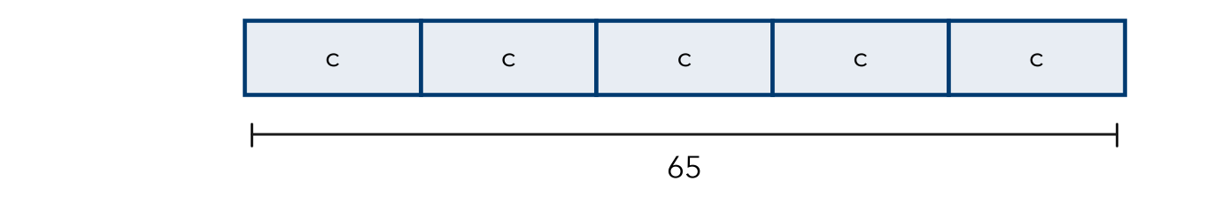
Equation and solution

3. Bus Fare. A family pays $11.25 for 5 bus fares. Each fare costs the same. Write and solve an equation for the cost of one fare, f. Check your answer.

Show your work.
Answer dollars

4. Garden Rows. Ms. Bell plants 84 seedlings in 6 equal rows. Write and solve a multiplication equation for s, the seedlings in each row.
Answer seedlings

5. Compare. Without solving, tell which equation has the greater solution: 4n = 80 or 5n = 80. Explain. Then solve both to check.

CHECK YOURSELF | □ I can do this on my own | □ I need a little help | □ I have a question about #
AT HOME Find a package with equal parts (eggs, juice boxes, crayons). Write a multiplication equation for it and solve for one part.
Name Date Period
Lesson 8-3 · Homework Packet · Sheet 2 of 2
Division Equations
Maryland Standard 6.EE.B.7 · Learning target — I can solve a division equation by multiplying both sides by the same number.

REMEMBER  • To solve x ÷ a = b, multiply both sides by a.  • The solution is the whole, so it is greater than b.  • Check: divide your solution by a. | WORKED EXAMPLE  Solve n ÷ 4 = 15.  Step 1 Multiply both sides by 4: n = 15 × 4 = 60  Step 2 Check: 60 ÷ 4 = 15, so it checks.  Answer n = 60
PRACTICE show your work · label units
1. Solve each equation.
a. n ÷ 7 = 6 | b. y ÷ 5 = 13 | c. k ÷ 10 = 4.5

2. Write a division equation for the tape diagram. Then solve it.

Equation and solution

3. Jump Rope. A rope is cut into 8 equal pieces, each 2.5 meters long. Write and solve a division equation for r, the whole rope.

Show your work.
Answer meters

4. Pizza Party. A pizza is cut into equal slices. 6 friends share it, and each gets 2 slices. Write and solve a division equation for z, the slices in the pizza.
Answer slices

5. Find the Error. Kayla and 3 friends share cards equally. Each gets 9 cards. Kayla writes c ÷ 3 = 9. Explain her mistake. Write and solve a correct equation.

TEST PRACTICE choose the best answer
6. Solve y ÷ 6 = 9.
A y = 1.5 | B y = 3 | C y = 15 | D y = 54

7. 12 students share p pretzels equally. Each gets 5. Which equation fits?
A p ÷ 12 = 5 | B 12 ÷ p = 5 | C 5p = 12 | D p − 12 = 5

CHECK YOURSELF | □ I can do this on my own | □ I need a little help | □ I have a question about #

