Name Date Period
Lesson 8-5 · Homework Packet · Sheet 1 of 2
Graphing Inequalities
Maryland Standard 6.EE.B.8 · Learning target — I can graph an inequality on a number line using an open or a closed dot.

REMEMBER  • Use an open dot for < or >. Use a closed dot for ≤ or ≥.  • Draw the arrow toward the solutions. The dot depends on the symbol, not on the sign of the number.  • Test a number under your arrow. It should make the inequality true. | WORKED EXAMPLE  Graph y > −2.  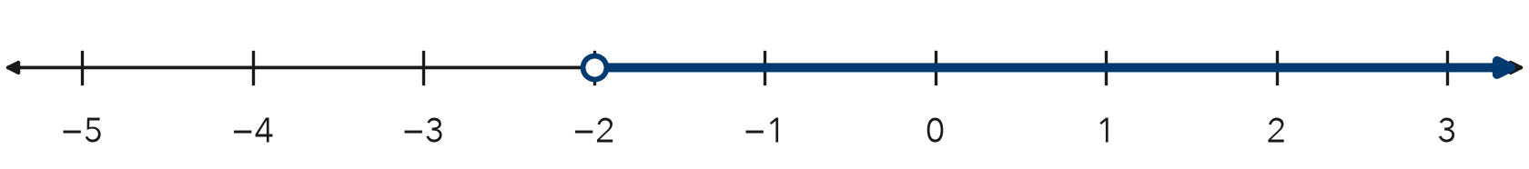  Step 1 > does not include −2, so draw an open dot at −2.  Step 2 Solutions are greater, so the arrow points right.  Answer Open dot at −2, arrow right
PRACTICE use the number lines · show your work
1. For each graph, tell the dot (open or closed) and the arrow direction (left or right).
a. x ≥ 9 | b. n < −4
c. p ≤ 0 | d. k > 2.5
e. w ≥ −6 | f. r < 7
g. b > −1.5 | h. c ≤ 12

2. Graph a ≤ −1 on the number line. Then name one solution.
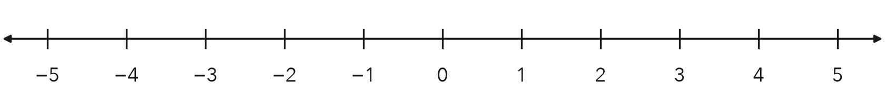
One solution

3. Hiking Trail. A trail is open to hikers who are at least 10 years old. Write an inequality for a, a hiker’s age. Then graph it.
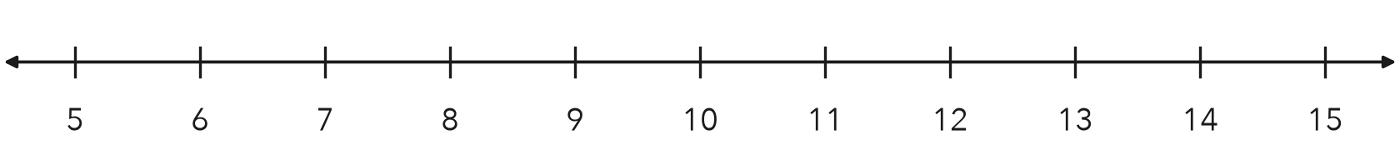
Inequality

4. Read the Graph. Write the inequality shown, using m. Then describe a real situation it could show.
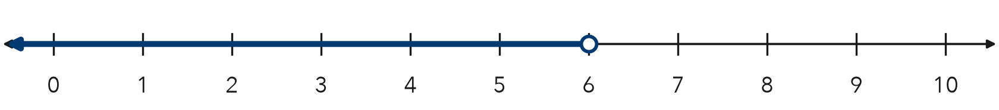

CHECK YOURSELF | □ I can do this on my own | □ I need a little help | □ I have a question about #
AT HOME Ask someone at home for a rule with a limit (bedtime, screen time, a speed limit). Write it as an inequality and graph it.
Name Date Period
Lesson 8-5 · Homework Packet · Sheet 2 of 2
Testing Solutions to Inequalities
Maryland Standard 6.EE.B.8 · Learning target — I can test values against an inequality and graph the solution set.

REMEMBER  • Substitute the value. A true statement means it is a solution.  • An inequality usually has many solutions.  • The boundary is a solution for ≤ and ≥ only. | WORKED EXAMPLE  Which of 6, 8, and 11 are solutions of x ≥ 8?  Step 1 Test 6: 6 ≥ 8 is false. Test 8: 8 ≥ 8 is true.  Step 2 Test 11: 11 ≥ 8 is true.  Answer 8 and 11 are solutions; 6 is not.
PRACTICE show your work · label units
1. Substitute each value. Write yes if it is a solution or no if it is not.
Inequality | x = 4 | x = 7 | x = 10
x > 7
x ≤ 7
x ≥ 4

2. Is the value a solution? Write yes or no.
a. x < 9; x = 9 | b. m ≥ −1; m = 0 | c. t ≤ 2.5; t = 3

3. Bowling. A bowling team wins a trophy for scoring more than 450 points. Write an inequality for the score, s. Test 450, 445, and 472.
Inequality and winning scores

4. Test −3, 0, and 2 in y ≤ −1. Then graph y ≤ −1 on the number line.
Solutions from the list

5. Find the Error. Bianca says n < 12 has 12 solutions: 11, 10, 9, and so on down to 0. Explain what she is missing.

TEST PRACTICE choose the best answer
6. Which value is not a solution of k ≥ −2?
A −3 | B −2 | C 0 | D 5

7. Which value is a solution of n > 15?
A 12 | B 14.9 | C 15 | D 15.5

CHECK YOURSELF | □ I can do this on my own | □ I need a little help | □ I have a question about #

