Name Date Period
Lesson 9-1 · Homework Packet · Sheet 1 of 2
Independent and Dependent Variables
Maryland Standard 6.EE.C.9 · Learning target — I can name the independent and dependent variables in a relationship.

REMEMBER  • The independent variable is the input you choose or control.  • The dependent variable is the output. It depends on the input.  • On a graph: independent on the x-axis, dependent on the y-axis. | WORKED EXAMPLE  The more cars Andre washes, the more money he earns. Name the variables.  Step 1 Andre controls how many cars he washes.  Step 2 Test: “Money earned depends on cars washed.” It makes sense.  Answer Independent: cars washed · Dependent: money earned
PRACTICE show your work · label units
1. For each pair of quantities, write I under the independent variable and D under the dependent variable.
 | Quantity | I or D | Quantity | I or D
a. | minutes biking |  | miles traveled
b. | total cost |  | tickets bought
c. | guests at a party |  | cups of juice needed

2. Bus Ride. The longer Imani rides the bus, the farther she gets from home. Write a sentence about these two quantities that uses “depends on.”
Sentence

3. Dog Walking. Rosa earns $6 per dog she walks. Name both variables.
Independent / Dependent

4. Sunflower. Kenji graphs the height of his sunflower each week.  a. Name the independent variable.  b. Name the dependent variable.  c. What does the point (4, 20) mean? | 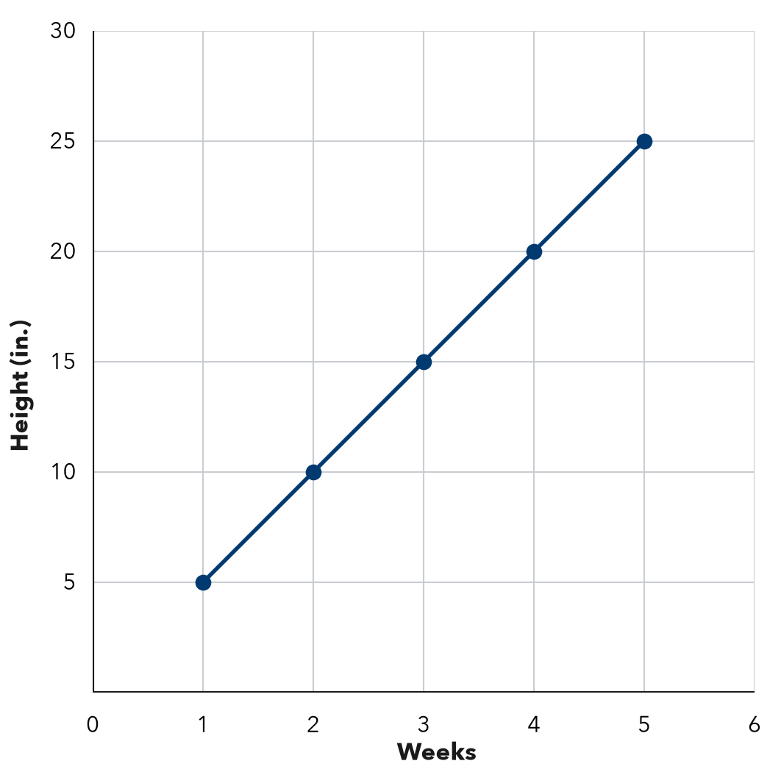

5. Find the Error. The number of people at a picnic changes how many sandwiches are needed. Leah says the sandwiches are independent because that is the bigger number. Explain her mistake.

CHECK YOURSELF | □ I can do this on my own | □ I need a little help | □ I have a question about #
AT HOME Name two things at home that change together. Which one depends on the other?
Name Date Period
Lesson 9-1 · Homework Packet · Sheet 2 of 2
Tables of Values
Maryland Standard 6.EE.C.9 · Learning target — I can build a table of values for a relationship between two variables.

REMEMBER  • A table of values pairs each input (x) with its output (y).  • Use the rule on every input. With a fee, multiply first, then add. | WORKED EXAMPLE  A copier prints 20 pages each minute. Make a table for 1, 2, and 4 minutes.  Step 1 Minutes is x. Pages is y. The rule is y = 20x.  Step 2 20 × 1 = 20, 20 × 2 = 40, 20 × 4 = 80  Answer 20, 40, and 80 pages
PRACTICE show your work · label units
1. Use the rule y = x + 8 to complete the table.
x | 0 | 2 | 4 | 7
y

2. Skate Rental. A rink charges $5 to get in plus $3 for each hour of skating. Complete the table.
Hours (x) | 1 | 2 | 3 | 6
Cost in $ (y)

3. Marker Boxes. The table shows markers in boxes. Describe the rule. Then fill in the missing values.
Boxes (x) | 1 | 2 | 3 | 4 | 8
Markers (y) | 8 | 16 | 24
Rule

4. Find the Error. Marcus made a table for y = 2x + 1. He wrote x: 1, 2, 3, 4 and y: 3, 5, 7, 8. Which y value is wrong? What should it be?
Answer

5. Stretch. A taxi charges $4 plus $2 for each mile. Complete the table. How many miles cost $20?
Miles (x) | 1 | 3 | 5
Cost in $ (y) |  |  |  | 20

TEST PRACTICE choose the best answer
6. A rule is “multiply by 4, then add 5.” What is y when x = 6?
A 24 | B 44 | C 29 | D 15

7. A table has x-values 1, 2, and 3. Which y-values match the rule y = x + 6?
A 6, 12, 18 | B 7, 8, 9 | C 7, 14, 21 | D 6, 7, 8

CHECK YOURSELF | □ I can do this on my own | □ I need a little help | □ I have a question about #

