Name Date Period
Lesson 9-2 · Homework Packet · Sheet 1 of 2
From Table to Graph
Maryland Standard 6.EE.C.9 · Learning target — I can turn a table of values into points and plot them on a graph.

REMEMBER  • Each row of a table becomes an ordered pair (x, y).  • To plot (x, y), start at (0, 0). Move right x, then up y.  • Points from a constant rate line up in a straight line. | WORKED EXAMPLE  Movie tickets cost $8 each. Write ordered pairs for 1, 2, and 3 tickets.  Step 1 Tickets is x. Cost is y. Multiply each x by 8.  Step 2 8 × 1 = 8, 8 × 2 = 16, 8 × 3 = 24  Answer (1, 8), (2, 16), (3, 24)
PRACTICE show your work · label units
1. Write each table row as an ordered pair (x, y).
a. x = 4, y = 12 | b. x = 0, y = 0
c. x = 6, y = 30 | d. x = 9, y = 2

2. Smoothies. Smoothies cost $4 each. Complete the table. Then plot the points on the grid and connect them. | 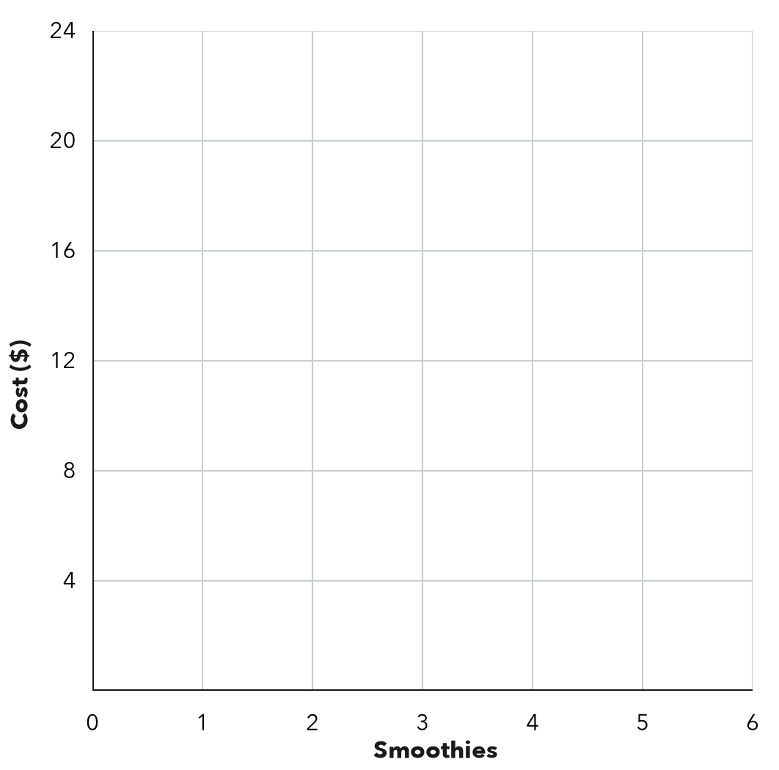
  Smoothies (x) | 1 | 2 | 3 | 5
  Cost in $ (y)

3. Hiking. The graph shows how far Kofi hikes.  a. Write the ordered pair for 5 hours.  b. What does (3, 6) mean?  c. Miles per hour: | 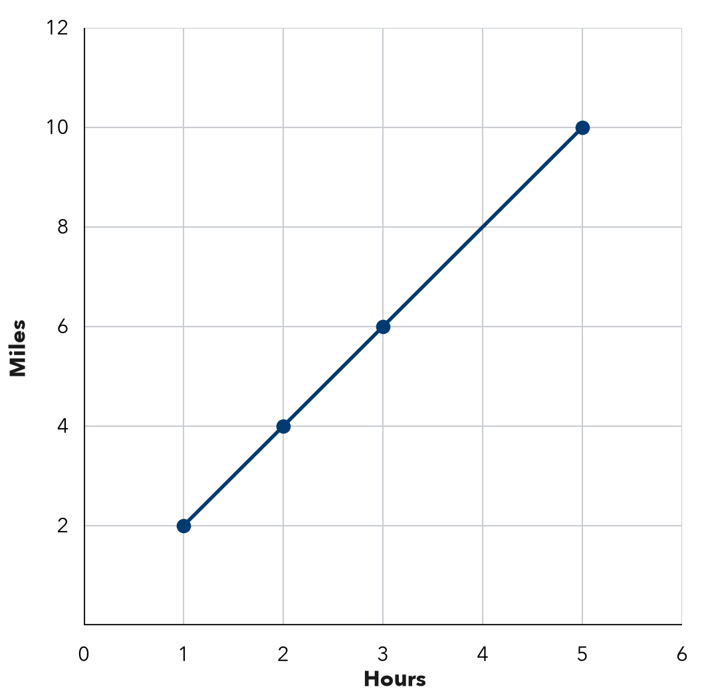

4. Bike Rental. A bike rents for $6 per hour. Write the ordered pairs (hours, cost) for renting 1, 3, and 4 hours. Then tell what (0, 0) means.
Ordered pairs

5. Find the Error. Teo’s table shows x (hours): 2, 4 and y (dollars): 10, 20. He plotted (10, 2) and (20, 4). Explain his mistake. Which points should he plot?

CHECK YOURSELF | □ I can do this on my own | □ I need a little help | □ I have a question about #
AT HOME Show someone at home how to plot (3, 5): right 3, then up 5.
Name Date Period
Lesson 9-2 · Homework Packet · Sheet 2 of 2
Analyzing a Graph
Maryland Standard 6.EE.C.9 · Learning target — I can read a relationship off a graph and describe the rate it shows.

REMEMBER  • For a line through (0, 0), the unit rate is y ÷ x. The point (3, 12) means 3 of x go with 12 of y.  • With the same scales, a steeper line has a greater rate. | WORKED EXAMPLE  A line through (0, 0) passes through (2, 10). Find the unit rate and y when x = 7.  Step 1 Unit rate: 10 ÷ 2 = 5  Step 2 y = 5 × 7 = 35  Answer 5 per unit; y = 35
PRACTICE show your work · label units

1. Filling a Pool. The graph shows the water in a pool.  a. What does (4, 60) mean?  b. Gallons per minute:  c. Gallons after 9 minutes: | 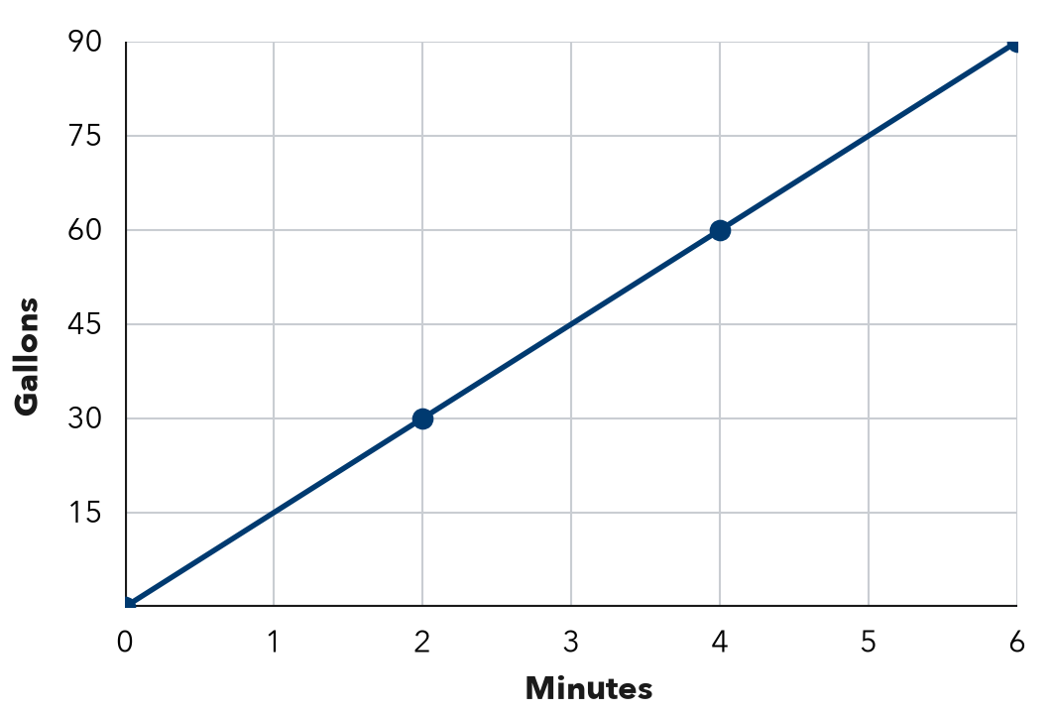

2. Each line passes through (0, 0) and the given point. Find the unit rate.
a. (3, 21) | b. (5, 40) | c. (8, 96)

3. Reading. A line through (0, 0) shows that Ana reads 18 pages in 3 hours. Find her unit rate. How many pages does she read in 7 hours?
Answer

4. Two Jobs. The graph shows pay for two jobs. Find each pay rate. Which line is steeper, and what does it mean?  Answer | 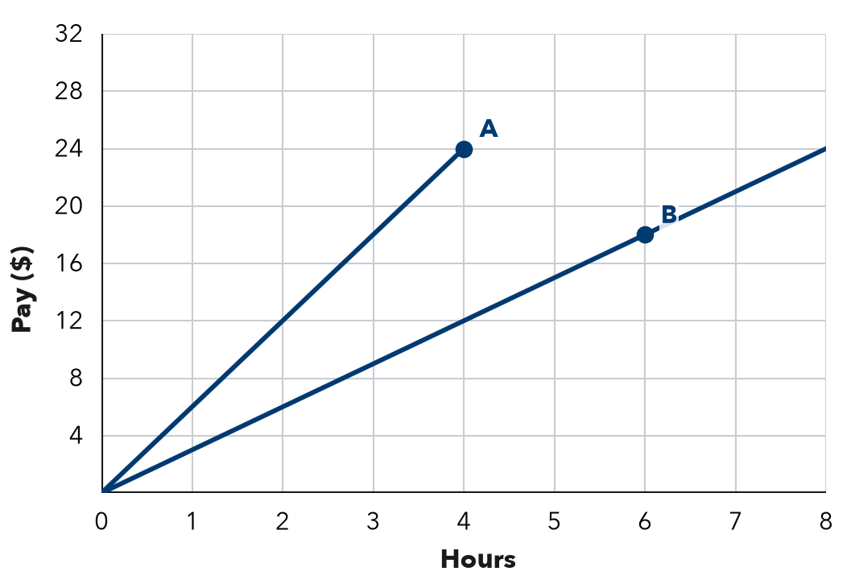

5. Savings. Jada’s savings graph passes through (0, 10), (1, 15), and (2, 20). She says it is proportional. Is she right? What does (0, 10) mean?

TEST PRACTICE choose the best answer
6. A line through the origin passes through (5, 35). What is the unit rate?
A 5 | B 30 | C 7 | D 175

7. Line P passes through (1, 4). Line Q passes through (1, 9). Both start at (0, 0). Which is true?
A P is steeper. | B Q is steeper; greater rate.
C They have the same rate. | D Q is steeper; smaller rate.

CHECK YOURSELF | □ I can do this on my own | □ I need a little help | □ I have a question about #

