Name |  | Date |  | Period

Lesson 9-2 · Session 1
Homework
From Table to Graph
Maryland Standard 6.EE.C.9 · Learning target — I can turn a table of values into points and plot them on a graph.
Show a model, calculation, or explanation for each exercise. Label units and answer every part.
Exercises 1–12 earn 1 point for a correct response and 1 for supporting work. Spiral Review and Test Practice earn 1 point each.
REMEMBER review this before you start
• Each row of a table of values becomes one ordered pair (x, y) to plot on a coordinate graph.
• Plot several points from the table, then look for a pattern (often a straight line).
• Watch out — a fee shifts the line up so it no longer starts at the origin.
• Check it — every plotted point should satisfy the rule from the table.
WORKED EXAMPLE the same steps you practiced in class
Turning a Table into Points on a Graph A rental site charges $7 per movie. Make a table for 1, 2, and 3 movies, then list the points to plot.
Step 1 Independent: number of movies (x). Dependent: total cost (y).
Step 2 Multiply each x by the rate: 1 7 · 2 14 · 3 21
Step 3 Write each row as an ordered pair (x, y): (1, 7), (2, 14), (3, 21).
Step 4 Plot each pair: move right along the x-axis first, then up to the y value.
Answer Points to plot: (1, 7), (2, 14), and (3, 21). They rise in a straight path.
EXERCISES 12 exercises · 24 points
1. Using the table x: 1,2,3 y: 2,4,6 — write the three ordered pairs. ______

Show your work.
Answer
2. Plot the three ordered pairs from problem 1 on a coordinate plane.

Graph. Plot the three ordered pairs and draw the line through them and the origin.​
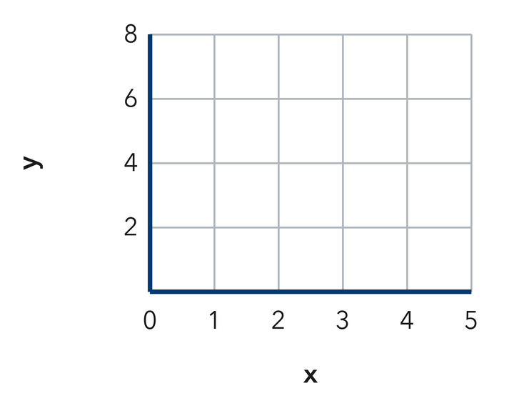
Show your work.
Answer
3. Do the points in problem 1 form a straight line? What does this tell you about the relationship?

Show your work.
Answer
4. Write each table row as an ordered pair (x, y).
a. x = 3 and y = 15 ______
b. x = 6 and y = 12 ______
c. x = 0 and y = 0 ______
d. x = 5 and y = 45 ______
e. x = 10 and y = 70 ______

Answer
5. Trail Mix. A corner shop sells trail mix for $4 a pound. Make a table for 2, 3, and 6 pounds, then write the three ordered pairs.

Show your work.

Answer
6. Stair Climb. Kwame climbs 14 stairs for every floor of his apartment building. Write the ordered pairs for 2, 5, and 8 floors, then explain what the middle point means.

Show your work.

Answer
7. Lemonade Stand. A stand charges $3 for each cup of lemonade. Plot the points for 1, 2, 4, and 6 cups, label each axis with its quantity, then tell whether the points lie on a straight path.

Graph. Plot the four points, label each one, and draw the line through the origin.​
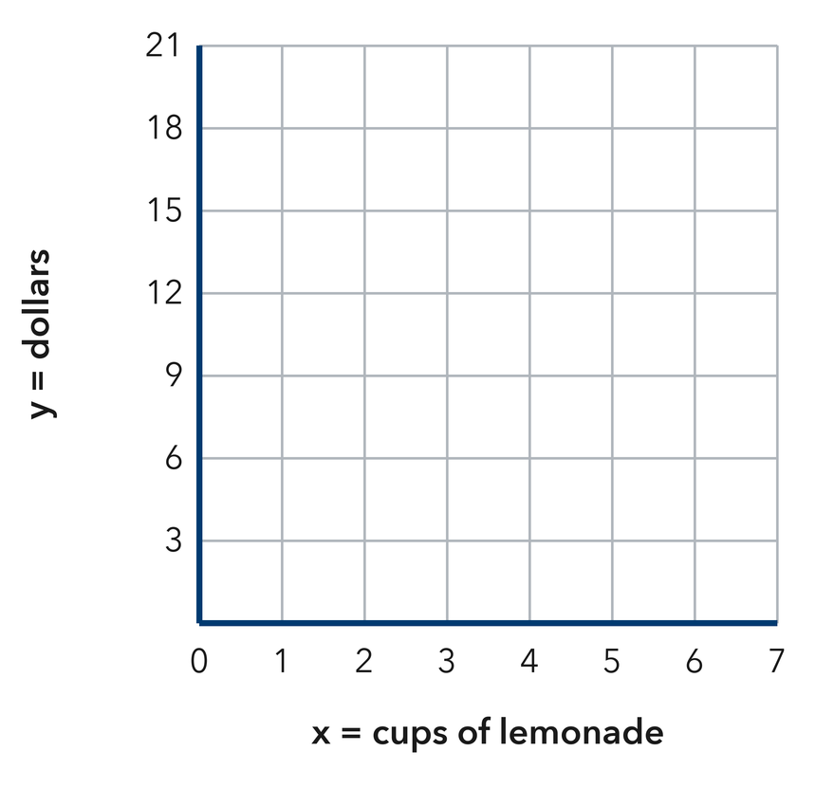
Show your work.

Answer
8. A student plotted the pairs from the table x: 2, 4, 6 and y: 10, 20, 30 by using each x-value vertically and each y-value horizontally. Explain the mix-up, then describe how to plot (4, 20).

Show your work.

Answer
9. At $6 per book, list the ordered pairs for 1, 2, and 4 books.

Show your work.
Answer three pairs
10. A table gives (1, 11), (2, 22), and (3, 33). Describe the rule and the shape of the graph.

Show your work.
Answer rule and shape
11. With a Fee. A plan charges $10 plus $4 per month. List the pairs for 1, 2, and 3 months.

Show your work.
Answer three pairs
12. Find the Mistake. For x = 2 and y = 16, Cass plotted (16, 2). Explain the mistake.

Show your work.
Answer the mistake
SPIRAL REVIEW earlier skills · 1 point each
13. From Lesson 9-1 Session 2. A rule is “multiply by 6, then add 2.” Find y when x = 5.
Answer
14. From Lesson 8-2 Session 1. Solve x + 34 = 61.
Answer
15. From Lesson 6-6 Session 1. Simplify 6n + 7 + 2n.
Answer
TEST PRACTICE multiple choice · fill one box · 1 point each
16. A row of x = 7, y = 35 becomes —
□ A. (42, 0) | □ B. (35, 7) | □ C. (7, 7) | □ D. (7, 35)
17. A graph with a starting fee does not pass through the —
□ A. origin | □ B. x-axis | □ C. y-axis | □ D. first quadrant
18. At $12 per hour, 4 hours gives the pair —
□ A. (48, 4) | □ B. (4, 48) | □ C. (4, 12) | □ D. (12, 4)
CHECK YOURSELF Score: ______ / 30
□ Solved on my own | □ Needed a hint | □ Need help on Question # ______
Substitute one input-output pair into your rule. Check units and whether your answer fits the situation.

