Name |  | Date |  | Period
Lesson 9-2 · Session 2
Guided Practice
Analyzing a Graph
VOCABULARY read and say each word before you begin
rate of change  Spanish: tasa de cambio | How much y changes each time x goes up by one. | up $4 per hour
unit rate  Spanish: tasa unitaria | The amount of y that goes with exactly one unit of x. | 60 miles per hour
origin  Spanish: origen | The point (0, 0) where the two axes meet. | (0, 0)
steeper | With matching axes and scales, a larger rise per unit of x. | up 9 beats up 2
represent  Spanish: representar | To show one relationship as a table, graph, or rule. | table graph
EXPLORE TOGETHER Class Launch · 8–10 min
1. Scooter Rental Graph  A scooter rental graph shows minutes on the x-axis and cost in dollars on the y-axis. It passes through (1, 7), (2, 14), (4, 28), and (5, 35).  a. Read. What does the point (4, 28) tell you about this rental? __________  b. Rate. How much does the cost climb each time the minutes go up by one? $ ______  c. Plot. Plot the four points on the coordinate plane below and connect them with a straight edge. | d. Predict. Use your graph to find the cost of a 3-minute rental: ______ How did you read it?  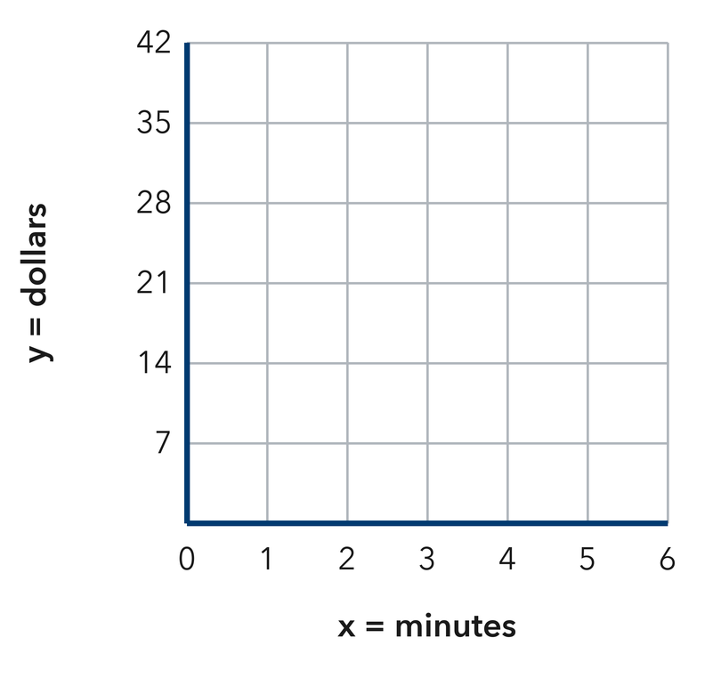​
  TURN AND TALK
  How does the steepness of a graph show the rate between two quantities?
PRACTICE WITH A PARTNER You Do Together · 10–12 min
2. Hiking Trail. A hiking graph shows hours on the x-axis and miles walked on the y-axis. It passes through (1, 2), (3, 6), and (5, 10).  a. Miles walked each hour __________  b. Use the pattern to find the miles after 8 hours __________ | c. Graph. Plot the ordered pairs on the coordinate plane below, then draw a straight line through them.​  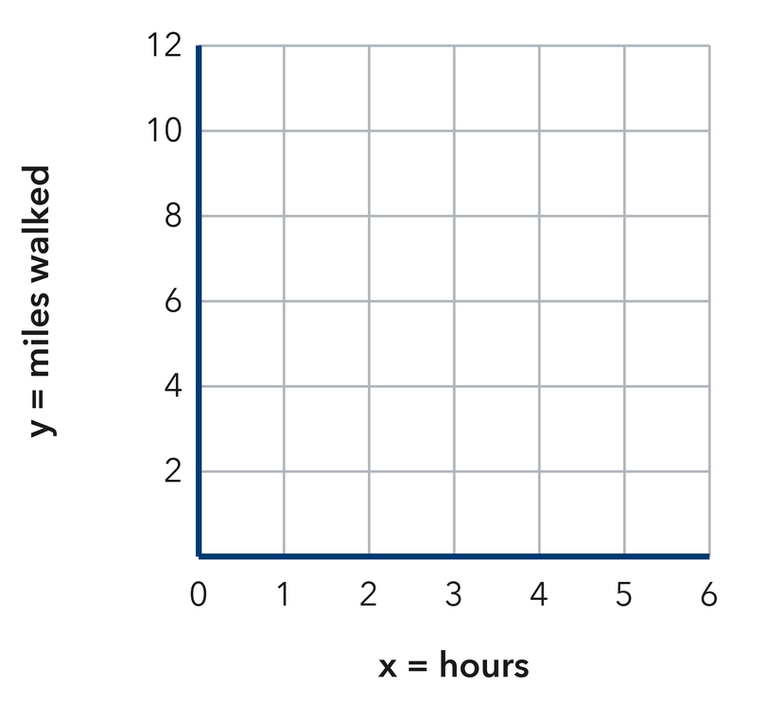
  PARTNER TALK
  Why do all of these points lie along one straight path?

3. Phone Storage. A storage graph shows songs downloaded on the x-axis and megabytes used on the y-axis. It passes through (2, 8), (5, 20), and (10, 40).  a. Megabytes for one song __________  b. What do the coordinates of (5, 20) mean here? __________ | 4. Ferris Wheel. A ride graph shows minutes on the x-axis and turns of a Ferris wheel on the y-axis. It passes through (3, 9), (6, 18), and (8, 24).  a. Turns in one minute __________  b. Use the pattern to find the turns after 15 minutes __________
  PARTNER TALK
  How can a single point on a graph tell you the unit rate? Explain.
  PARTNER TALK
  What would a flatter line on this same graph tell you about the ride?
PRACTICE ON YOUR OWN You Do · 8 problems · 18–20 min
5. Sunflower Growth. A sunflower graph shows weeks on the x-axis and height in inches on the y-axis. It passes through (2, 14), (4, 28), and (6, 42).  Find the rate of change, then determine the plant’s height at 9 weeks.  Hint Compare two points that sit two weeks apart, then scale that jump down to one week.  Answer inches per week; height at 9 weeks | 6. Two Pay Graphs. Job A’s pay graph passes through (1, 6) and (3, 18). Job B’s pay graph passes through (1, 9) and (3, 27). Explain which graph is steeper and what that means about the pay.  Hint Work out how much each graph climbs for one hour, then set those two climbs side by side.  Answer steeper graph + what it means

7. Water Tank. A tank graph shows hours on the x-axis and gallons on the y-axis. It passes through (2, 50), (4, 100), and (7, 175).  Determine the unit rate, then write the ordered pair that belongs at 10 hours.  Hint Divide the y value of one point by its x value to get the amount for a single hour.  Answer gallons per hour; ordered pair | 8. Package Scanner. A warehouse graph shows minutes on the x-axis and packages scanned on the y-axis. It passes through (4, 16), (6, 24), and (10, 40).  Find the rate of change, then determine the packages scanned in 25 minutes  Hint Divide one point’s y value by its own x value to get the packages for a single minute.  Answer packages per minute; packages at 25 minutes

9. Lawn Signs. A fundraiser graph shows lawn signs sold on the x-axis and dollars raised on the y-axis. It passes through (3, 45) and (7, 105). Yusuf says the point (3, 45) means the group raises $45 each hour.
Explain the mistake in how Yusuf read the graph, then state what (3, 45) really means
Hint Check what each axis measures before naming a rate, then divide to get the money from one sign.
Answer mistake + money from one sign

10. Taxi Graph. A taxi graph passes through (1, 15), (2, 30), and (3, 45). Describe the relationship and give the rate.  Hint Compare each y with its x.  Answer the rate and your description | Read the graph. This is the taxi graph. Use it to describe the relationship and read the rate.​  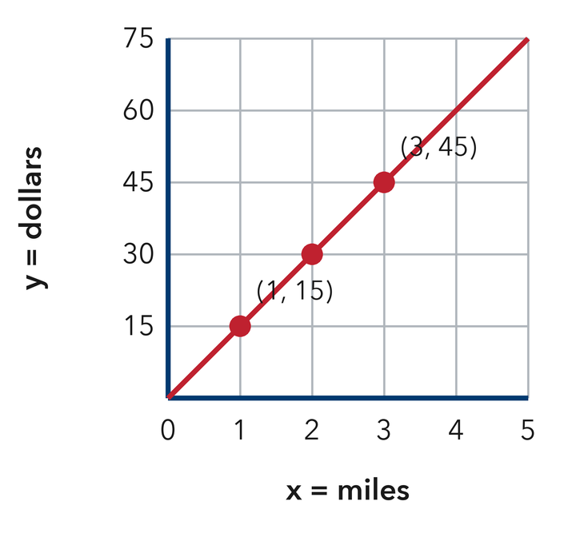
  Show your work.

11. Read the Rate. A graph passes through (2, 18) and (5, 45).  a. Find the rate of change. __________  b. Find y when x = 8. __________  Hint Divide each y by its x to check the rate.  Answer a and b | c. Read the graph. This graph passes through both points. Read the rate straight off it.​  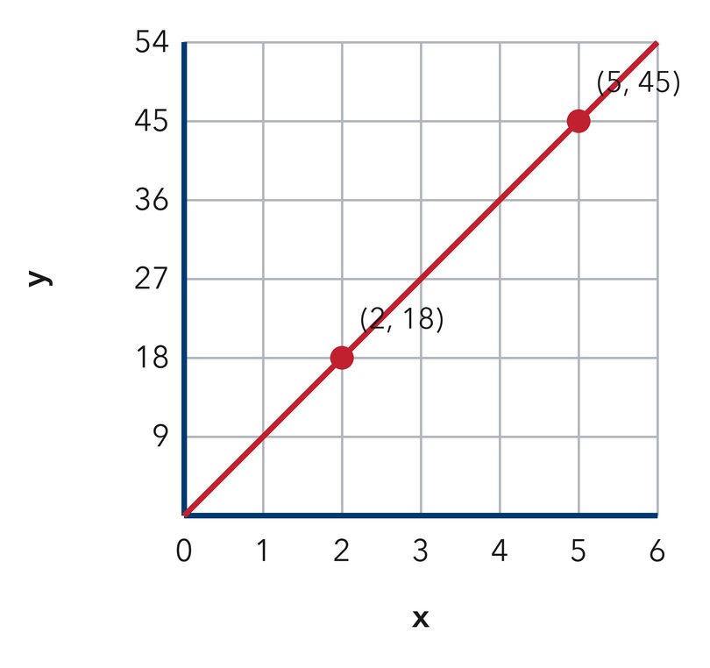
  Show your work.

12. Compare Steepness. Line P passes through (1, 4) and line Q through (1, 9). Both start at the origin.
a. Which line is steeper? __________
b. What does the steeper line mean in a cost situation? __________
Hint A bigger rise for the same run is steeper.
Answer a and b
ANALYZE THE ERROR 5 min
13. Read the work below. Explain the mistake, then show the correct reasoning.
BIANCA’S WORK

A walking graph passes through (2, 100) and (4, 200). Bianca said the walker takes 100 steps each minute.
a. Explain the mistake. Check how Bianca used the point (2, 100). What step did she skip? | b. Show correct work  Correct answer
  Show the correct work.
STRETCH YOUR THINKING multi-step reasoning · 8 min
14. Two Riders. Rider 1’s graph passes through (2, 24) and Rider 2’s through (3, 30). Both graph distance in kilometres against hours and start at the origin.  a. Find each rider’s rate.  b. Whose line is steeper, and what does that mean?  c. Find how far each rider travels in 5 hours and the gap between them.  Answer both rates, the steeper line, and the gap | d. Graph both riders. Draw each rider’s line on the same plane, label them 1 and 2, then compare the steepness.​  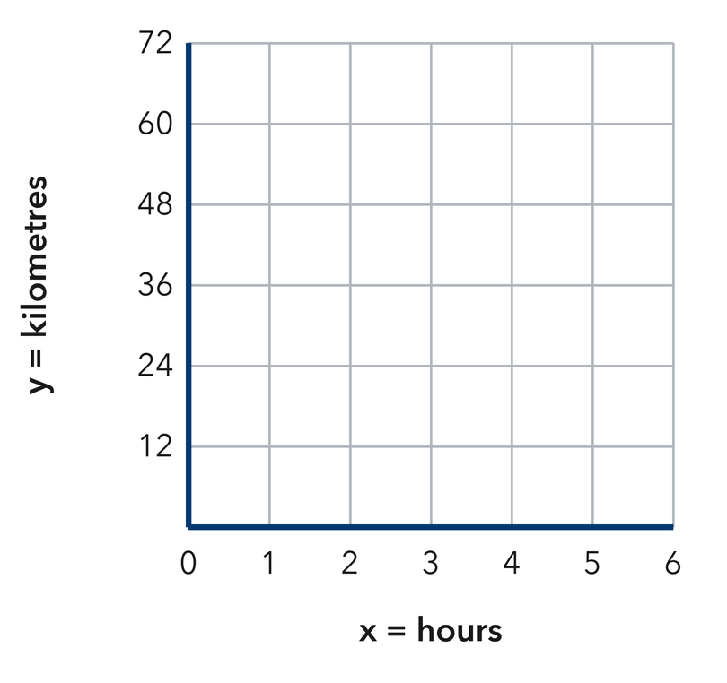
  Show your work.
TEST PRACTICE multiple choice · fill one box · 6 min
15. A graph through (1, 8) and (2, 16) shows a rate of — | 16. A steeper line shows a —
  □ A. 16 per unit | □ B. 8 per unit | □ C. 2 per unit | □ D. 24 per unit
  □ A. larger total only | □ B. smaller rate | □ C. larger rate | □ D. zero rate

17. A graph through (3, 21) has a rate of — | 18. The point where a line meets the y-axis shows the value when x is —
  □ A. 24 per unit | □ B. 21 per unit | □ C. 3 per unit | □ D. 7 per unit
  □ A. 0 | □ B. 1 | □ C. the rate | □ D. the total
SPIRAL REVIEW earlier skills · keep them sharp · 6 min
19. From Lesson 9-2 Session 1. At $8 per ticket, list the pair for 3 tickets.  Answer | 20. From Lesson 9-1 Session 1. Which variable goes on the y-axis?  Answer

21. From Lesson 8-3 Session 1. Solve 8n = 88.  Answer | 22. From Lesson 5-2 Session 1. A triangle has base 16 ft and height 7 ft. Find its area.  Answer
CHECK YOUR UNDERSTANDING 5 min
23. Movie Night Popcorn. A popcorn graph shows bags on the x-axis and dollars on the y-axis. It passes through (3, 24) and (6, 48).  a. Cost of one bag __________  b. Plot both points, extend the path, and find the cost of 8 bags __________  Hint Get the cost for a single bag first, then stretch that pattern farther along the graph.  Answer | c. Graph. Plot the ordered pairs on the coordinate plane below, then draw a straight line through them.​  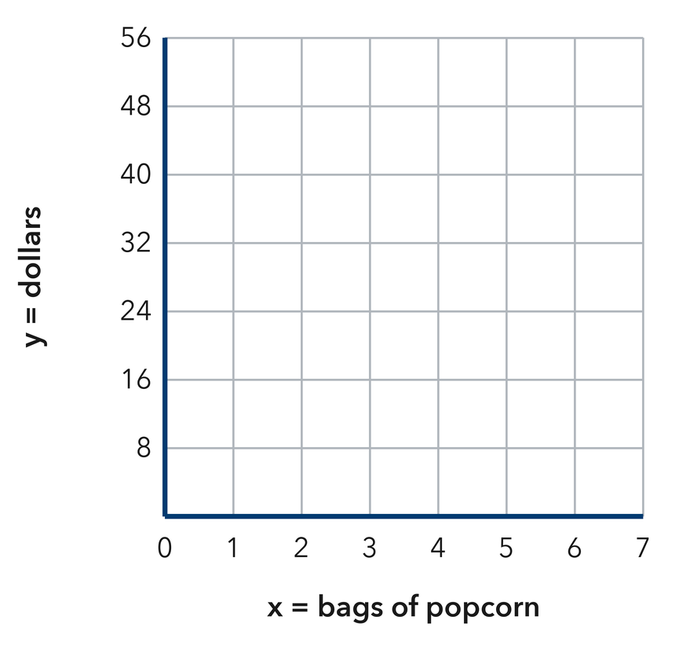
  Show your work.

□ 4 — Can teach it | □ 3 — Got it | □ 2 — Need hint | □ 1 — Need help
Circle your confidence. Star one problem that shows your learning.

