Name Date Period
Lesson 9-4 · Homework Packet · Sheet 1 of 2
Substitute and Solve
Maryland Standard 6.EE.C.9 · Learning target — I can substitute a value into an equation to find the matching output.

REMEMBER  • To find the output, substitute the input for x.  • Then use order of operations: multiply first, then add or subtract. | WORKED EXAMPLE  Use y = 6x + 4 to find y when x = 5.  Step 1 Substitute: y = 6 × 5 + 4  Step 2 Multiply, then add: 30 + 4 = 34  Answer y = 34, so (5, 34)
PRACTICE show your work · label units
1. Substitute to find y.
a. y = 4x + 7, x = 3 | b. y = 9x, x = 8
c. y = 3x − 2, x = 10 | d. y = x + 15, x = 27

2. Complete the table for y = 2x + 3. Then plot the points and connect them. | 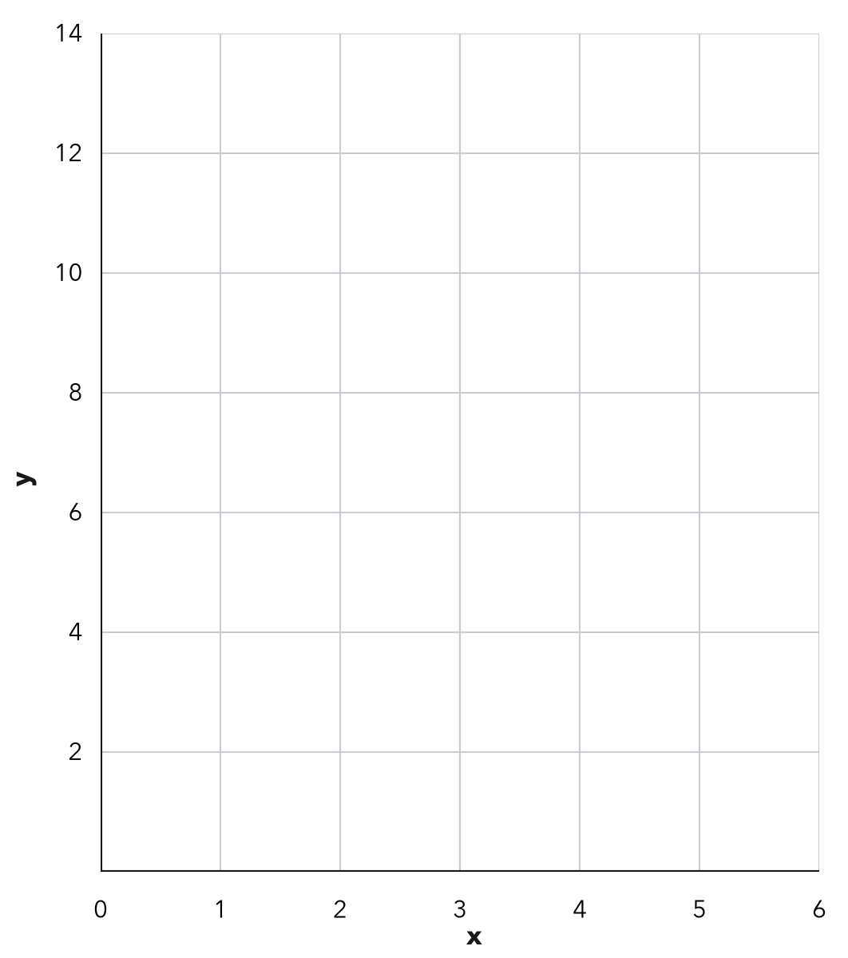
  x | 0 | 1 | 2 | 4 | 5
  y

3. Water Tank. A tank has 20 gallons. It fills at 15 gallons each minute, so g = 15m + 20.
a. Gallons after 6 minutes: gal
b. Gallons after 10 minutes: gal

4. Bike Rental. A bike rental costs c = 7h + 5 dollars for h hours. Find the cost of renting for 3 hours. Then find the cost for 8 hours.
Costs

5. On the Line? Substitute x to decide whether each point is on the graph of y = 5x + 2.
a. (4, 22): 5 × 4 + 2 = On the line? □ Yes □ No
b. (6, 30): 5 × 6 + 2 = On the line? □ Yes □ No

6. Find the Error. For y = 4x + 3 with x = 5, Dev added first: 4 + 3 = 7, and 7 × 5 = 35. Explain his mistake and find y.

CHECK YOURSELF | □ I can do this on my own | □ I need a little help | □ I have a question about #
AT HOME Pick a rule like y = 2x + 1. Ask someone at home for an input and find the output together.
Name Date Period
Lesson 9-4 · Homework Packet · Sheet 2 of 2
Working Backward to a Goal
Maryland Standard 6.EE.C.9 · Learning target — I can work backward from a goal to find the input an equation needs.

REMEMBER  • Know the goal (y)? Substitute it, then solve for x.  • Undo in reverse order: subtract the fee first, then divide by the rate.  • In a counting problem, a decimal answer may need to be rounded up. | WORKED EXAMPLE  A rental costs y = 4x + 10 for x hours. How many hours cost $46?  Step 1 Subtract 10: 46 − 10 = 36  Step 2 Divide by 4: 36 ÷ 4 = 9  Answer 9 hours
PRACTICE show your work · label units
1. Solve for x.
a. 7x = 63 | b. 8x = 104
c. 3x + 5 = 32 | d. 6x + 12 = 60

2. Trip Fund. A class has $45 and earns $15 a week: y = 15x + 45. How many weeks until it has $210?
Answer weeks

3. Gift Fund. A club has $30 in its gift fund. Members add $12 each week, so y = 12x + 30. How many weeks until the fund has $150?
Answer weeks

4. Plant Growth. A plant is 6 cm tall and grows 3 cm a week: h = 3w + 6.  a. Use the graph. When is it 18 cm?  b. Use the equation. When is it 33 cm? | 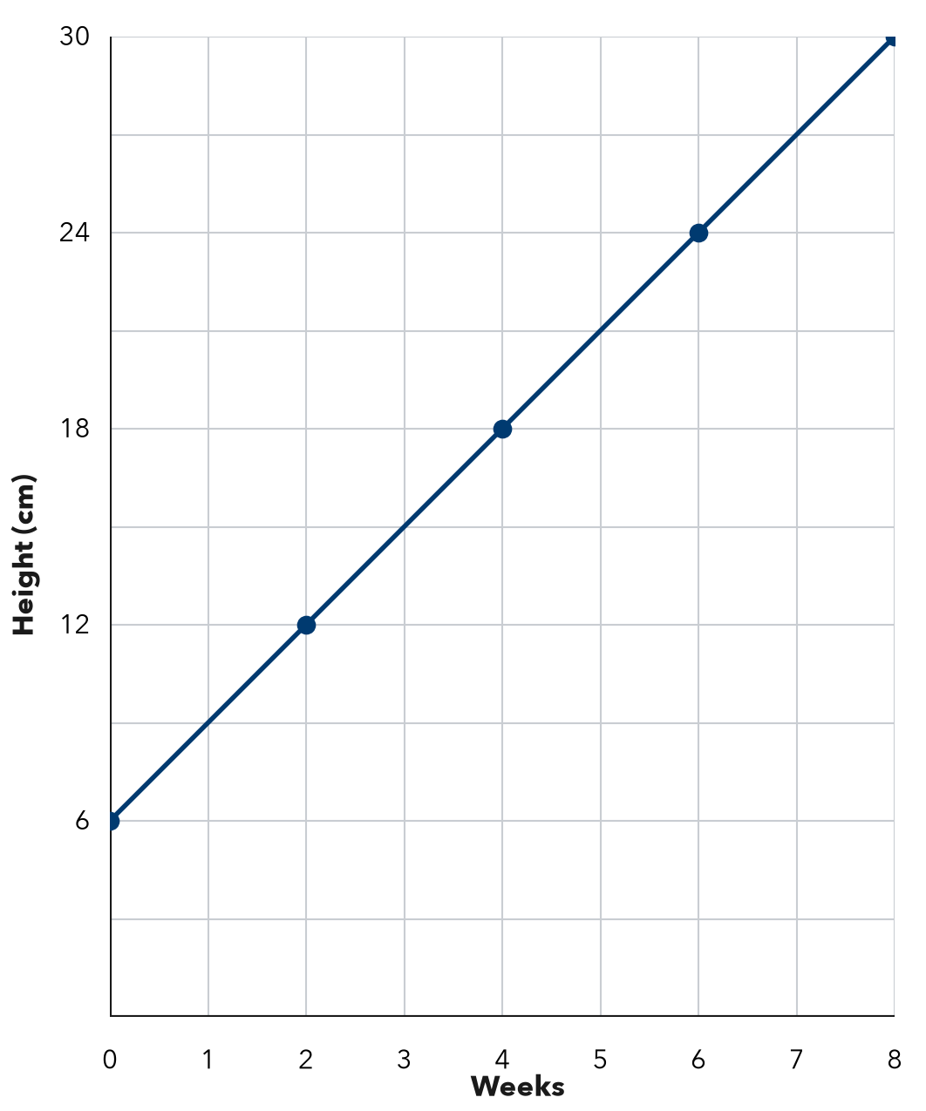

5. Round Up. A box holds 12 cookies. Ana needs 150 cookies, so she says 12.5 boxes. How many boxes should she buy? Explain.

TEST PRACTICE choose the best answer
6. A rental costs y = 8x + 12 dollars for x hours. Max has $60. How many hours can he rent?
A 5 hours | B 6 hours | C 7.5 hours | D 9 hours

7. Mia solved 5x + 20 = 85 by dividing 85 by 5 first. What is the correct value of x?
A x = 17 | B x = 21 | C x = 13 | D x = 65

CHECK YOURSELF | □ I can do this on my own | □ I need a little help | □ I have a question about #

