Lesson 2-2 · Session 1

Building a Histogram
Version 2 / Regular
Name ______________________________ Date ______________ Period ______
Maryland Standard 6.SP.B.4 · Learning target — I can group data into equal intervals and build a histogram from a frequency table.
Show a model, calculation, or explanation. Answer every part and label units when needed.
Exercises 1–12 earn 1 point for a correct response and 1 for supporting work. Spiral Review and Test Practice earn 1 point each.
Learn from a model
REMEMBER  • A histogram groups numerical data into equal-width intervals and shows a bar for each interval — no gaps between bars.  • Unlike a dot plot, a histogram cannot show each individual data value.  • Watch out — intervals must be equal in width and must not overlap, or the bars will mislead.  • Check it — the frequencies must add up to the number of data values you started with. | WORKED EXAMPLE  Grouping Data into a Frequency Table Seven plants grew these heights in cm: 61, 74, 88, 76, 63, 71, 79. Use ten-unit intervals.  Step 1 Choose equal intervals that cover the data with no gaps: 60-69, 70-79, 80-89.  Step 2 Tally each value into exactly one interval. 61 and 63 both land in 60-69.  Step 3 Count each interval. 60-69 holds two plants, 70-79 holds four, 80-89 holds one.  Step 4 Draw touching bars at those heights above the three interval labels.  Answer The frequency table reads 60-69: 2, 70-79: 4, 80-89: 1, and the tallest bar is 70-79.

Practice
1. Ten quiz scores are: 62, 65, 71, 74, 78, 81, 84, 88, 91, 96. Complete the frequency table using intervals of 10.
Interval: 60-69 ______ 70-79 ______ 80-89 ______ 90-99 ______
Answer ______________________________
SHOW YOUR THINKING


2. Use your frequency table to draw a histogram with touching bars. Label the axes, scale, and intervals.
Histogram. Draw one touching bar per interval.​
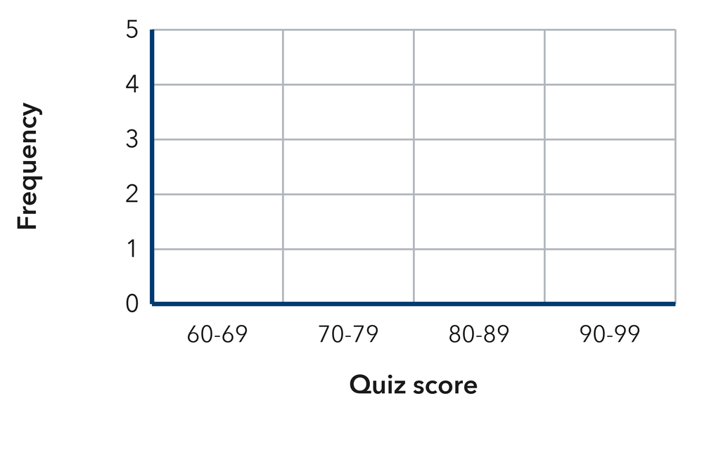
Answer ______________________________
SHOW YOUR THINKING

3. Which interval has the greatest frequency (the tallest bar)? ______
Answer ______________________________
SHOW YOUR THINKING

4. Use the data 14, 23, 8, 31, 27, 19, 35, 11 and intervals of 10.
a. 0-9 ______
b. 10-19 ______
c. 20-29 ______
d. 30-39 ______
e. Total values ______
Answer ______________________________
SHOW YOUR THINKING


5. Cereal Boxes. Nine boxes weigh these numbers of ounces: 12, 18, 25, 14, 21, 29, 16, 22, 11. Find the frequency for 10-14, 15-19, 20-24, and 25-29.
Answer ______________________________
SHOW YOUR THINKING

6. Skate Park Ages. Ten skaters are these ages: 9, 11, 14, 10, 13, 15, 12, 11, 16, 10. Build a frequency table for 9-10, 11-12, 13-14, and 15-16, then draw the histogram.
Histogram. Draw one touching bar per interval. Use the intervals 9-10, 11-12, 13-14 and 15-16.​
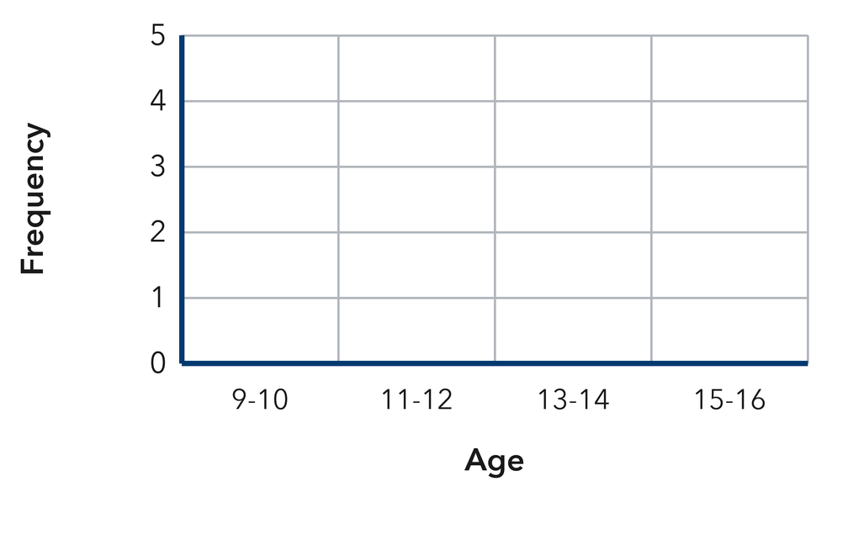
Answer ______________________________
SHOW YOUR THINKING

7. Missing Bar. A histogram of 20 phone calls has a bar of height 4 over 0-4 minutes, 9 over 5-9, and 3 over 15-19, plus one more bar over 10-14. Find the missing height.
Answer ______________________________
SHOW YOUR THINKING

8. Endpoint Trouble. Elena drew a histogram with the intervals 0-10, 10-20, 20-30. Explain the problem with her intervals and write a corrected set.
Answer ______________________________
EXPLAIN WITH MATHEMATICAL EVIDENCE


9. Nine scores are 44, 57, 61, 52, 48, 66, 59, 63, and 55. Give the frequency for 40–49, 50–59, and 60–69.
Answer ______________________________ three frequencies
SHOW YOUR THINKING

10. A frequency table shows 20–29: 6, 30–39: 9, 40–49: 5. How many values are in the table?
Answer ______________________________ values
SHOW YOUR THINKING

11. Pick Intervals. Daily temperatures run from 34° to 79°. Name the equal intervals of width 10 you would use.
Answer ______________________________ your intervals
RECORD YOUR RESPONSE

12. Find the Mistake. Nia used the intervals 10–20, 20–30, and 30–40. Explain the problem and give a fix.
Answer ______________________________ the problem and the fix
EXPLAIN WITH MATHEMATICAL EVIDENCE

Spiral review
13. From Lesson 2-1 Session 2. Which value is most common in 4, 6, 6, 6, 9?
Answer ______________________________
SHOW YOUR THINKING

14. Grade 5. Find 5.4 + 3.8.
Answer ______________________________
SHOW YOUR THINKING

15. Grade 5. Write 1/4 as a decimal.
Answer ______________________________
SHOW YOUR THINKING

Test practice
16. A histogram bar over 50–59 has height 8. This means —
□ A. there are 8 intervals
□ B. the mean is 8
□ C. 8 values are 50–59
□ D. the range is 8

17. Frequencies of 5, 3, 7, and 4 come from how many values?
□ A. 4 | □ B. 7
□ C. 20 | □ D. 19

18. Histogram intervals must be —
□ A. equal in width
□ B. different widths
□ C. in a circle
□ D. listed backward

Check and revise
CHECK YOUR MATHEMATICS  Count every value once. Use the tail, not the tallest stack, to name skew.  Every part answered / Work shown / Units labeled when needed | HOW DID IT GO?  I can do this:  Independently / With a hint / With help  Question to revisit: ______
One correction or question I want to discuss: __________________________________
Check one response against the data. State which measure or feature supports your answer.

