Lesson 2-4 · Session 1

Building a Box Plot
Version 2 / Regular
Name ______________________________ Date ______________ Period ______
Maryland Standard 6.SP.B.4 · Learning target — I can find the five-number summary of a data set and use it to build a box plot.
Show a model, calculation, or explanation. Answer every part and label units when needed.
Exercises 1–12 earn 1 point for a correct response and 1 for supporting work. Spiral Review and Test Practice earn 1 point each.
Learn from a model
REMEMBER  • The five-number summary is: minimum, Q1 (lower quartile), median, Q3 (upper quartile), maximum.  • A box plot uses these five numbers to show the spread of the data.  • Watch out — with an odd count, the median is not part of either half when you find Q1 and Q3.  • Check it — the five numbers must read in order: min ≤ Q1 ≤ median ≤ Q3 ≤ max. | WORKED EXAMPLE  Finding the Five-number Summary Seven daily high temperatures in degrees are 58, 71, 64, 83, 66, 77, 61. Build the box plot.  Step 1 Order the values: 58, 61, 64, 66, 71, 77, 83.  Step 2 Mark the median, 66 — the middle value of the seven.  Step 3 Lower half 58, 61, 64 gives quartile 1 as 61. Upper half gives quartile 3 as 77.  Step 4 Draw a box from 61 to 77 with a line at 66, then whiskers out to 58 and to 83.  Answer Five-number summary: 58, 61, 66, 77, 83. The box covers the middle half of the data.

Practice
1. Data set: 2, 4, 5, 7, 8, 9, 11, 12, 15. Find the five-number summary.
Min ______ Q1 ______ Median ______ Q3 ______ Max ______
Answer ______________________________
SHOW YOUR THINKING


2. Draw and label a number line, then make a box plot for the data in problem 1.
Box plot. Mark all five values on the scale, then draw the box and both whiskers.​
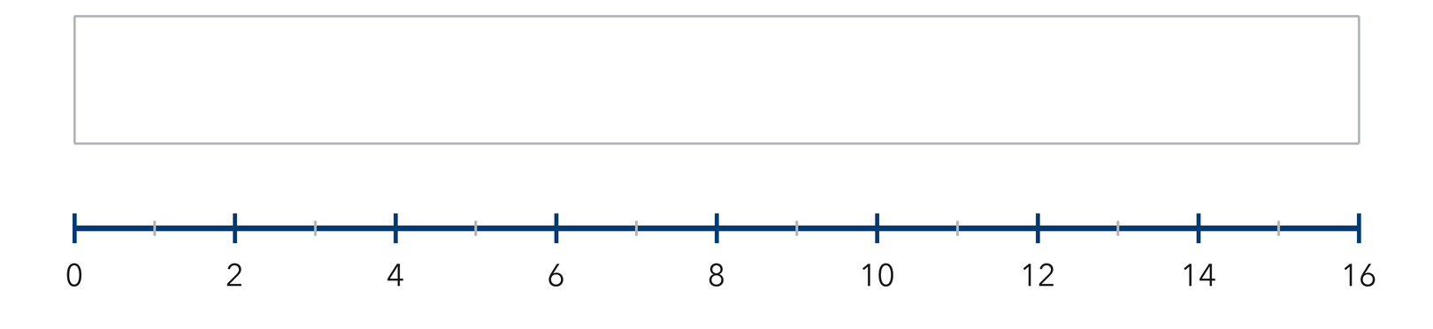
Answer ______________________________
SHOW YOUR THINKING

3. What does the length of the box (from Q1 to Q3) tell you about the middle 50% of the data?
Answer ______________________________
SHOW YOUR THINKING

4. Use the ordered data 6, 10, 14, 18, 22, 26, 30.
a. Minimum ______
b. Q1 ______
c. Median ______
d. Q3 ______
e. Maximum ______
Answer ______________________________
SHOW YOUR THINKING


5. Apple Harvest. Seven baskets hold 24, 31, 19, 40, 27, 36, 22 apples. Find the five-number summary.
Answer ______________________________
SHOW YOUR THINKING

6. Swim Times. Eight swim times in seconds are 41, 47, 39, 53, 45, 49, 43, 55. Find the five-number summary.
Answer ______________________________
SHOW YOUR THINKING

7. Reading the Box. A box plot of daily temperatures shows minimum 48, quartile 1 at 56, median 61, quartile 3 at 70, maximum 82. Find the width of the box and explain what share of the days falls inside it.
Read the box plot. This is the temperature plot the problem describes.​
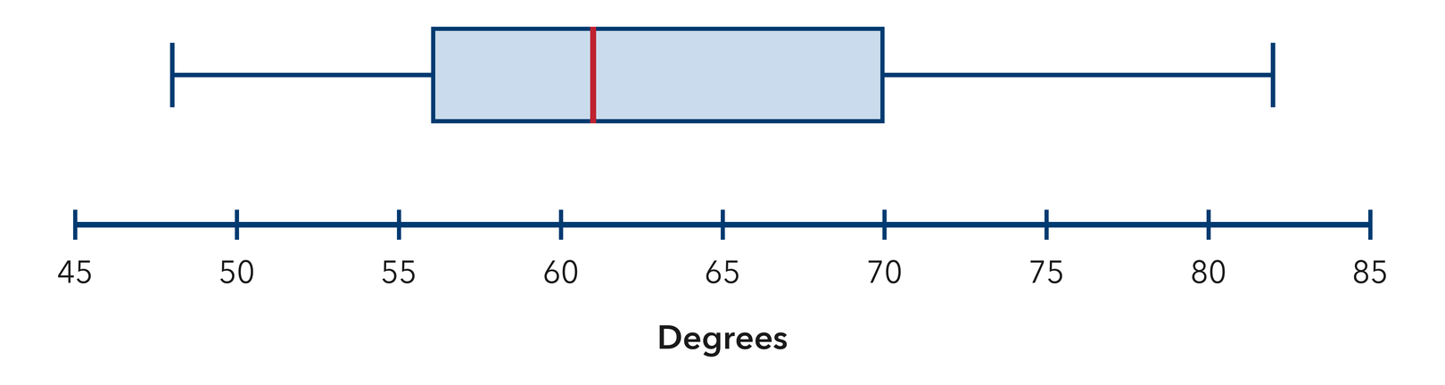
Answer ______________________________
EXPLAIN WITH MATHEMATICAL EVIDENCE


8. Halfway Claim. Percy says the median of a box plot always sits exactly halfway between Q1 and Q3. Use the summary 12, 15, 17, 25, 30 to explain why he is wrong.
Sentence Frame: "I know this because..."
Answer ______________________________
EXPLAIN WITH MATHEMATICAL EVIDENCE

9. Find the five-number summary of 20, 34, 27, 41, 23, 38, and 30.
Answer min, Q1, median, Q3, max
SHOW YOUR THINKING

10. A box plot has min 5, Q1 11, median 15, Q3 22, max 28. How long is the box?
Answer ______________________________ units
SHOW YOUR THINKING

11. Eight Values. Find the five-number summary of 62, 55, 71, 58, 66, 74, 60, and 68.
Answer min, Q1, median, Q3, max
SHOW YOUR THINKING

12. Find the Mistake. Devon included the median in both halves when finding Q1 and Q3 for a set of 7 values. Explain why that is wrong.
Sentence Frame: "I know this because..."
Answer ______________________________ the explanation
EXPLAIN WITH MATHEMATICAL EVIDENCE

Spiral review
13. From Lesson 2-3 Session 2. Find the median of 11, 17, 23, 29.
Answer ______________________________
SHOW YOUR THINKING

14. From Lesson 2-2 Session 2. Bars of height 2, 4, 9, 4, 2 describe what shape?
Answer ______________________________
RECORD YOUR RESPONSE

15. Grade 5. Find 9.6 ÷ 8.
Answer ______________________________
SHOW YOUR THINKING

Test practice
16. The whiskers of a box plot reach the —
□ A. minimum and maximum
□ B. quartiles
□ C. mean
□ D. median

17. Q3 is the median of the —
□ A. lower half | □ B. upper half
□ C. whole set | □ D. box

18. For 10, 20, 30, 40, 50, 60, 70, what is Q1?
□ A. 10 | □ B. 30
□ C. 20 | □ D. 40

Check and revise
CHECK YOUR MATHEMATICS  Use consistent units and the same measure when comparing two groups.  Every part answered / Work shown / Units labeled when needed | HOW DID IT GO?  I can do this:  Independently / With a hint / With help  Question to revisit: ______
One correction or question I want to discuss: __________________________________
Check one response against the data. State which measure or feature supports your answer.

