Name |  | Date |  | Period
LESSON 5-8 · SESSION 1 · GUIDED PRACTICE
Surface Area of Pyramids
TODAY’S GOAL I can add a pyramid’s base area and triangular face areas.

THE IDEA
A pyramid has one base and triangle sides. Slant height is the height of a side triangle, measured along its face. Add the base and all the triangles.
Tip: if only the slanted faces are covered, leave out the base. If there is a price per square unit, multiply the area by the price.

EXAMPLE | Read each step.
Example: A square pyramid has a base 10 cm on each side. Each triangle has a slant height of 7 cm.
1 | Find the base: 10 × 10 = 100 cm².
2 | Find one triangle: 10 × 7 ÷ 2 = 35 cm².
3 | Find all four triangles: 4 × 35 = 140 cm².
4 | Add: 100 + 140 = 240. The surface area is 240 cm².
Check: Did I count the base plus all 4 triangles, using the slant height?

WORDS TO KNOW | Read the meaning; find the word in a problem.
pyramid  Spanish: pirámide | A solid with one base and triangle sides that meet at a point. | square base + 4 triangles
base  Spanish: base | The flat bottom face of the pyramid. | the square on the net
slant height  Spanish: altura inclinada | The height of a side triangle, measured along its slanted face. | used in ½ × b × slant
lateral face  Spanish: cara lateral | One of the side triangles of a pyramid. It is not the base. | 4 on a square pyramid
apex  Spanish: ápice | The top point where all the side faces meet. | tip of the pyramid

TRY IT TOGETHER | Use the example above to complete each part.
1. Paper Pyramid Replica
A class model of a pyramid has a square base 16 cm on each side. Every triangular face has a slant height of 15 cm.
a. Net. Sketch the net: a square with a triangle on each side. Faces in all: ______
b. Base. Area of the square base: ______ × ______ = ______ cm²
c. Faces. ONE triangle: ½ × ______ × ______ = ______ cm² All four: ______ cm²
d. Total. Surface area of the model: ______ cm²

e. Net. Draw the net on the grid below, label every face with its dimensions, and mark the matching pairs.​ | 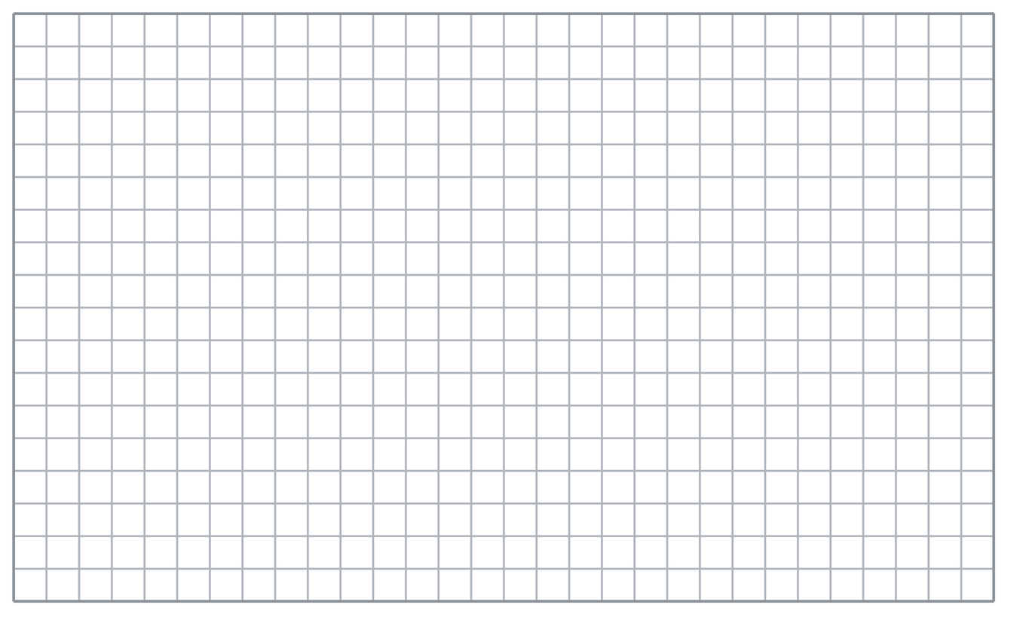

TURN AND TALK
Why do you use the slant height instead of the pyramid’s straight-up height?

PRACTICE WITH A PARTNER | Take turns solving and explaining. Check each other’s work.
2. Gift Topper. A gift topper is a square pyramid with a base 8 in. on each side and a slant height of 11 in.  a. Base area __________  b. Surface area __________ | 3. Pyramid Tent. A pyramid tent has a square base 6 ft on each side and a slant height of 5 ft. The floor of the tent is open ground, not fabric.  a. Area of ONE fabric panel __________  b. Fabric for the whole tent __________
  PARTNER TALK
  For this right square pyramid, how can you show the four triangular faces are congruent?
  PARTNER TALK
  How does leaving out the base change what you add together? Explain.

4. Trophy Top. The top of a trophy is a square pyramid with a base 12 cm on each side and a slant height of 10 cm. Every face is plated, base included.
a. Base area __________
b. Surface area __________

PARTNER TALK
Which measure belongs to the square, and which one belongs to the triangles?

PRACTICE ON YOUR OWN | Show your steps. Label quantities. Use a hint if you need one.
5. Roof Cap. A roof cap is a square pyramid with a base 20 ft on each side and a slant height of 26 ft. Every face will be shingled, including the bottom.  Sketch a net, then find the surface area of the roof cap.  Hint Find the square base, then one triangular face, then think about how many of those faces there are.  Answer surface area in ft² | Net. Draw the net on the grid below, label every face with its dimensions, and mark the matching pairs.​
  Show your work.

6. Glass Pyramid. A glass pyramid has a square base 30 m on each side and a slant height of 25 m. Only the four slanted faces are made of glass.  Find the total area of glass in the pyramid.  Hint Only the slanted faces are glass, so the base does not belong anywhere in this total.  Answer glass area in m² | 7. Priya’s Pyramid. A square pyramid has a base 18 cm on each side and a slant height of 13 cm. Priya says its surface area is 117 cm².  Justify or correct Priya’s answer.  Hint Priya’s number matches one piece of the net. Which pieces are still missing from her total?  Answer true surface area (Is Priya right?)

8. Sand Mold. A sand mold is a square pyramid with a base 16 in. on each side and a slant height of 10 in. Every face is counted, base included.  Sketch a net, then find the surface area of the mold.  Hint Find the square base, then one triangular face, then count how many of those faces the net has.  Answer surface area in in² | Net. Draw the net on the grid below, label every face with its dimensions, and mark the matching pairs.​
  Show your work.

9. Lantern Shade. A lantern shade is a square pyramid with a base 15 cm on each side and a slant height of 14 cm. Only the four slanted faces are covered in paper.  Find the area of paper the shade needs.  Hint Only the slanted faces are covered, so the base square stays out of this total.  Answer paper area in cm² | 10. Square Pyramid. A square pyramid has a base 10 cm on each side. Each triangular face has a base of 10 cm and a slant height of 12 cm. Find the surface area.  Hint How does the area of this shape compare to the area of a rectangle with the same base and height?  Answer cm²

11. Monument Model. A square pyramid has a base 6 in. on a side and a slant height of 9 in. Find the surface area.  Hint How does the area of this shape compare to the area of a rectangle with the same base and height?  Answer in² | 12. Two Parts. A square pyramid has a base 8 m on a side and a slant height of 10 m.  a. Find the base area. __________  b. Find the total area of the four triangles. __________  Hint How does the area of this shape compare to the area of a rectangle with the same base and height?  Answer: label your responses a and b

FIND AND FIX THE MISTAKE | Explain what went wrong, then solve it correctly.
13. Read the student’s work. Identify the incorrect step, explain why it is incorrect, and show a correct solution.
Sentence Frame: "I know this because..."

ETHAN’S WORK
A square pyramid has a base 22 in. on each side and a slant height of 17 in. Ethan wrote: ‘SA = 484 + 187 = 671 in².’
a. Explain the mistake. Both of Ethan’s numbers are correct areas. How many triangles does the net have? | b. Show correct work  Correct answer (with units, if needed)
  Write the correct steps and label the answer. Check that it fits the problem.

PUT THE IDEAS TOGETHER | Solve each part. Explain how the steps connect.
Sentence Frame: "I know this because..."
14. Museum Model. A square pyramid model has a base 14 in. on a side and a slant height of 15 in. Gold foil covers the four triangular faces at $0.04 per square inch.
a. Find the base area and the area of one triangular face.
b. Find the total surface area.
c. Find the cost of the foil for the four triangles only.

Answer both areas, the total, and the cost
CHOOSE THE BEST ANSWER | Solve first, then mark one answer for each question.
15. A square pyramid has how many triangular faces? | 16. For triangles you use the pyramid’s —
  □ A. 4 | □ B. 3 | □ C. 5 | □ D. 6
  □ A. vertical height. | □ B. slant height. | □ C. base area. | □ D. volume

17. A base of 25 cm² plus four triangles of 20 cm² each gives — | 18. A pyramid’s surface area is the base area plus the area of its —
  □ A. 500 cm² | □ B. 45 cm² | □ C. 105 cm² | □ D. 80 cm²
  □ A. vertices | □ B. rectangles | □ C. edges | □ D. triangular faces.

REVIEW EARLIER SKILLS | Show the steps you remember; check your result.
19. From Lesson 5-7 Session 2. Two triangular ends of 20 cm² each contribute what total?  Answer (include labels or units) | 20. From Lesson 5-7 Session 1. A cube has edges of 3 m. Find its surface area.  Answer (include labels or units)

21. From Lesson 4-4 Session 1. Find 45% of 200.  Answer (include labels or units) | 22. From Lesson 3-6 Session 1. Convert 8 yards to feet.  Answer (include labels or units)

SHOW WHAT YOU LEARNED | Solve on your own, then check your answer.
23. Museum Model. A museum model is a square pyramid with a base 24 in. on each side and a slant height of 25 in. Every face is covered, base included.
a. Area of the square base __________
b. Surface area of the model __________
Hint Add the base to all four slanted faces. The slant height belongs to the triangles, not to the square.

Answer (include labels or units)

□ 4 — Can teach it | □ 3 — Got it | □ 2 — Need hint | □ 1 — Need help
Mark one confidence box. Star a problem you can explain. If you need help, write its number: _____.

