Lesson 7-5 · Session 1

Plotting Points on the Coordinate Plane
Version 2 / Regular
Name ______________________________ Date ______________ Period ______
Maryland Standard 6.NS.C.6c · Learning target — I can plot a point with rational coordinates and name the quadrant it lies in.
Show a model, calculation, or explanation. Answer every part and label units when needed.
Exercises 1–12 earn 1 point for a correct response and 1 for supporting work. Spiral Review and Test Practice earn 1 point each.
Learn from a model
REMEMBER  • A coordinate point (x, y) tells you how far to move right/left (x) and up/down (y) from the origin (0,0).  • The plane is divided into 4 quadrants by the x-axis and y-axis.  • Watch out — always move along the x-axis first; reversing the order lands you in the wrong place.  • Check it — the signs of the two coordinates name the quadrant before you even plot. | WORKED EXAMPLE  Plotting a Point with Rational Coordinates Plot the point (−3.5, 2.5) on a coordinate plane and name the quadrant it lands in.  Step 1 Start at the origin, the point where the two axes cross.  Step 2 The x-coordinate is −3.5, so move left three and a half units along the x-axis.  Step 3 The y-coordinate is 2.5, so move up two and a half units from there.  Step 4 Left and up together land the point in the upper left section. Label it.  Answer The point (−3.5, 2.5) sits in Quadrant II — left of the y-axis and above the x-axis.

Practice
1. Plot the point (3, −2) on a coordinate plane. Which quadrant is it in? ______
Coordinate plane. Plot and label the points on the plane below.​
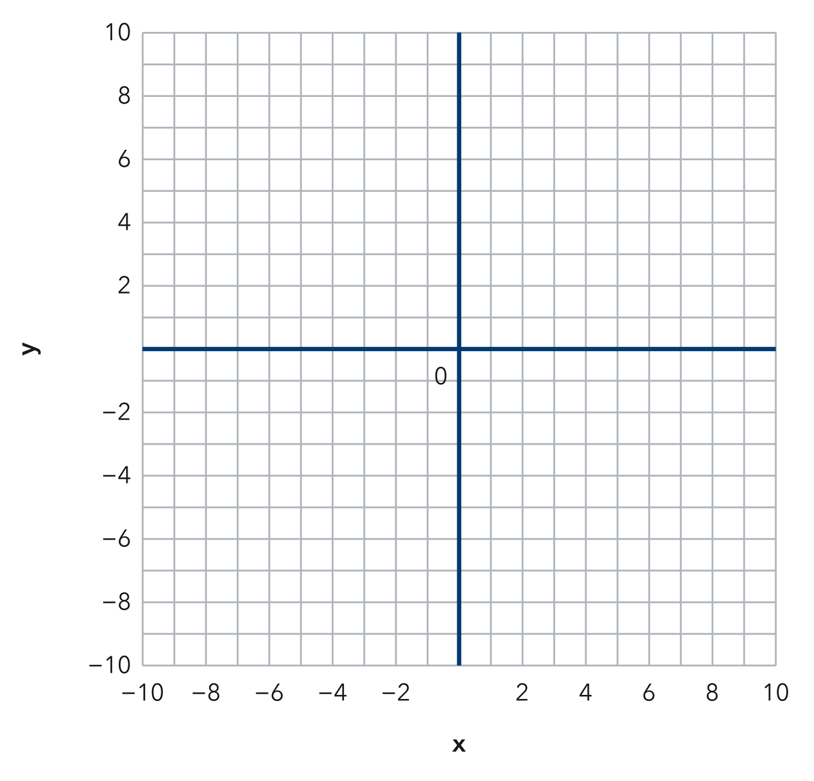
Answer ______________________________
SHOW YOUR THINKING


2. Plot the point (−4, 5). Which quadrant is it in? ______
Answer ______________________________
PLOT AND LABEL YOUR POINTS
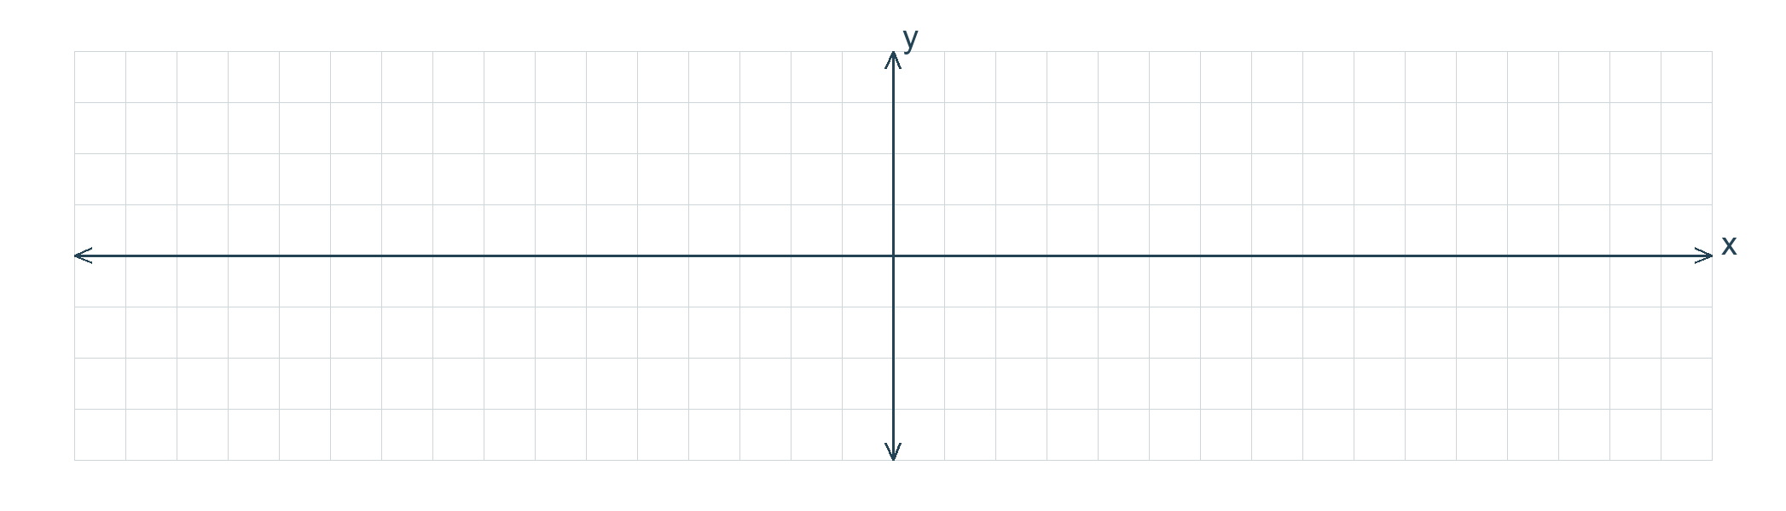

3. Name the coordinates of a point in Quadrant III (where both x and y are negative).
Answer ______________________________
RECORD YOUR RESPONSE

4. Write each answer on the line.
a. Quadrant of (−6, −1): ______
b. Quadrant of (2, 8): ______
c. Quadrant of (9, −7): ______
d. The point (0, −4) sits on which axis? ______
e. The ordered pair for the origin is ______
Answer ______________________________
SHOW YOUR THINKING


5. Camp Map. On a camp map the flagpole is the origin. Plot the mess hall at (−7, 4) and the dock at (5, −8), then name the quadrant for each one.
Coordinate plane. Plot and label the points on the plane below.​
Answer ______________________________
RECORD YOUR RESPONSE

6. Rational Point. Plot the point (−2.5, −6.5) on a coordinate plane, then name the quadrant it lands in.
Coordinate plane. Plot and label the points on the plane below.​
Answer ______________________________
RECORD YOUR RESPONSE

7. Two Pairs. Plot (−3, 8) and (8, −3) on one grid. Explain why they do not name the same point.
Sentence Frame: "I know this because..."
Coordinate plane. Plot and label the points on the plane below.​
Answer ______________________________
EXPLAIN WITH MATHEMATICAL EVIDENCE


8. Tevin says every point with a negative number in it lands in Quadrant III. Explain why he is wrong, then give one point with a negative number that lands in Quadrant II.
Sentence Frame: "I know this because..."
Answer ______________________________
EXPLAIN WITH MATHEMATICAL EVIDENCE

9. Name the quadrant of (−6, −2) and of (3, 8).
Answer ______________________________ both quadrants
RECORD YOUR RESPONSE

10. Name the quadrant of (−1.5, 4.5).
Answer ______________________________ the quadrant
RECORD YOUR RESPONSE

11. Order Matters. Explain why (−7, 2) and (2, −7) are different points, and name each quadrant.
Sentence Frame: "I know this because..."
Answer ______________________________ your explanation and both quadrants
EXPLAIN WITH MATHEMATICAL EVIDENCE

12. Find the Mistake. Asked to plot (−2, 5), Bo moved up 2 and left 5. Explain the mistake.
Answer ______________________________ the mistake
EXPLAIN WITH MATHEMATICAL EVIDENCE

Spiral review
13. From Lesson 7-4 Session 1. Which is greater, −5 or −8?
Answer ______________________________
SHOW YOUR THINKING

14. From Lesson 6-7 Session 1. Find the GCF of 18 and 27.
Answer ______________________________
SHOW YOUR THINKING

15. From Lesson 4-4 Session 1. Find 30% of 220.
Answer ______________________________
SHOW YOUR THINKING

Test practice
16. The point (−3, −9) lies in —
□ A. Quadrant IV
□ B. Quadrant I
□ C. Quadrant II
□ D. Quadrant III

17. A point with a positive x and a negative y lies in —
□ A. Quadrant IV
□ B. Quadrant I
□ C. Quadrant II
□ D. Quadrant III

18. In (x, y), the second number moves you —
□ A. right or left
□ B. up or down
□ C. diagonally
□ D. nowhere

Check and revise
CHECK YOUR MATHEMATICS  Check coordinate order and which sign changes across the named axis.  Every part answered / Work shown / Units labeled when needed | HOW DID IT GO?  I can do this:  Independently / With a hint / With help  Question to revisit: ______
One correction or question I want to discuss: __________________________________
Check signs, scale, and labels. Use a number line or coordinate grid to verify one response.

