Lesson 7-6 · Session 1

Distance Between Points on a Grid
Version 2 / Regular
Name ______________________________ Date ______________ Period ______
Maryland Standard 6.NS.C.8 · Learning target — I can find the distance between two points that share a coordinate.
Show a model, calculation, or explanation. Answer every part and label units when needed.
Exercises 1–12 earn 1 point for a correct response and 1 for supporting work. Spiral Review and Test Practice earn 1 point each.
Learn from a model
REMEMBER  • When two points share the same x-coordinate or same y-coordinate, find the distance using the difference (absolute value) between the other coordinates.  • Count grid squares to check your answer.  • Watch out — distance uses the coordinate that changes, not the one that stays the same.  • Check it — count the units on a sketch to confirm your arithmetic. | WORKED EXAMPLE  Finding the Distance Between Two Points on a Vertical Line On a map where each unit is one kilometer, find the distance from J(−4.5, 8.5) to K(−4.5, −3.5).  Step 1 The x-coordinates match, so both points sit on one vertical line.  Step 2 The y-coordinates have different signs, so the trip crosses the x-axis.  Step 3 Distance from 0 for each y-coordinate: |8.5| = 8.5 and |−3.5| = 3.5  Step 4 Join the two distances: 8.5 + 3.5 = 12  Answer The points are 12 units apart, so the trip is 12 kilometers straight up and down.

Practice
1. Find the distance between (2, 3) and (2, −5) (same x-coordinate).
Answer ______________________________
SHOW YOUR THINKING


2. Find the distance between (−4, 1) and (6, 1) (same y-coordinate).
Answer ______________________________
SHOW YOUR THINKING

3. Plot both pairs of points from problems 1 and 2 and count the grid squares to check your answers.
Coordinate plane. Plot and label the points on the plane below. Then count the grid squares between each pair.​
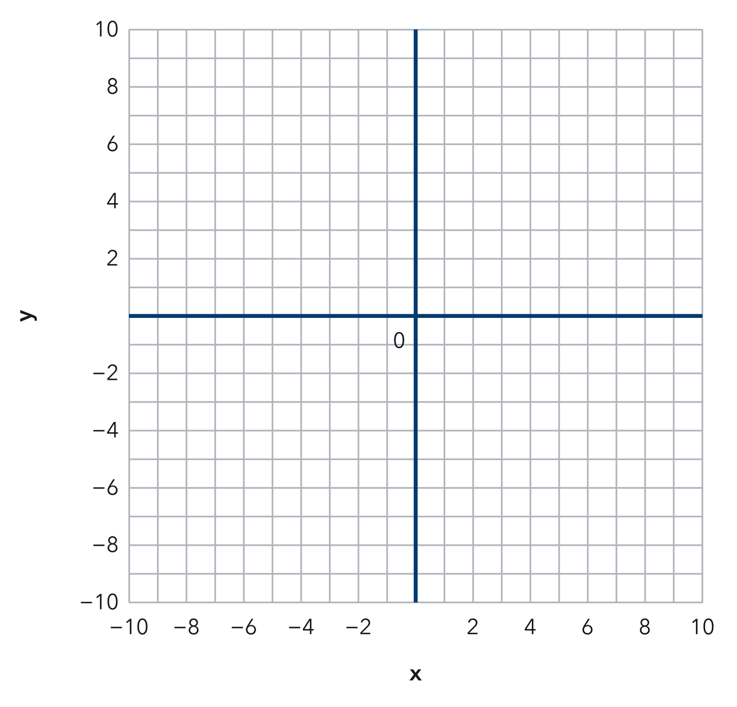
Answer ______________________________
SHOW YOUR THINKING

4. Write each distance on the line.
a. Distance between (5, 9) and (5, −3): ______
b. Distance between (−7, 2) and (8, 2): ______
c. Distance between (−1, −4) and (−1, −16): ______
d. |−11| + |6| = ______
e. Distance between (3, 7) and (3, 20): ______
Answer ______________________________
SHOW YOUR THINKING


5. Two Hydrants. Two hydrants sit at (−9, 4) and (−9, −10) on a city grid where each unit is one meter. Find the distance between them.
Answer ______________________________
SHOW YOUR THINKING

6. Straight Walk. Malia walks straight from (−12, 6) to (7, 6). Each unit is one block. Find how far she walks, then tell which coordinates you used.
Answer ______________________________
SHOW YOUR THINKING

7. Missing Corner. Point R sits at (−5, 11). Point S sits 18 units directly below R. Write the coordinates of point S.
Answer ______________________________
SHOW YOUR THINKING

8. Andre found the distance from (4, −8) to (4, 5) by subtracting 5 from 8 and writing 3 units. Explain the mistake, then show the correct distance.
Answer ______________________________
EXPLAIN WITH MATHEMATICAL EVIDENCE


9. Find the distance from (7, 1) to (7, 12).
Answer ______________________________ units
SHOW YOUR THINKING

10. Find the distance from (−8, 3) to (4, 3).
Answer ______________________________ units
SHOW YOUR THINKING

11. Same Side. Find the distance from (−5, −2) to (−5, −11).
Answer ______________________________ units
SHOW YOUR THINKING

12. Find the Mistake. For (2, 6) to (2, −4), Tom wrote 2 units. Explain the mistake.
Answer ______________________________ the mistake and the distance
EXPLAIN WITH MATHEMATICAL EVIDENCE

Spiral review
13. From Lesson 7-5 Session 2. Reflect (−2, 7) across the y-axis.
Answer ______________________________
SHOW YOUR THINKING

14. From Lesson 6-8 Session 1. Simplify 6(m + 1) + 2m.
Answer ______________________________
SHOW YOUR THINKING

15. From Lesson 4-4 Session 1. Find 85% of 200.
Answer ______________________________
SHOW YOUR THINKING

Test practice
16. The distance from (0, 5) to (0, −5) is —
□ A. 5 | □ B. 0
□ C. 10 | □ D. 25

17. Two points with the same y-value lie on a —
□ A. circle
□ B. vertical line
□ C. diagonal
□ D. horizontal line

18. The distance from (−9, 2) to (−3, 2) is —
□ A. 6 | □ B. 12
□ C. −6 | □ D. 27

Check and revise
CHECK YOUR MATHEMATICS  The horizontal or vertical shortcut applies when one coordinate is the same.  Every part answered / Work shown / Units labeled when needed | HOW DID IT GO?  I can do this:  Independently / With a hint / With help  Question to revisit: ______
One correction or question I want to discuss: __________________________________
Check signs, scale, and labels. Use a number line or coordinate grid to verify one response.

