Lesson 9-2 · Session 1

From Table to Graph
Version 2 / Regular
Name ______________________________ Date ______________ Period ______
Maryland Standard 6.EE.C.9 · Learning target — I can turn a table of values into points and plot them on a graph.
Show a model, calculation, or explanation. Answer every part and label units when needed.
Exercises 1–12 earn 1 point for a correct response and 1 for supporting work. Spiral Review and Test Practice earn 1 point each.
Learn from a model
REMEMBER  • Each row of a table of values becomes one ordered pair (x, y) to plot on a coordinate graph.  • Plot several points from the table, then look for a pattern (often a straight line).  • Watch out — a fee shifts the line up so it no longer starts at the origin.  • Check it — every plotted point should satisfy the rule from the table. | WORKED EXAMPLE  Turning a Table into Points on a Graph A rental site charges $7 per movie. Make a table for 1, 2, and 3 movies, then list the points to plot.  Step 1 Independent: number of movies (x). Dependent: total cost (y).  Step 2 Multiply each x by the rate: 1 7 · 2 14 · 3 21  Step 3 Write each row as an ordered pair (x, y): (1, 7), (2, 14), (3, 21).  Step 4 Plot each pair: move right along the x-axis first, then up to the y value.  Answer Points to plot: (1, 7), (2, 14), and (3, 21). They rise in a straight path.

Practice
1. Using the table x: 1,2,3 y: 2,4,6 — write the three ordered pairs. ______
Answer ______________________________
SHOW YOUR THINKING


2. Plot the three ordered pairs from problem 1 on a coordinate plane.
Graph. Plot the three ordered pairs and draw the line through them and the origin.​
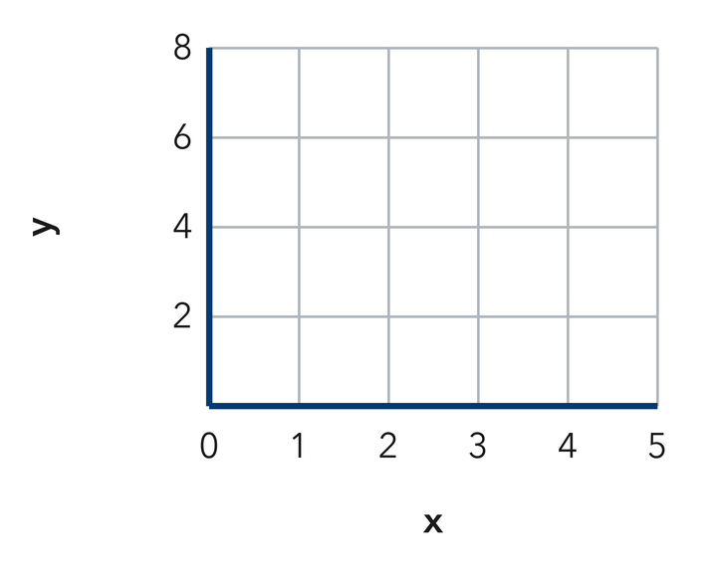
Answer ______________________________
SHOW YOUR THINKING

3. Do the points in problem 1 form a straight line? What does this tell you about the relationship?
Answer ______________________________
SHOW YOUR THINKING

4. Write each table row as an ordered pair (x, y).
a. x = 3 and y = 15 ______
b. x = 6 and y = 12 ______
c. x = 0 and y = 0 ______
d. x = 5 and y = 45 ______
e. x = 10 and y = 70 ______
Answer ______________________________
SHOW YOUR THINKING


5. Trail Mix. A corner shop sells trail mix for $4 a pound. Make a table for 2, 3, and 6 pounds, then write the three ordered pairs.
Answer ______________________________
SHOW YOUR THINKING

6. Stair Climb. Kwame climbs 14 stairs for every floor of his apartment building. Write the ordered pairs for 2, 5, and 8 floors, then explain what the middle point means.
Answer ______________________________
EXPLAIN WITH MATHEMATICAL EVIDENCE


7. Lemonade Stand. A stand charges $3 for each cup of lemonade. Plot the points for 1, 2, 4, and 6 cups, label each axis with its quantity, then tell whether the points lie on a straight path.
Graph. Plot the four points, label each one, and draw the line through the origin.​
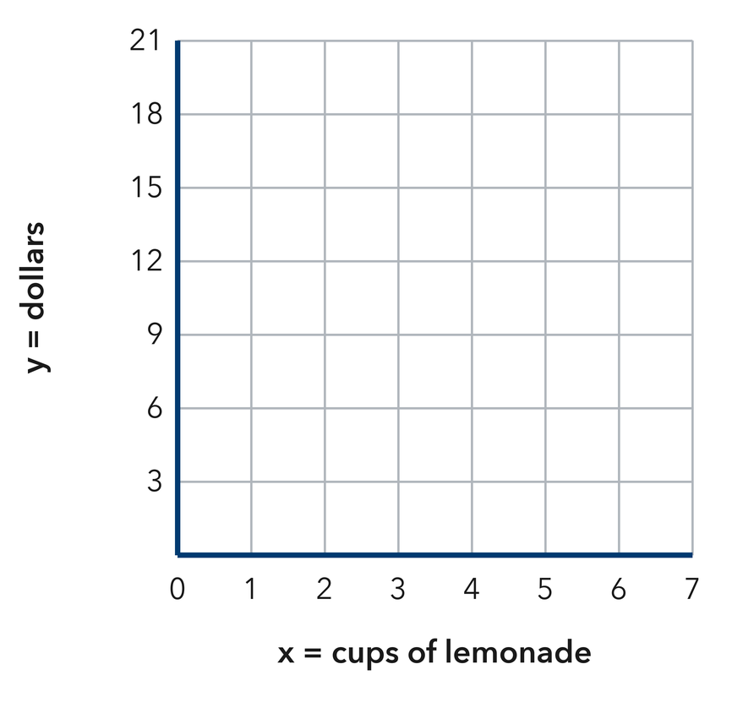
Answer ______________________________
SHOW YOUR THINKING

8. A student plotted the pairs from the table x: 2, 4, 6 and y: 10, 20, 30 by using each x-value vertically and each y-value horizontally. Explain the mix-up, then describe how to plot (4, 20).
Answer ______________________________
EXPLAIN WITH MATHEMATICAL EVIDENCE

9. At $6 per book, list the ordered pairs for 1, 2, and 4 books.
Answer ______________________________ three pairs
SHOW YOUR THINKING

10. A table gives (1, 11), (2, 22), and (3, 33). Describe the rule and the shape of the graph.
Answer ______________________________ rule and shape
RECORD YOUR RESPONSE

11. With a Fee. A plan charges $10 plus $4 per month. List the pairs for 1, 2, and 3 months.
Answer ______________________________ three pairs
SHOW YOUR THINKING

12. Find the Mistake. For x = 2 and y = 16, Cass plotted (16, 2). Explain the mistake.
Answer ______________________________ the mistake
EXPLAIN WITH MATHEMATICAL EVIDENCE

Spiral review
13. From Lesson 9-1 Session 2. A rule is “multiply by 6, then add 2.” Find y when x = 5.
Answer ______________________________
SHOW YOUR THINKING

14. From Lesson 8-2 Session 1. Solve x + 34 = 61.
Answer ______________________________
SHOW YOUR THINKING

15. From Lesson 6-6 Session 1. Simplify 6n + 7 + 2n.
Answer ______________________________
SHOW YOUR THINKING

Test practice
16. A row of x = 7, y = 35 becomes —
□ A. (42, 0) | □ B. (35, 7)
□ C. (7, 7) | □ D. (7, 35)

17. A graph with a starting fee does not pass through the —
□ A. origin
□ B. x-axis
□ C. y-axis
□ D. first quadrant

18. At $12 per hour, 4 hours gives the pair —
□ A. (48, 4) | □ B. (4, 48)
□ C. (4, 12) | □ D. (12, 4)

Check and revise
CHECK YOUR MATHEMATICS  Check every pair using the same rule and label quantities and units.  Every part answered / Work shown / Units labeled when needed | HOW DID IT GO?  I can do this:  Independently / With a hint / With help  Question to revisit: ______
One correction or question I want to discuss: __________________________________
Substitute one input-output pair into your rule. Check units and whether your answer fits the situation.

