Name Date Period
Unit 4 · End-of-Unit Assessment - Form A

Working with Percents
Lessons 4.1–4.5. Show your work and label units. Use the model when there is one.

SHOW WHAT YOU KNOW show your work · label units

1. Seats. Each square is one seat. The shaded squares are full seats. (2 points)  a. What percent of the seats are full? %  b. What percent are empty? % | 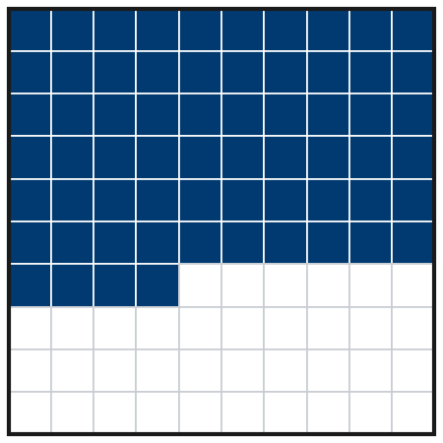

2. Sunflower. A sunflower was 20 cm tall in June. In July it is 46 cm tall. July’s height is what percent of June’s height? (3 points)
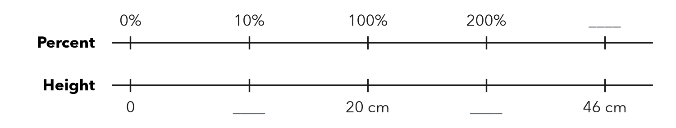

Show your work.
Answer %

3. Same Value. Complete the table. (3 points)
Fraction | Decimal | Percent
3/20
 | 0.8
 |  | 62%

4. Select All. Which numbers are greater than 0.6? Check all that apply. (2 points)
□ A 5/8 | □ B 58%
□ C 0.65 | □ D 3/5
□ E 61%

5. Games Won. A team won 17 of 40 games. Between which two benchmarks (0%, 25%, 50%, 75%, 100%) is that? Which one is it closer to? (2 points)

Show your work.
Between / closer to

6. Estimate. Estimate 31% of 590. Show the friendly numbers you used. (2 points)

Show your work.
About

7. Sale. A $45 game is 20% off. How much money do you save? What is the sale price? (3 points)
a. You save dollars
b. Sale price dollars

Show your work.

8. Free Throws. Kai made 49 of 70 free throws. Lena made 18 of 24. Who has the better rate? Use percents. (3 points)

Show your work.
Better rate

9. Club. 27 students is 60% of the club. How many students are in the club? Complete the double number line. (3 points)
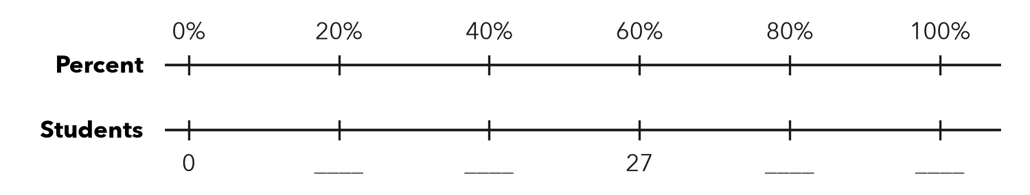

Show your work.
Whole students

10. Bikes. A store sold 42 bikes. That is 35% of all its bikes. Which equation finds t, the total number of bikes? Then solve it. (3 points)
A 0.35 × 42 = t | B 0.35t = 42 | C 42t = 35 | D t = 42 − 35
t =

Total: ______ / 26 points

