Name Date Period
Unit 4 · End-of-Unit Assessment - Form B · Level 1

Working with Percents
Lessons 4.1–4.5. Show your work and label units. Use the model when there is one.

WORD BANK  percent (por ciento) — out of 100  whole (el entero) — all of it = 100%  part (la parte) — some of the whole | rate (la tasa) — how many out of how many  estimate (estimar) — a close answer with friendly numbers

PERCENT HELP | 1/10 = 0.1 = 10% | 1/5 = 0.2 = 20% | 1/4 = 0.25 = 25% | 1/3 = about 0.333 = about 33.3% | 1/2 = 0.5 = 50% | 3/4 = 0.75 = 75% | 1 = 1 = 100%

SHOW WHAT YOU KNOW show your work · label units

1. Seats. Each square is one seat. The shaded squares are full seats. (2 points)  Step 1 Count the shaded squares. Each square is 1%.  Step 2 Full + empty = 100%.  a. What percent of the seats are full? %  b. What percent are empty? % | 

2. Puppy. A puppy weighed 4 kg at 2 months. At 6 months it weighs 11 kg. The 6-month weight is what percent of the 2-month weight? (3 points)
Step 1 The first amount is 100%. Find 10% (or 25%) of it.
Step 2 How many of those make the new amount?
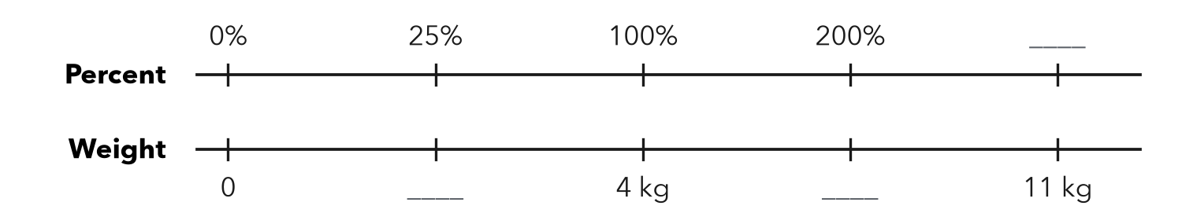

Show your work.
Answer %

3. Same Value. Complete the table. (3 points)
Step 1 Percent so decimal: move the point two places left.
Step 2 Fraction so percent: make the bottom number 100.
Fraction | Decimal | Percent
7/20
 | 0.6
 |  | 44%

4. Select All. Which numbers are greater than 0.4? Check all that apply. (2 points)
Step 1 Write every number as a percent first.
Step 2 Check only the ones that are more.
□ A 3/8 | □ B 45%
□ C 0.42 | □ D 2/5
□ E 39%

5. Games Won. A team won 47 of 80 games. Between which two benchmarks (0%, 25%, 50%, 75%, 100%) is that? Which one is it closer to? (2 points)
Step 1 Find 25% and 50% of the total.
Step 2 Is the count between them? Which is closer?

Show your work.
Between / closer to

6. Estimate. Estimate 49% of 702. Show the friendly numbers you used. (2 points)
Step 1 Round the percent and the number to friendly numbers.
Step 2 Find 10%, then build the percent.

Show your work.
About

7. Jacket. A $60 jacket is 15% off. How much money do you save? What is the sale price? (3 points)
Step 1 Find 10% of the price. Build the percent off.
Step 2 Price − savings = sale price.
a. You save dollars
b. Sale price dollars

Show your work.

8. Free Throws. Ana made 27 of 36 shots. Ben made 36 of 50. Who has the better rate? Use percents. (3 points)
Frame made %. made %. has the better rate because .

Show your work.
Better rate

9. Choir. 32 singers is 80% of the choir. How many singers are in the choir? Complete the double number line. (3 points)
Step 1 Find 20%: divide the known amount by how many 20% jumps.
Step 2 Count up by that amount to 100%.
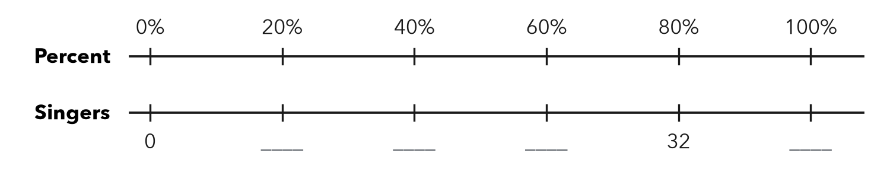

Show your work.
Whole singers

10. Library. A library lent 63 books. That is 45% of all its books. Which equation finds t, the total number of books? Then solve it. (3 points)
Step 1 The total is unknown, so the percent multiplies t.
Step 2 Divide the part by the decimal.
A 0.45 × 63 = t | B 0.45t = 63 | C 63t = 45 | D t = 63 − 45
t =

Total: ______ / 26 points

