Name Date Period
Unit 4 · End-of-Unit Assessment - Form B

Working with Percents
Lessons 4.1–4.5. Show your work and label units. Use the model when there is one.

SHOW WHAT YOU KNOW show your work · label units

1. Seats. Each square is one seat. The shaded squares are full seats. (2 points)  a. What percent of the seats are full? %  b. What percent are empty? % | 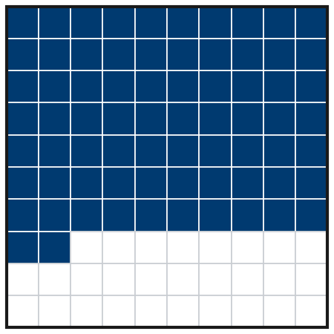

2. Puppy. A puppy weighed 4 kg at 2 months. At 6 months it weighs 11 kg. The 6-month weight is what percent of the 2-month weight? (3 points)
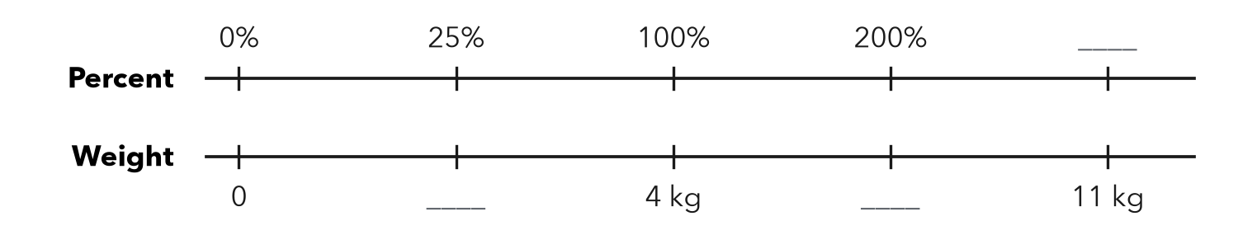

Show your work.
Answer %

3. Same Value. Complete the table. (3 points)
Fraction | Decimal | Percent
7/20
 | 0.6
 |  | 44%

4. Select All. Which numbers are greater than 0.4? Check all that apply. (2 points)
□ A 3/8 | □ B 45%
□ C 0.42 | □ D 2/5
□ E 39%

5. Games Won. A team won 47 of 80 games. Between which two benchmarks (0%, 25%, 50%, 75%, 100%) is that? Which one is it closer to? (2 points)

Show your work.
Between / closer to

6. Estimate. Estimate 49% of 702. Show the friendly numbers you used. (2 points)

Show your work.
About

7. Jacket. A $60 jacket is 15% off. How much money do you save? What is the sale price? (3 points)
a. You save dollars
b. Sale price dollars

Show your work.

8. Free Throws. Ana made 27 of 36 shots. Ben made 36 of 50. Who has the better rate? Use percents. (3 points)

Show your work.
Better rate

9. Choir. 32 singers is 80% of the choir. How many singers are in the choir? Complete the double number line. (3 points)
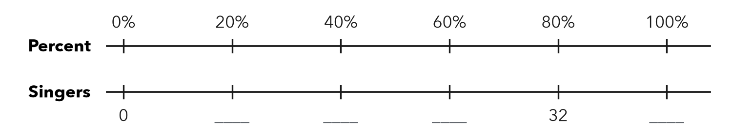

Show your work.
Whole singers

10. Library. A library lent 63 books. That is 45% of all its books. Which equation finds t, the total number of books? Then solve it. (3 points)
A 0.45 × 63 = t | B 0.45t = 63 | C 63t = 45 | D t = 63 − 45
t =

Total: ______ / 26 points

