Unit 4 · Vocabulary Cards

Unit 4 Word Wall & Study Cards
Cut on the dashed lines. Use for a word wall, partner quizzing or a ring of study cards. Every card has a picture to explain.
LESSON 4-1  percent  por ciento  Out of 100, or per hundred.  Example 40% = 40 out of 100  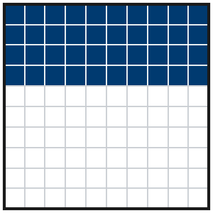  Say it: Explain the picture to a partner. | LESSON 4-1  decimal grid  cuadrícula decimal  A grid of 100 squares. Each square is 1%.  Example 62 shaded = 62%  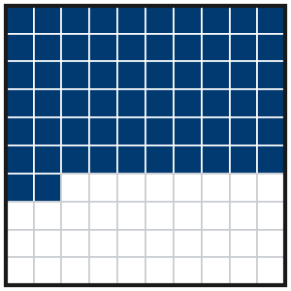  Say it: Explain the picture to a partner.
LESSON 4-1  equivalent ratio  razón equivalente  Shows the same comparison with different numbers.  Example 2 : 5 = 40 : 100  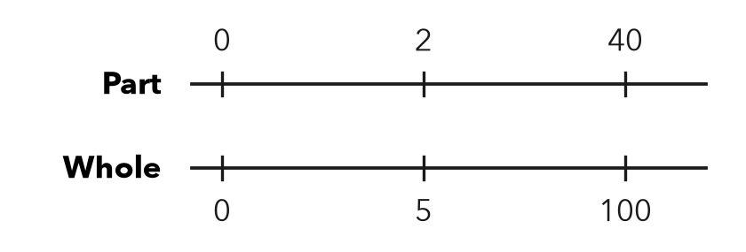  Say it: Explain the picture to a partner. | LESSON 4-1  the whole  el entero  The amount that counts as 100%.  Example last year’s total = 100%  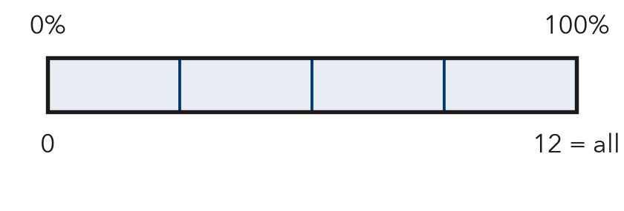  Say it: Explain the picture to a partner.
LESSON 4-1  times as much  veces tanto como  Tells how many wholes an amount makes.  Example 3 times as much = 300%  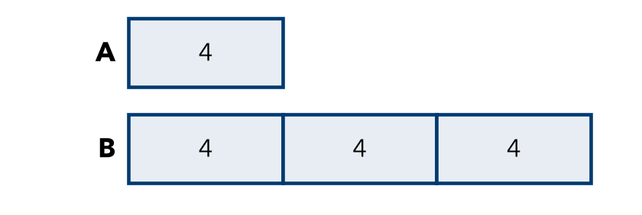  Say it: Explain the picture to a partner. | LESSON 4-1  greater than 100%  mayor que 100%  More than the whole.  Example 150% = 1.5 wholes  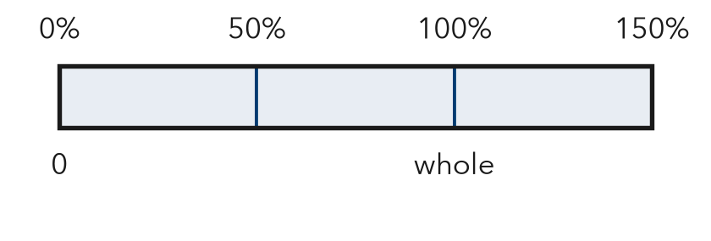  Say it: Explain the picture to a partner.
LESSON 4-2  equivalent  equivalente  Names the same amount in a different way.  Example 3/4 = 0.75 = 75%  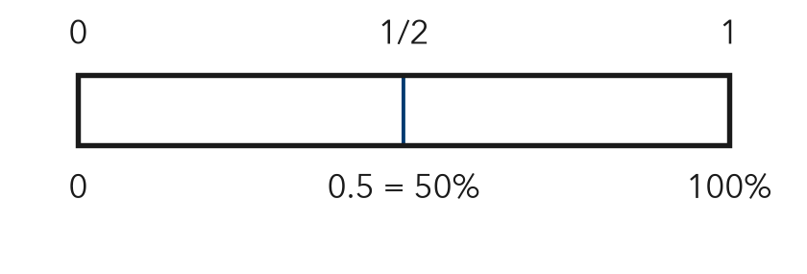  Say it: Explain the picture to a partner. | LESSON 4-2  hundredths  centésimas  Parts out of 100; the second place after the point.  Example 0.09 = 9 hundredths = 9%  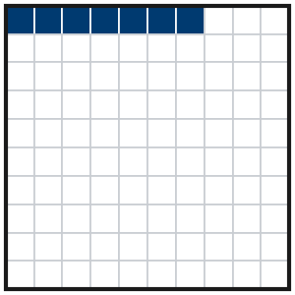  Say it: Explain the picture to a partner.
LESSON 4-2  common form  forma común  Every value written the same way before you compare.  Example 0.7, 3/5, 65% as 70%, 60%, 65%  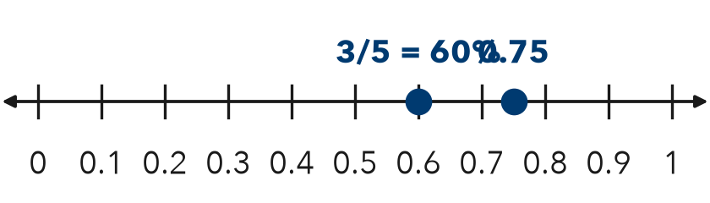  Say it: Explain the picture to a partner. | LESSON 4-2  benchmark  punto de referencia  An easy number you know well, used to compare other numbers.  Example 1/2 = 50%  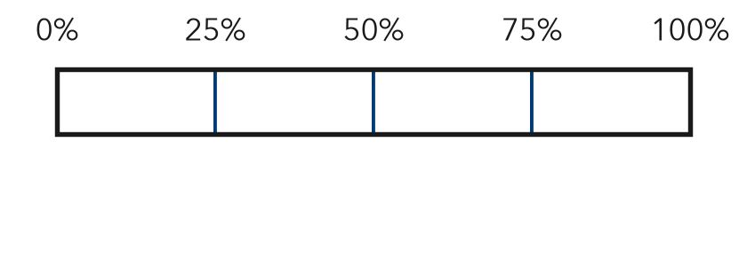  Say it: Explain the picture to a partner.
LESSON 4-2  order  orden  To list numbers from least to greatest, or greatest to least.  Example 0.2, 35%, 1/2  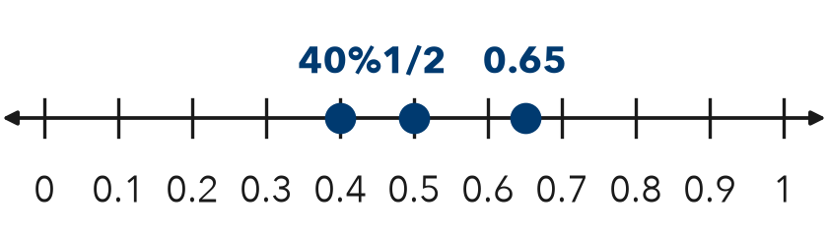  Say it: Explain the picture to a partner. | LESSON 4-3  estimate  estimar  A close answer that is not exact.  Example about 50% done  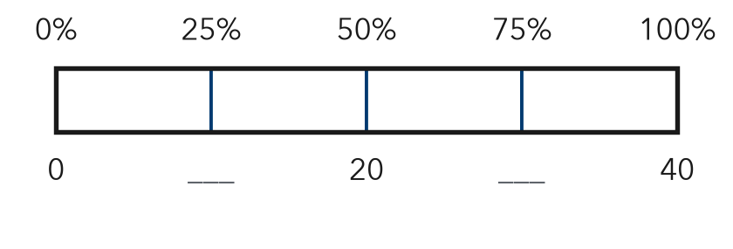  Say it: Explain the picture to a partner.
LESSON 4-3  benchmark percent  porcentaje de referencia  An easy percent to use, like 10%, 25%, 50%, or 75%.  Example 50% = one half  Say it: Explain the picture to a partner. | LESSON 4-3  compatible (friendly) numbers  números compatibles  Numbers that are easy to compute with in your head.  Example 19% of 312 ≈ 20% of 300  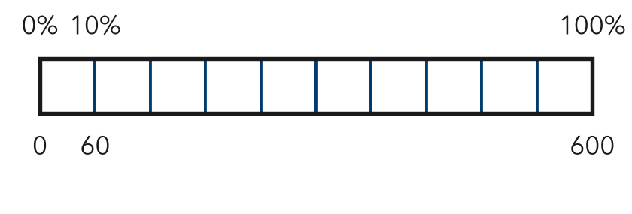  Say it: Explain the picture to a partner.
LESSON 4-3  ten percent  diez por ciento  One tenth of the whole: divide by 10.  Example 10% of 300 = 30  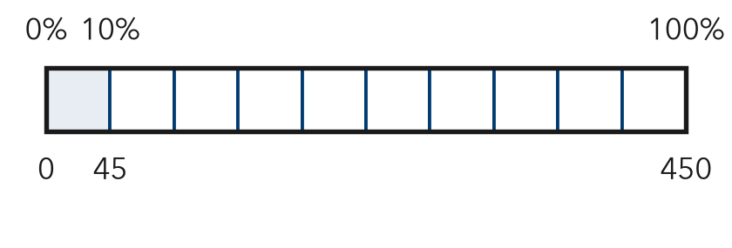  Say it: Explain the picture to a partner. | LESSON 4-4  part  parte  The piece of the whole that the percent tells about.  Example 25% of 80 is 20  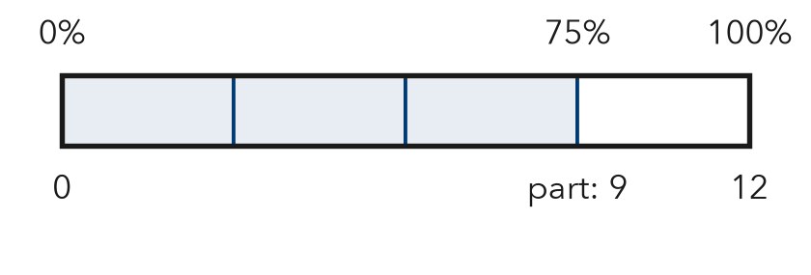  Say it: Explain the picture to a partner.
LESSON 4-4  whole  el entero  The full amount. It comes right after the word “of.”  Example in 45% of 140, the whole is 140  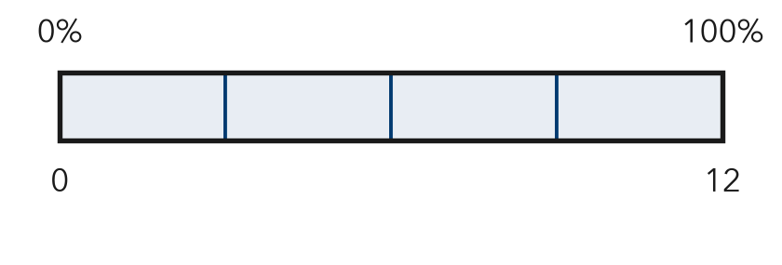  Say it: Explain the picture to a partner. | LESSON 4-4  equation  ecuación  A math sentence with an equal sign.  Example part = 0.45 × 140  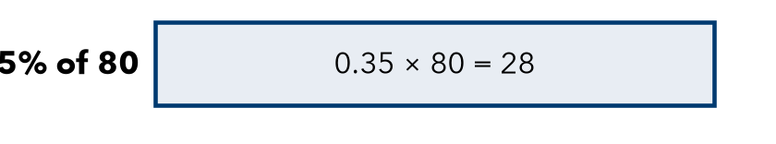  Say it: Explain the picture to a partner.
LESSON 4-4  part-to-whole ratio  razón de parte al entero  Compares part of a group to the whole group.  Example 18 out of 24 shots  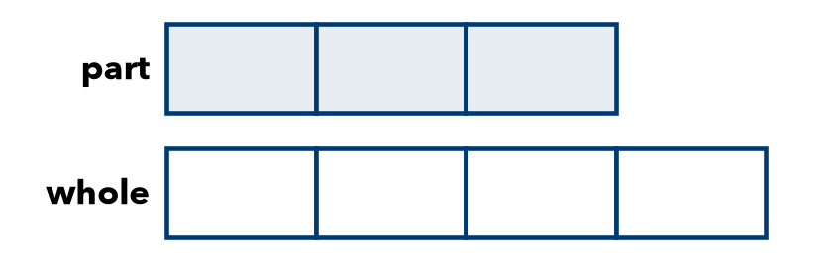  Say it: Explain the picture to a partner. | LESSON 4-4  common whole  entero común  The same total, like 100, used for every group.  Example 75/100 and 80/100  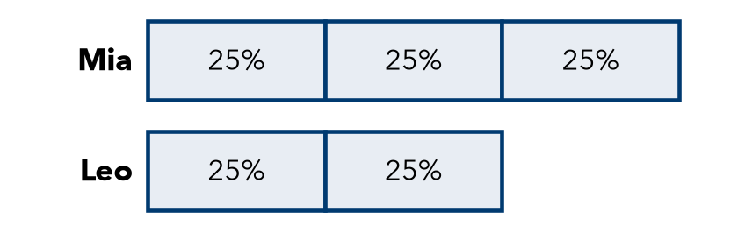  Say it: Explain the picture to a partner.
LESSON 4-4  compare  comparar  To decide which amount is greater or less.  Example 80% > 75%  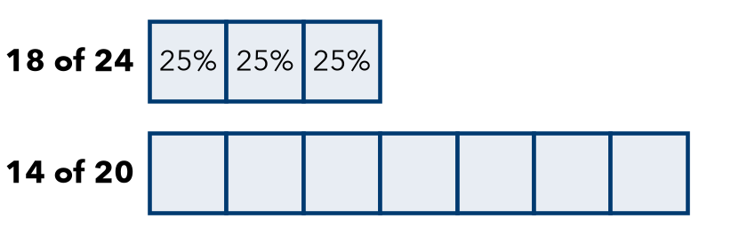  Say it: Explain the picture to a partner. | LESSON 4-5  double number line  doble recta numérica  Two lines that match amounts with percents.  Example $6 at 10%, $60 at 100%  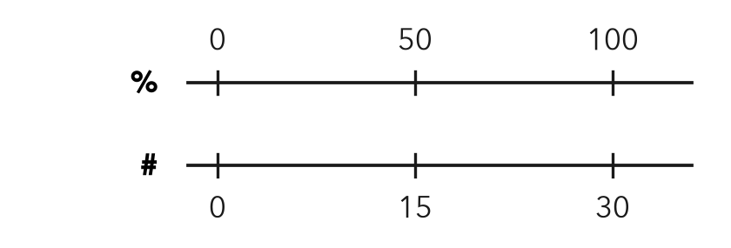  Say it: Explain the picture to a partner.
LESSON 4-5  variable  variable  A letter that stands for an unknown number.  Example w = the whole  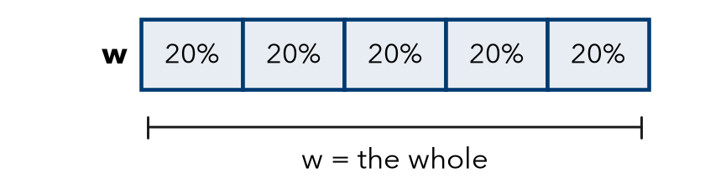  Say it: Explain the picture to a partner. | LESSON 4-5  inverse operation  operación inversa  An operation that undoes another. Division undoes multiplication.  Example w = 138 ÷ 0.6  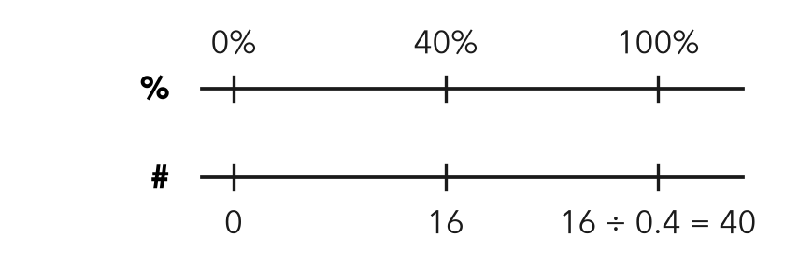  Say it: Explain the picture to a partner.
LESSON 4-4  discount  descuento  The amount taken off a price.  Example 25% off $80 = $20 off; you pay $60  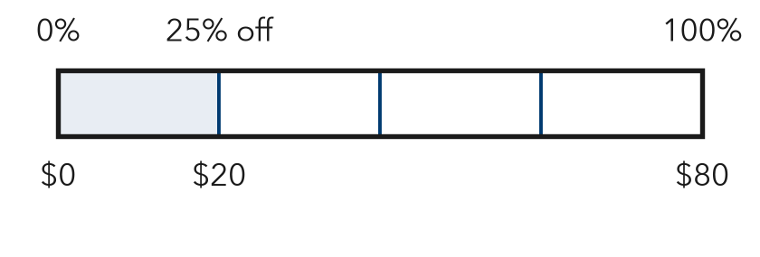  Say it: Explain the picture to a partner. | LESSON 4-1  tape diagram  diagrama de cinta  A bar split into equal parts to show a whole and its parts.  Example 5 equal parts: each part is 20%  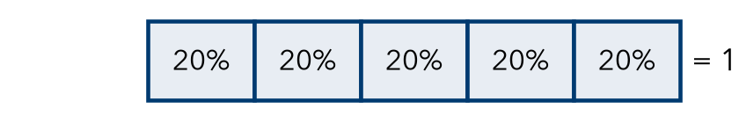  Say it: Explain the picture to a partner.
LESSON 4-4
base
base
The whole you find the percent of. It is 100%.
Example In 20% of 50, the base is 50
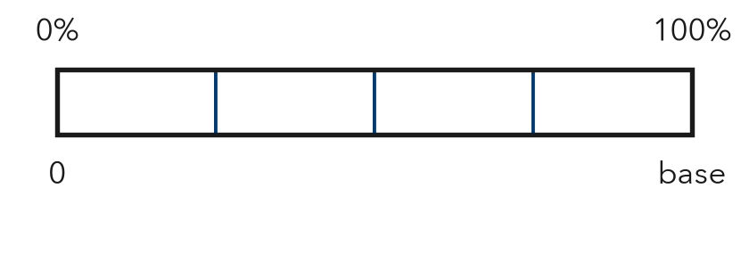
Say it: Explain the picture to a partner.

