Name Date Period
Lesson 2-1 · Session 2 · Guided Steps · Form B
Dot Plots and Shape
Learning target — I can build a dot plot and describe the shape of the data it shows. · 6.SP.B.4
REMEMBER
• A dot plot shows one dot for each data value. Repeated values stack up.
• The peak (tallest stack) is the most common value. Total dots = number of values.
• Symmetric: both sides match. Skewed left/right: the long tail points that way.
GUIDED PRACTICE fill in each blank — problems 1–4
1. Water Bottles. Ms. Rivera asked 9 students how many bottles they filled on Tuesday: 3, 1, 4, 3, 5, 2, 3, 4, 3. Make a dot plot.
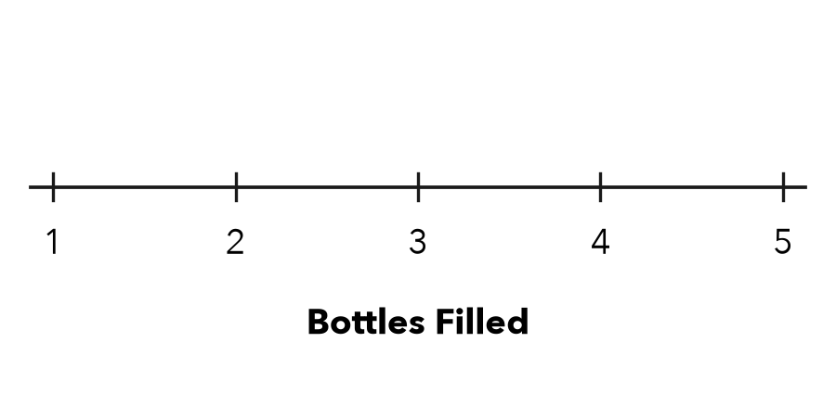
Step 1 Tally each value in the list as you draw its dot
Step 2 1: 2: 3: 4: 5:
Step 3 The total dots must equal the number of
a. Most common value:
b. Shape:

2. Free Throws. Seven players made these free throws: 5, 8, 6, 5, 7, 5, 9. Make a dot plot. What is the most common value?
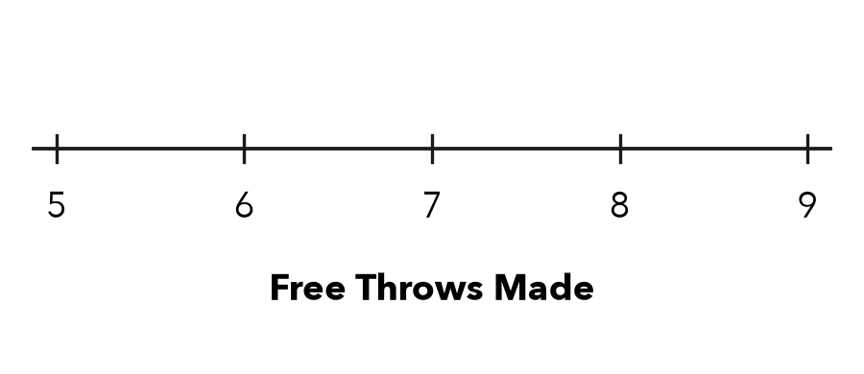
Step 1 Draw one dot for each value
Step 2 5: 6: 7: 8: 9:
Step 3 The tallest stack is over
Most common value:

3. Read the Stacks. On a dot plot, 4 has 6 dots and 5 has 3 dots.  Step 1 Each dot stands for student  Step 2 Dots over 4 = students  a. Students who chose 4:  Step 3 + =  b. Students in both stacks: | 4. Count the Dots. A dot plot has stacks of 4, 2, 5 and 1 dots. How many data values does it show?  Step 1 Add the stack heights  Step 2 4 + 2 + 5 + 1 =  Values

ON YOUR OWN use the open space · show your work · label units
5. Shape Claim. Amira says this plot of quiz scores is symmetric. Is she right? Explain.  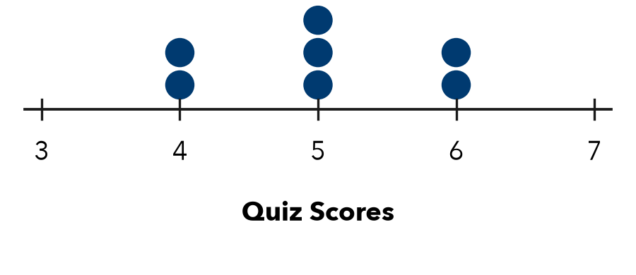  Show your work.  Right? | 6. One More Reader. The plot shows pages read. Then one more student reads 28 pages. Find the new most common value. Does the greatest value change?  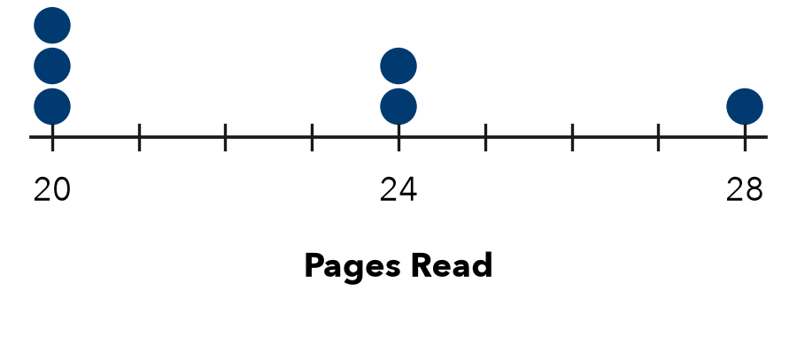  Show your work.  Most common  Does the greatest value change?

7. Bracelet Beads. The plot shows bead counts. Name the most common value and the shape.  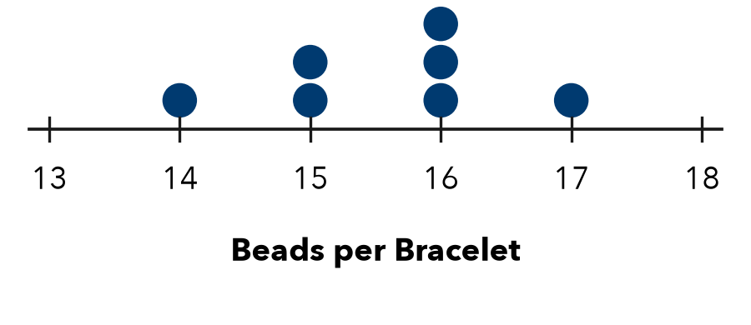  Show your work.  Value; shape | 8. Library Books. Ten students finished these numbers of books: 2, 4, 3, 4, 5, 4, 3, 6, 4, 3. Make a dot plot. Name the most common value.  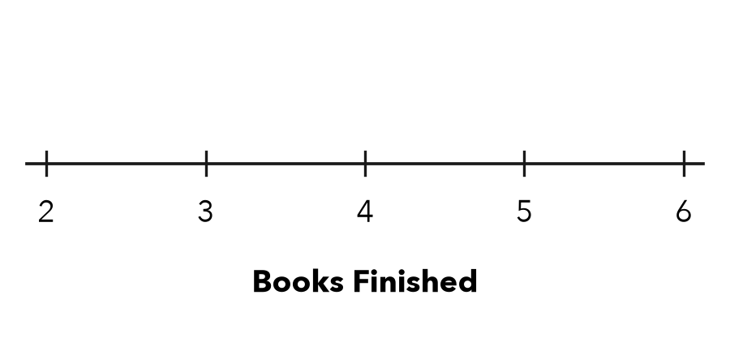  Show your work.  Most common

FIND THE ERROR explain the mistake, then fix it
9. Eli’s Work. For the data 2, 5, 5, 8, Eli drew one dot above each of 2, 5 and 8. Explain the mistake and tell what the plot should show.
Show your work.

TEST PRACTICE choose the best answer
10. A dot plot’s tallest stack sits over 9. The value 9 is the —
A least value B greatest value C most common value D number of dots

11. Which data set makes a symmetric dot plot?
A 1, 2, 2, 3 B 1, 1, 1, 4 C 1, 4, 4, 4 D 1, 1, 2, 5

CHECK YOURSELF
□ I can do this on my own □ I need a little help □ I have a question about #

