Name Date Period
Lesson 2-10 · Session 2 · Guided Steps · Form A
Matching Center and Spread
Learning target — I can match a measure of center and a measure of spread to the shape of a data set. · 6.SP.B.5d
REMEMBER
• Symmetric, no outlier: mean and MAD. Skewed or outlier: median and IQR.
• Never mix the pairs. MAD is built from the mean; IQR is built from the median.
• A long tail to the right means skewed right; to the left means skewed left.
GUIDED PRACTICE fill in each blank — problems 1–4
1. Write the pair you would report: mean and MAD, or median and IQR.
a. 31, 33, 35, 37, 39  Step 1 Far-away value?  Step 2 Pair: and | b. 31, 33, 35, 37, 290  Step 1 Far-away value?  Step 2 Pair: and

c. 44, 46, 48, 50, 52, 54, 56  Step 1 Far-away value?  Step 2 Pair: and | d. 12, 13, 15, 17, 19, 21, 400  Step 1 Far-away value?  Step 2 Pair: and

2. Donations. The histogram shows the sizes of 20 donations.
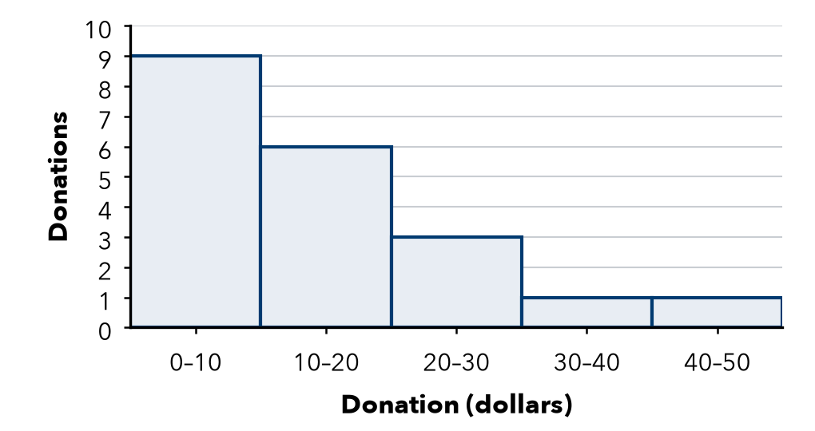
Step 1 The long tail points to the .
Step 2 a. Shape: skewed
Step 3 b. Pair to report: and

3. Balanced Scores. Set W is 52, 54, 56, 58, 60. It is symmetric.
Step 1 Add: 52 + 54 + 56 + 58 + 60 =
Step 2 a. Mean: ÷ 5 =
Value | 52 | 54 | 56 | 58 | 60
Distance from mean

Step 3 Add the distances:
Step 4 b. MAD: ÷ 5 =

4. One Big Night. Ticket sales for seven shows were 12, 13, 15, 17, 19, 21 and 400.
Step 1 a. Median = middle value:
Step 2 Lower half: 12, 13, 15 → Q1 =
Step 3 Upper half: 19, 21, 400 → Q3 =
Step 4 b. IQR: − =

ON YOUR OWN use the open space · show your work · label units
5. Mismatched Pair. Fernanda reports a median of 70 for a skewed set, with the MAD for spread. What spread should she use?  Show your work.  Spread | 6. Heartbeats. Heartbeats per ten seconds: 25, 27, 29, 31, 33, 35, 37. Name the pair to report. Find the center.  Show your work.  Center

7. One New Value. The set 80, 82, 84, 86, 88 is symmetric. Then a new value, 500, joins the set.
a. Pair to report before:
b. Pair to report after:
c. New median:
Show your work.

8. Deli Wait Times. The box plot shows wait times, in minutes.
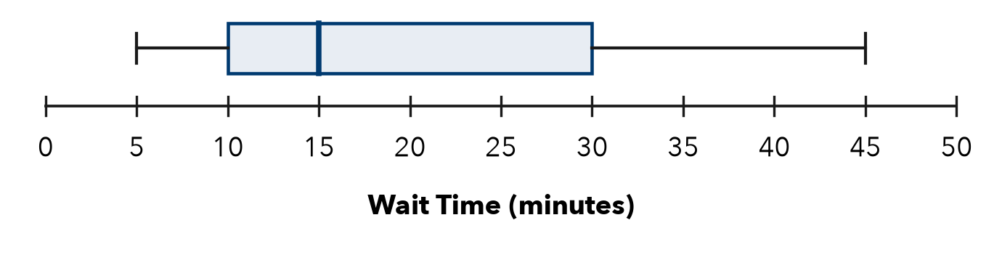
a. Shape:
b. Median: min
c. IQR: min
Show your work.

FIND THE ERROR explain the mistake, then fix it
9. Malik’s Work. Malik saw a set with one huge outlier and chose the mean and MAD, saying “the mean always uses every value.” Explain his mistake.
Show your work.

TEST PRACTICE choose the best answer
10. Symmetric data with no outlier is best summarized by —
A mean and MAD B median and MAD C mean and IQR D range only

11. Which pairing is incorrect?
A mean with MAD B median with IQR C mean with IQR D center with spread

CHECK YOURSELF
□ I can do this on my own □ I need a little help □ I have a question about #

