Name Date Period
Lesson 2-10 · Session 2 · Guided Steps · Form B
Matching Center and Spread
Learning target — I can match a measure of center and a measure of spread to the shape of a data set. · 6.SP.B.5d
REMEMBER
• Symmetric, no outlier: mean and MAD. Skewed or outlier: median and IQR.
• Never mix the pairs. MAD is built from the mean; IQR is built from the median.
• A long tail to the right means skewed right; to the left means skewed left.
GUIDED PRACTICE fill in each blank — problems 1–4
1. Write the pair you would report: mean and MAD, or median and IQR.
a. 52, 54, 56, 58, 60  Step 1 Far-away value?  Step 2 Pair: and | b. 52, 54, 56, 58, 310  Step 1 Far-away value?  Step 2 Pair: and

c. 63, 65, 67, 69, 71, 73, 75  Step 1 Far-away value?  Step 2 Pair: and | d. 1, 45, 47, 49, 51  Step 1 Far-away value?  Step 2 Pair: and

2. Test Scores. The histogram shows the scores of 22 students.
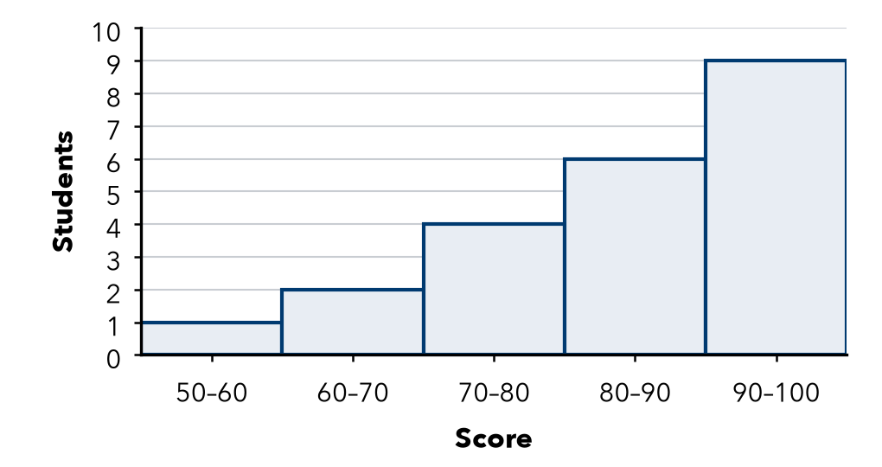
Step 1 The long tail points to the .
Step 2 a. Shape: skewed
Step 3 b. Pair to report: and

3. Balanced Scores. Set R is 40, 43, 45, 47, 50. It is symmetric.
Step 1 Add: 40 + 43 + 45 + 47 + 50 =
Step 2 a. Mean: ÷ 5 =
Value | 40 | 43 | 45 | 47 | 50
Distance from mean

Step 3 Add the distances:
Step 4 b. MAD: ÷ 5 =

4. One Big Night. Ticket sales for seven shows were 14, 16, 17, 19, 22, 24 and 350.
Step 1 a. Median = middle value:
Step 2 Lower half: 14, 16, 17 → Q1 =
Step 3 Upper half: 22, 24, 350 → Q3 =
Step 4 b. IQR: − =

ON YOUR OWN use the open space · show your work · label units
5. Mismatched Pair. Ana reports a mean of 64 for a symmetric set, with the IQR for spread. What spread should she use?  Show your work.  Spread | 6. Book Fair. Daily sales: 63, 65, 67, 69, 71, 73, 75. Name the pair to report. Find the center.  Show your work.  Center

7. One New Value. The set 60, 62, 64, 66, 68 is symmetric. Then a new value, 400, joins the set.
a. Pair to report before:
b. Pair to report after:
c. New median:
Show your work.

8. Deli Wait Times. The box plot shows wait times, in minutes.
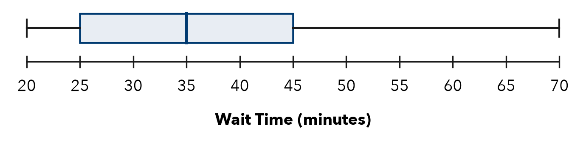
a. Shape:
b. Median: min
c. IQR: min
Show your work.

FIND THE ERROR explain the mistake, then fix it
9. Priya’s Work. Priya saw a set with one huge outlier and chose the mean and MAD, saying “the mean always uses every value.” Explain her mistake.
Show your work.

TEST PRACTICE choose the best answer
10. A long tail to the right means the data is —
A symmetric B skewed right C skewed left D clustered

11. An outlier makes you switch from the mean to the —
A MAD B range C total D median

CHECK YOURSELF
□ I can do this on my own □ I need a little help □ I have a question about #

