Lesson 2.10 Guided Notes

Session 1 · Mean or Median?
I can choose the mean or the median to describe a data set based on its shape. · 6.SP.B.5d
Word / Spanish | Meaning — complete the blank | Example
outlier / valor atípico | A value _____ away from the others. | 2, 3, 4, 32: 32
skewed / asimétrico | Most values sit on one side, with a long ______. | tail to the right
symmetric / simétrico | Both sides of the data look about the ______. | 20, 22, 24, 26, 28
measure of center / medida de centro | One number that shows a _________ value. | mean or median

Key idea
An outlier pulls the ______ toward it, but barely moves the median.
Skewed data or an outlier: use the ________. Symmetric data: use the mean.

Worked example
Five friends saved $6, $7, $8, $9 and $50. Which center describes a typical friend?
The outlier is _____.
Median: the middle of 6, 7, 8, 9, 50 is _____.
Mean: 80 ÷ 5 = _____, more than four of the five savings.
Answer: Use the ________: about $8.

You try
1. Write the better measure of center: mean or median.
a. 70, 72, 74, 76, 78 ______
b. 7, 8, 9, 10, 65 ______
________________________________________________________________
2. Comic book prices are $4, $5, $6, $7 and $53. Find the mean and median. Which is better?
________________________________________________________________
Sum it up: I use the median instead of the mean when ___ because ___.
________________________________________________________________

Session 2 · Matching Center and Spread
I can match a measure of center and a measure of spread to the shape of a data set. · 6.SP.B.5d
Word / Spanish | Meaning — complete the blank | Example
symmetric / simétrico | Both sides of the data look about the ______. | 20, 22, 24, 26, 28
skewed / asimétrico | Most values sit on one side, with a long ______. | 20, 22, 24, 26, 150
mean and MAD / media y DMA | The pair for ___________ data with no outlier. | center plus average distance
median and IQR / mediana y rango intercuartil | The pair for skewed data or data with an _________. | middle plus middle half

Key idea
MAD is built from the ______; IQR is built from the median. Never mix the pairs.
Look for an outlier or a long ______ before you choose a pair.

Worked example
Set C: 20, 22, 24, 26, 28. Set D: 20, 22, 24, 26, 150. Pick a pair for each.
Set C is ___________: mean 24, MAD 12 ÷ 5 = 2.4.
Set D has an outlier, _____: median 24.
Answer: C: mean and MAD. D: ________ and IQR.

You try
1. Write the pair you would report.
a. 40, 42, 44, 46, 48 ______
b. 40, 42, 44, 46, 300 ______
________________________________________________________________
2. Seven values are 22, 24, 26, 28, 30, 32, 320. Find the median and the IQR.
________________________________________________________________
Sum it up: I report the median and IQR when ___ because ___.
________________________________________________________________

Session 1 · Model, reason, and explain
Mean or Median? · 6.SP.B.5d
Success: represent the quantities, justify the relationship, and check the result with the correct units.
Five families collected 2, 3, 4, 5, and 26 books. Find the mean and median. Choose a measure for a typical family's collection, then for dividing the total equally among five delivery boxes.
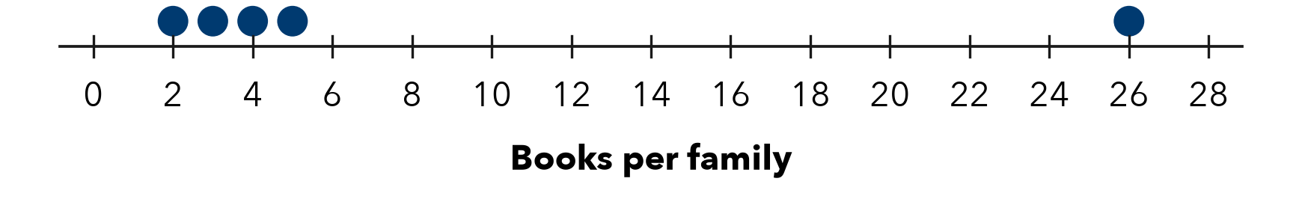
________________________________________________________________
________________________________________________________________
________________________________________________________________

Extend your reasoning
Explain why calling the mean 'wrong' because of an extreme value is misleading.
________________________________________________________________
________________________________________________________________
Self-check: Did my model, calculation, explanation, and units agree?

Session 2 · Model, reason, and explain
Matching Center and Spread · 6.SP.B.5d
Success: represent the quantities, justify the relationship, and check the result with the correct units.
Compare A: 4,6,8,10,12 and B: 4,6,8,10,32. Describe shape, choose a center/spread pair, and justify your choice for describing typical observations. Use the stated median-of-halves convention.
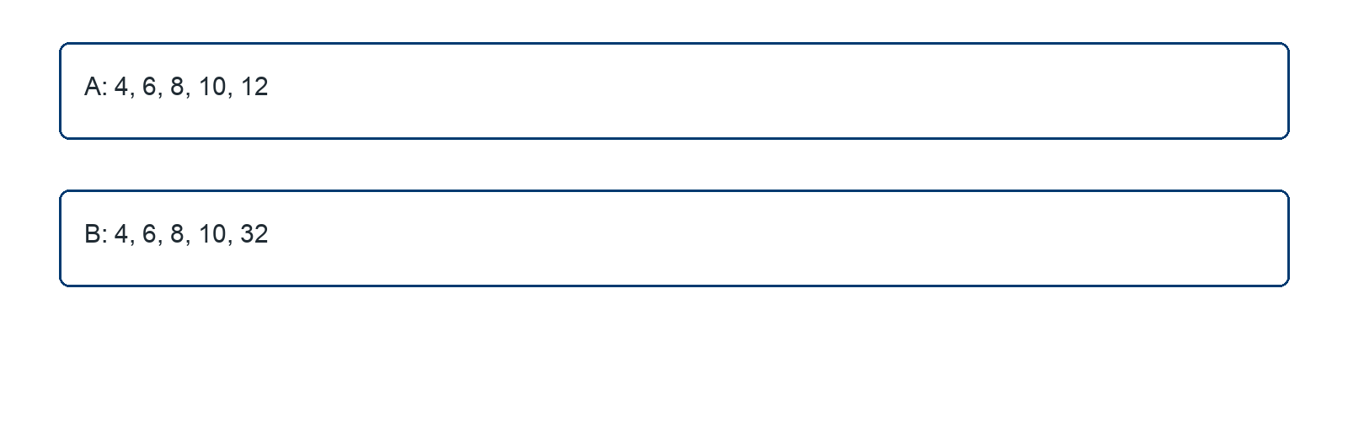
________________________________________________________________
________________________________________________________________
________________________________________________________________

Extend your reasoning
How does the small sample affect a blanket claim that IQR ignores the largest value?
________________________________________________________________
________________________________________________________________
Self-check: Did my model, calculation, explanation, and units agree?

