Name Date Period
Lesson 2-2 · Session 1 · Guided Steps · Form B
Building a Histogram
Learning target — I can group data into equal intervals and build a histogram from a frequency table. · 6.SP.B.4
REMEMBER
• An interval is a group of numbers, like 10–19. Intervals are equal in width and never overlap.
• Frequency = how many values fall in an interval. It sets the bar height.
• Histogram bars touch. All the bar heights add up to the number of values.
GUIDED PRACTICE fill in each blank — problems 1–4
1. Route 4. Nine students timed their bus rides (min): 5, 14, 22, 11, 8, 17, 26, 3, 19. Complete the table. Then draw the histogram.  Step 1 Cross off each value as you tally it  Step 2 Write each frequency in the table  Step 3 Frequencies add to values  Fewest rides interval:  Step 4 Draw touching bars with these heights | 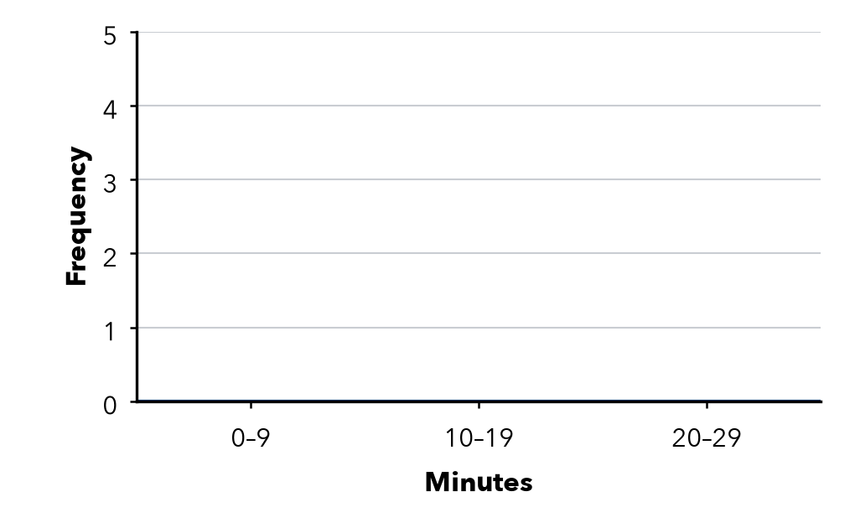
  Interval | Tally | Frequency
  0–9
  10–19
  20–29

2. Pushups. 9 students did these pushups: 17, 28, 6, 21, 14, 25, 29, 23, 12. Find each frequency and the total.
Step 1 Values from 0–9:
Step 2 Values from 10–19:
Step 3 Values from 20–29:
Step 4 Count each list for the frequencies
a. 0–9: b. 10–19: c. 20–29: d. Total:

3. Read the Table. 30–39: 6, 40–49: 9, 50–59: 5, 60–69: 2.  Step 1 Add: 6 + 9 + 5 + 2 =  Step 2 Biggest frequency:  a. Values in all:  b. Tallest bar: | 4. Missing Bar. A histogram shows 12 values. Two bars have heights 3 and 5. How tall is the third bar?  Step 1 3 + 5 =  Step 2 12 − =  Height

ON YOUR OWN use the open space · show your work · label units
5. Car Wash. Cars washed on 8 Saturdays: 15, 31, 8, 26, 37, 19, 22, 34. Find each frequency.  Show your work.  a. 0–9: b. 10–19:  c. 20–29: d. 30–39: | 6. Overlapping Bins. Desmond sorts 3, 8, 12, 15, 19 into the intervals 0–5, 5–10, 10–15, 15–20. What is wrong? Write intervals that work.  Show your work.  Intervals that work

7. Choose the Intervals. Plant heights run from 42 to 87 cm. Write five equal intervals of width 10 that cover every height.
Show your work.

Intervals

8. Field Day. Twelve runners finished in 31, 44, 38, 52, 47, 35, 41, 56, 39, 48, 33, 45 seconds. Complete the table.
Interval | Tally | Frequency
30–39
40–49
50–59

a. Which interval holds the fewest runners?
b. Why does a histogram show the times better than the list?
Show your work.

FIND THE ERROR explain the mistake, then fix it
9. Nadia’s Work. For the values 4, 12, 18, 26, Nadia drew bars over 0–9, 10–19 and 20–29 with a space between each bar. Explain the mistake and describe the correct histogram.
Show your work.

TEST PRACTICE choose the best answer
10. Which set of intervals is correct for a histogram?
A 0–5, 5–10, 10–15 B 0–9, 10–14, 15–29 C 0–9, 10–19, 20–29 D 0–10, 10–20, 20–30

11. Histogram bars touch because the intervals —
A are different widths B leave no gaps between them C overlap D have the same frequency

CHECK YOURSELF
□ I can do this on my own □ I need a little help □ I have a question about #

