Name Date Period
Lesson 2-2 · Session 2 · Guided Steps · Form A
Describing Histogram Shape
Learning target — I can describe the shape of a histogram using its peak, spread, and balance. · 6.SP.B.4
REMEMBER
• The peak is the interval with the tallest bar. It shows where a typical value falls.
• Symmetric: both sides match. Skewed right/left: the long tail points that way.
• A bar shows how many values are in an interval, not one exact value.
GUIDED PRACTICE fill in each blank — problems 1–4
1. Tomato Plants. Heights (cm): 14, 22, 18, 26, 17, 21, 12, 20, 24. Find each frequency. Then name the peak and the shape.
Step 1 10–14 holds:
Step 2 15–19 holds:
Step 3 20–24 holds:
Step 4 25–29 holds:
Step 5 Count each list for the frequencies
Step 6 The peak is the bar (tallest / shortest)
Step 7 The long tail points toward the values
a. 10–14: b. 15–19: c. 20–24:
d. 25–29: e. Peak: f. Shape:

2. Cabbage Weights. The histogram shows the weights of the cabbages in a garden.  Step 1 Read each bar's height: , , ,  Step 2 Add the heights: + + + =  Step 3 The tallest bar is over lb  Step 4 The bars shrink toward the weights  a. Peak interval: lb  b. Cabbages in all:  c. Shape: | 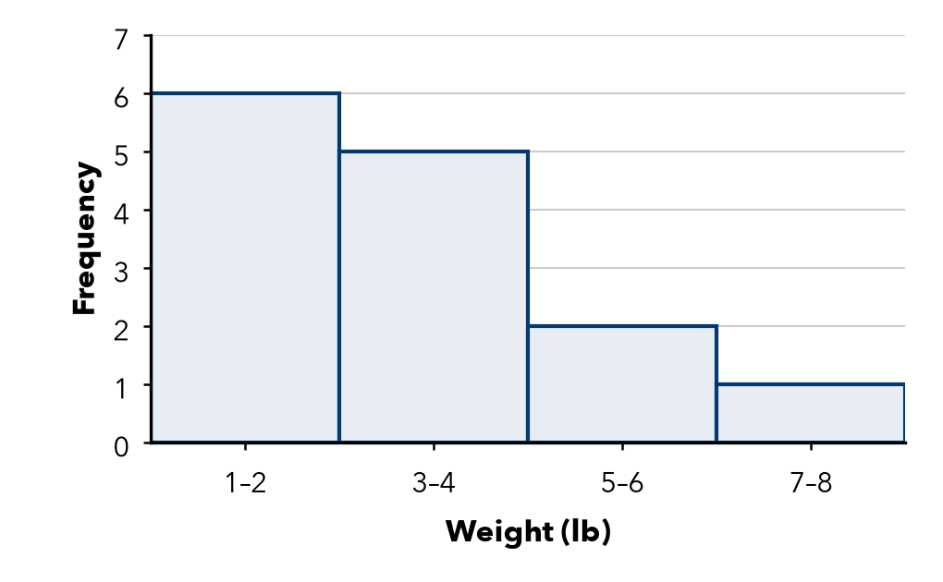

3. Museum Visitors. Each bar counts days. Which interval holds a typical day? Describe the shape.  Step 1 Read each bar's height: , , ,  Step 2 The tallest bar is over  Step 3 Do the left and right sides match?  Step 4 The tail points (left / right / neither)  a. Typical day:  b. Shape: | 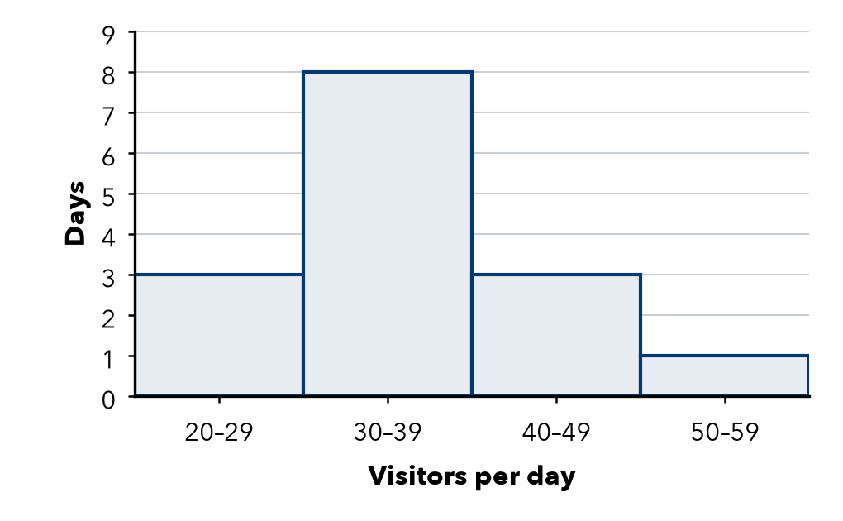

4. Read the Bars. Bars of 2, 7, 3 sit over 60–69, 70–79, 80–89.
Step 1 The tallest bar is over
Step 2 2 + 7 + 3 =
a. Peak:
b. Values in all:

ON YOUR OWN use the open space · show your work · label units
5. Name the Shape. Bar heights, left to right:  a. 1, 4, 8, 4, 1  b. 9, 5, 2, 1, 1  c. 1, 2, 4, 7  Show your work. | 6. Ramona’s Claim. Ramona says this histogram is symmetric. Is she right? Explain.  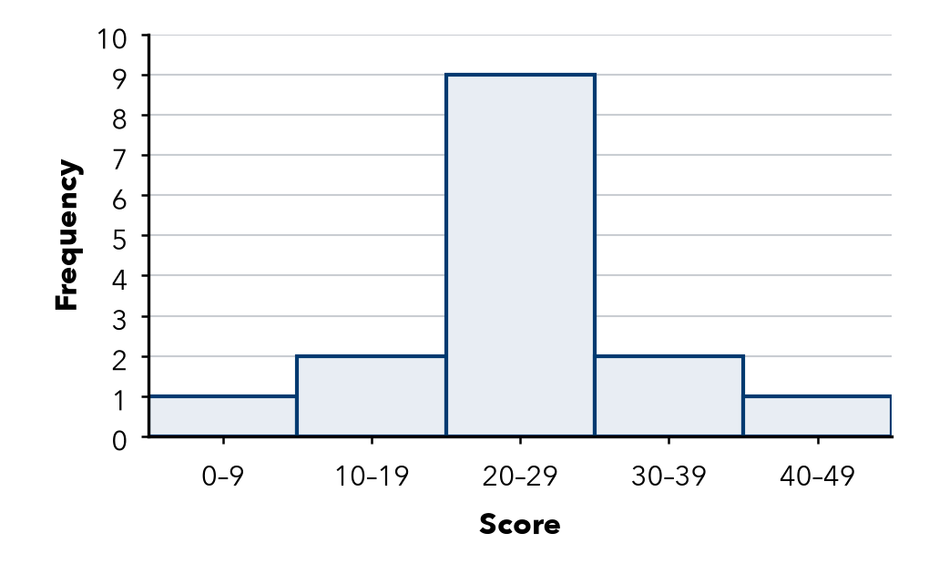  Show your work.  Right?

7. Ticket Prices. How many peaks does this histogram have? Explain why it is not symmetric.  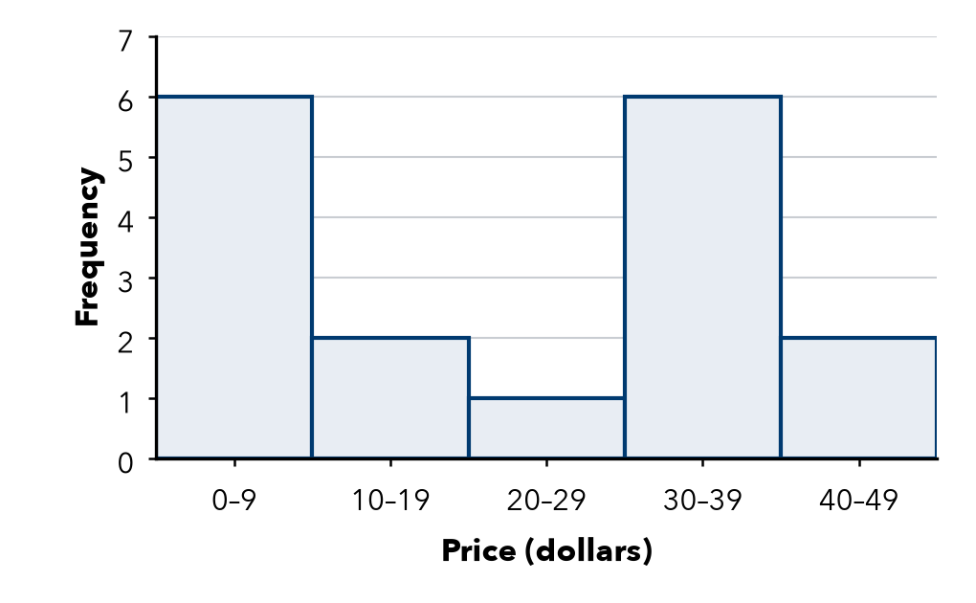  Show your work.  Peaks | 8. Display Choice. Tariq recorded 120 temperatures to the nearest tenth of a degree. Should he use a dot plot or a histogram? Explain.  Show your work.

FIND THE ERROR explain the mistake, then fix it
9. Colette’s Work. A histogram has bars of 2, 9, 2. Colette says, “The tallest bar means one value showed up 9 times.” Explain the mistake.
Show your work.

TEST PRACTICE choose the best answer
10. Bars of height 8, 4, 2, 1 from left to right describe a shape that is —
A symmetric B skewed left C skewed right D flat

11. The peak of a histogram is the interval with the —
A shortest bar B tallest bar C widest bar D last bar

CHECK YOURSELF
□ I can do this on my own □ I need a little help □ I have a question about #

