Lesson 2.2 Guided Notes

Session 1 · Building a Histogram
I can group data into equal intervals and build a histogram from a frequency table. · 6.SP.B.4
Word / Spanish | Meaning — complete the blank | Example
histogram / histograma | A graph of __________ bars; each bar counts the values in one interval. | bars over 0–9, 10–19, 20–29
interval / intervalo | A group of numbers, like 10–19. All intervals have the same _______. | 10–19 holds 10 whole numbers
frequency / frecuencia | __________ values land in one interval. | 10–19: 3 values

Key idea
Intervals must be the same _______ and must not _________.
The bar heights add up to the _______ number of values.

Worked example
Walk times (min): 4, 15, 9, 22, 11, 18, 27. Use 0–9, 10–19, 20–29.
0–9 holds 4 and 9, so its frequency is _____.
10–19 holds 15, 11 and 18: frequency _____.
20–29 holds 22 and 27: frequency _____.
Answer: Check: 2 + 3 + 2 = _____ values

You try
1. Ages: 13, 27, 21, 8, 16, 24, 29, 18. Find each frequency.
a. 0–9: ______
b. 10–19: ______
c. 20–29: ______
________________________________________________________________
2. A histogram shows 10 values. Two bars have heights 4 and 2. How tall is the third bar?
________________________________________________________________
Sum it up: To build a histogram, I first ___, then ___.
________________________________________________________________

Session 2 · Describing Histogram Shape
I can describe the shape of a histogram using its peak, spread, and balance. · 6.SP.B.4
Word / Spanish | Meaning — complete the blank | Example
peak / pico | The interval with the _________ bar. | bars 2, 7, 3: peak is the middle bar
symmetric / simétrico | The left and right sides _______. | 1, 4, 8, 4, 1
skewed right / sesgado a la derecha | The long ______ stretches to the right. | 9, 5, 2, 1, 1
skewed left / sesgado a la izquierda | The long tail stretches to the ______. | 1, 2, 3, 6, 8

Key idea
The ______ shows where a typical value falls.
Name a skewed shape for its ______, not for where the tall bars are.

Worked example
Bars of height 1, 3, 6, 9 sit over 0–9, 10–19, 20–29, 30–39. Describe the shape.
The tallest bar, 9, is over _______, so that is the peak.
The bars shrink toward the ______, so the tail is on the left.
Answer: The shape is _____________.

You try
1. Bar heights from left to right. Name each shape.
a. 2, 5, 9, 5, 2 ______
b. 10, 6, 3, 2, 1 ______
________________________________________________________________
2. Bars of 3, 8, 4 sit over 60–69, 70–79, 80–89. Name the peak and the number of values.
________________________________________________________________
Sum it up: A histogram is skewed right when ___ because ___.
________________________________________________________________

Session 1 · Model, reason, and explain
Building a Histogram · 6.SP.B.4
Success: represent the quantities, justify the relationship, and check the result with the correct units.
Reading times are 0, 9, 10, 19, 20, 24, 29, 30 minutes. Use intervals 0–9, 10–19, 20–29, 30–39. Make a frequency table and histogram. Explain where 10 and 20 belong.
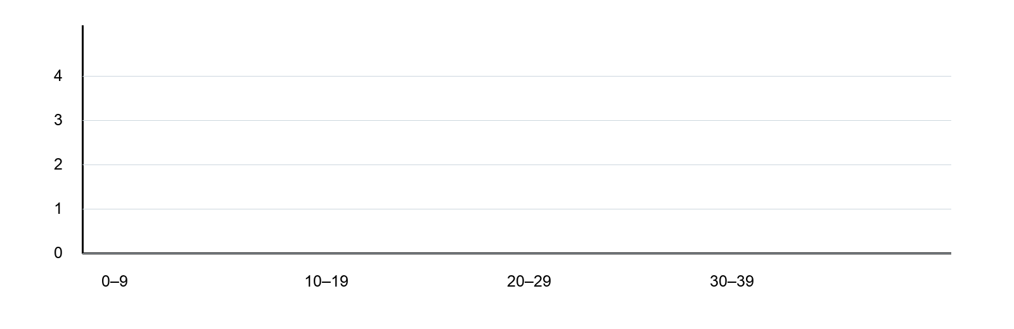
________________________________________________________________
________________________________________________________________
________________________________________________________________

Extend your reasoning
For measurements that include decimals, rewrite the intervals so 9.5 also has exactly one home.
________________________________________________________________
________________________________________________________________
Self-check: Did my model, calculation, explanation, and units agree?

Session 2 · Model, reason, and explain
Describing Histogram Shape · 6.SP.B.4
Success: represent the quantities, justify the relationship, and check the result with the correct units.
The histogram has interval frequencies 1, 2, 4, 7 from left to right. Which side has the tail? Explain why the location of the tallest bar does not name the tail.
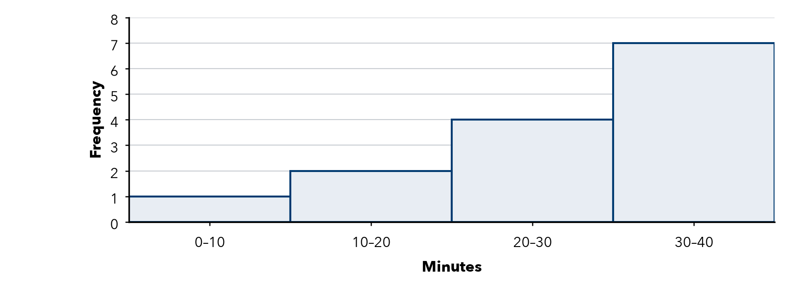
________________________________________________________________
________________________________________________________________
________________________________________________________________

Extend your reasoning
Design four interval frequencies that make a symmetric histogram with eight observations.
________________________________________________________________
________________________________________________________________
Self-check: Did my model, calculation, explanation, and units agree?

