Name Date Period
Lesson 2-6 · Session 2 · Guided Steps · Form A
Comparing Distributions
Learning target — I can compare two distributions using the median and the interquartile range together. · 6.SP.B.5d
REMEMBER
• Median = center: which group is typically higher or lower?
• IQR = spread: which group is more consistent (smaller IQR)?
• Use both to decide. Ask what is better here: a shorter wait or a higher score?
GUIDED PRACTICE fill in each blank — problems 1–4
1. Two Lunch Lines. Wait times (min). Line 1: 3, 5, 7, 8, 10, 12, 15. Line 2: 2, 4, 11, 13, 14, 16, 20.
Step 1 Line 1: median = 4th value =
Step 2 Q1 = 2nd value = ; Q3 = 6th value =
Step 3 Line 1: IQR = − =
Step 4 Line 2: median ; Q1 ; Q3 ; IQR
Step 5 Lower median = shorter wait; smaller IQR = steadier.
 | Median | Q1 | Q3 | IQR
Line 1
Line 2
Which to join

2. Two Carrot Plots. Plot A lengths (cm): 10, 12, 14, 15, 16, 17, 19. Plot B: 5, 11, 14, 15, 20, 23, 27.
Step 1 Median A = 4th:  Step 2 Q1 A = 2nd:  Step 3 Q3 A = 6th:  Step 4 IQR A = − = | Step 1 Median B = 4th:  Step 2 Q1 B = 2nd:  Step 3 Q3 B = 6th:  Step 4 IQR B = − =

a. Median A: b. IQR A: c. Median B: d. IQR B:

3. Two Months. Month 1: median 120 sales, IQR 40. Month 2: median 135, IQR 12.  Step 1 Compare the medians: and  Step 2 Compare the IQRs: and  Step 3 The larger median is typically higher; the smaller IQR is steadier.  a. Typically higher:  b. Steadier: | 4. Nikhil’s Claim. Set E: median 60, IQR 30. Set F: median 55, IQR 8. Nikhil says Set E wins in every way. Is Nikhil right?  Step 1 Set E median ; Set F median  Step 2 Set E IQR ; Set F IQR  Step 3 E is higher, but F is .  □ Right □ Not right

ON YOUR OWN use the open space · show your work · label units
5. Two Water Coolers. The box plots show cups served per hour.
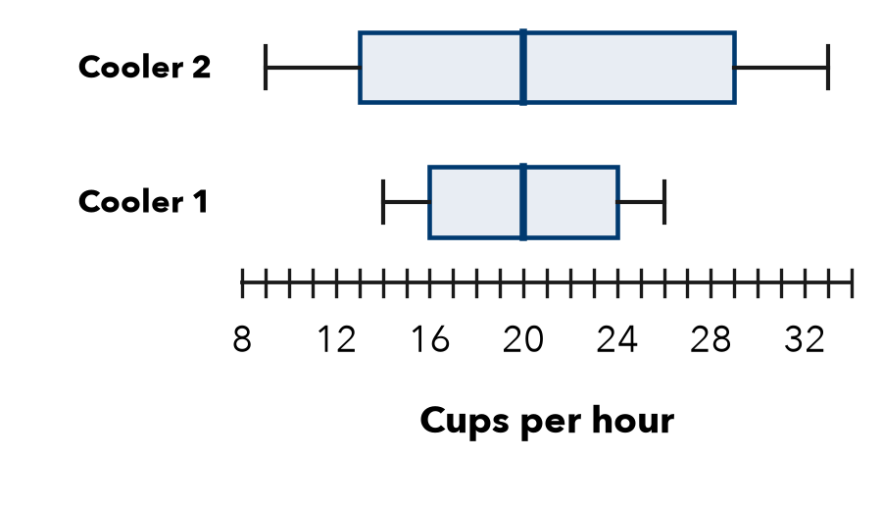
a. Median of 1: b. IQR of 1:
c. Median of 2: d. IQR of 2:
e. Compare them:
Show your work.

6. Coach’s Choice. Team 1: median 58 points, IQR 20. Team 2: median 52, IQR 5. The coach wants the team most likely to score close to its usual total.  □ Team 1 □ Team 2  Why  Show your work. | 7. Two Stores. Store P: median 46 sales, IQR 9. Store Q: median 52, IQR 21. Write a comparison that uses both measures.  Show your work.

8. Two Study Methods. Method 1 quiz scores: median 78, IQR 6. Method 2: median 83, IQR 24.
a. Higher typical score:
b. More dependable (use both IQRs):
c. Pick one method for the whole class. Argue using both measures.
Show your work.

FIND THE ERROR explain the mistake, then fix it
9. Kofi’s Work. Kofi wrote: “Group 1 has the larger median, so Group 1 must have the larger IQR too.” Explain the mistake.
Show your work.

TEST PRACTICE choose the best answer
10. To compare two skewed distributions fully, report the —
A median and IQR B median only C greatest values D number of values

11. Set A: median 60, IQR 5. Set B: median 60, IQR 18. Set A is —
A higher B more consistent C more spread out D lower

CHECK YOURSELF
□ I can do this on my own □ I need a little help □ I have a question about #

