Name Date Period
Lesson 2-6 · Session 2 · Guided Steps · Form B
Comparing Distributions
Learning target — I can compare two distributions using the median and the interquartile range together. · 6.SP.B.5d
REMEMBER
• Median = center: which group is typically higher or lower?
• IQR = spread: which group is more consistent (smaller IQR)?
• Use both to decide. Ask what is better here: a shorter wait or a higher score?
GUIDED PRACTICE fill in each blank — problems 1–4
1. Two Lunch Booths. Wait times (min). Booth 1: 4, 6, 8, 9, 11, 13, 16. Booth 2: 1, 3, 10, 14, 15, 17, 21.
Step 1 Booth 1: median = 4th value =
Step 2 Q1 = 2nd value = ; Q3 = 6th value =
Step 3 Booth 1: IQR = − =
Step 4 Booth 2: median ; Q1 ; Q3 ; IQR
Step 5 Lower median = shorter wait; smaller IQR = steadier.
 | Median | Q1 | Q3 | IQR
Booth 1
Booth 2
Which to join

2. Two Bean Plots. Plot A lengths (cm): 8, 10, 12, 14, 15, 17, 18. Plot B: 4, 9, 13, 14, 19, 22, 26.
Step 1 Median A = 4th:  Step 2 Q1 A = 2nd:  Step 3 Q3 A = 6th:  Step 4 IQR A = − = | Step 1 Median B = 4th:  Step 2 Q1 B = 2nd:  Step 3 Q3 B = 6th:  Step 4 IQR B = − =

a. Median A: b. IQR A: c. Median B: d. IQR B:

3. Two Months. Month 1: median 210 sales, IQR 15. Month 2: median 190, IQR 45.  Step 1 Compare the medians: and  Step 2 Compare the IQRs: and  Step 3 The larger median is typically higher; the smaller IQR is steadier.  a. Typically higher:  b. Steadier: | 4. Rosa’s Claim. Set E: median 72, IQR 28. Set F: median 68, IQR 7. Rosa says Set E wins in every way. Is Rosa right?  Step 1 Set E median ; Set F median  Step 2 Set E IQR ; Set F IQR  Step 3 E is higher, but F is .  □ Right □ Not right

ON YOUR OWN use the open space · show your work · label units
5. Two Fountains. The box plots show cups served per hour.
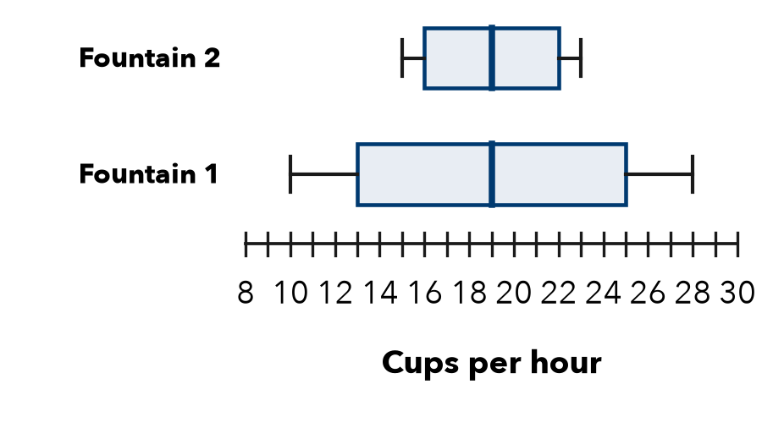
a. Median of 1: b. IQR of 1:
c. Median of 2: d. IQR of 2:
e. Compare them:
Show your work.

6. Coach’s Choice. Team 1: median 61 points, IQR 6. Team 2: median 66, IQR 25. The coach wants the team most likely to score close to its usual total.  □ Team 1 □ Team 2  Why  Show your work. | 7. Two Stores. Store R: median 38 sales, IQR 14. Store S: median 33, IQR 5. Write a comparison that uses both measures.  Show your work.

8. Two Study Methods. Method 1 quiz scores: median 85, IQR 20. Method 2: median 81, IQR 5.
a. Higher typical score:
b. More dependable (use both IQRs):
c. Pick one method for the whole class. Argue using both measures.
Show your work.

FIND THE ERROR explain the mistake, then fix it
9. Lucia’s Work. Lucia wrote: “Group 1 has the larger median, so Group 1 must have the larger IQR too.” Explain the mistake.
Show your work.

TEST PRACTICE choose the best answer
10. Medians of 48 and 55 differ by —
A 7 B 103 C 8 D 55

11. Group 1: median 12 cm, IQR 3 cm. Group 2: median 12 cm, IQR 9 cm. Which is more consistent?
A Group 1 B Group 2 C They are the same D Cannot tell

CHECK YOURSELF
□ I can do this on my own □ I need a little help □ I have a question about #

