Lesson 2.3 Guided Notes

Session 1 · Finding the Median
I can find the median of a data set by ordering the values and taking the middle one. · 6.SP.B.5c
Word / Spanish | Meaning — complete the blank | Example
median / mediana | The ________ value of a data set in order. | 2, 4, 6, 7, 9
data set / conjunto de datos | A _______ of values you collect. | 7, 2, 9, 4, 6
order / ordenar | To list values from _______ to greatest. | 2, 4, 6, 7, 9

Key idea
Always _______ the values before you find the median.
With an odd number of values, the median is the _____ value in the middle.
Changing the greatest value does not ________ the median.

Worked example
Find the median of 7, 2, 9, 4, 6.
Order the values: 2, 4, _____, 7, 9.
Cross off one value from each end until _____ is left.
Answer: Median = _____

You try
1. Find each median.
a. 5, 1, 8 ______
b. 12, 7, 15, 9, 10 ______
________________________________________________________________
2. Ages: 11, 13, 12, 15, 11, 14, 12. Find the median age.
________________________________________________________________
Sum it up: To find the median, I first ___, then ___.
________________________________________________________________

Session 2 · Median of an Even Data Set
I can find the median of a data set with an even number of values by averaging the two middle values. · 6.SP.B.5c
Word / Spanish | Meaning — complete the blank | Example
even number of values / número par de valores | A data set with _____ values in the middle. | 8, 12, 15, 19
middle values / valores centrales | The two values left after you cross off from both ______. | 12 and 15
average of two numbers / promedio de dos números | Add the two numbers, then ________ by 2. | (12 + 15) ÷ 2 = 13.5

Key idea
With an even number of values, the median is _________ between the two middle values.
The median does not have to be one of the ________ in the set.

Worked example
Find the median of 15, 8, 19, 12.
Order: 8, _____, _____, 19.
Add the middle values and divide by 2: 27 ÷ 2.
Answer: Median = ______

You try
1. Find each median.
a. 3, 9, 5, 7 ______
b. 20, 14, 18, 12, 10, 16 ______
________________________________________________________________
2. Six puppies weigh 8, 12, 5, 14, 10 and 7 pounds. Find the median weight.
________________________________________________________________
Sum it up: When a data set has an even number of values, I find the median by ___.
________________________________________________________________

Session 1 · Model, reason, and explain
Finding the Median · 6.SP.B.5c
Success: represent the quantities, justify the relationship, and check the result with the correct units.
Order 9, 3, 7, 3, 8. Mark the middle position. Explain why the repeated 3 must be kept when finding the median.
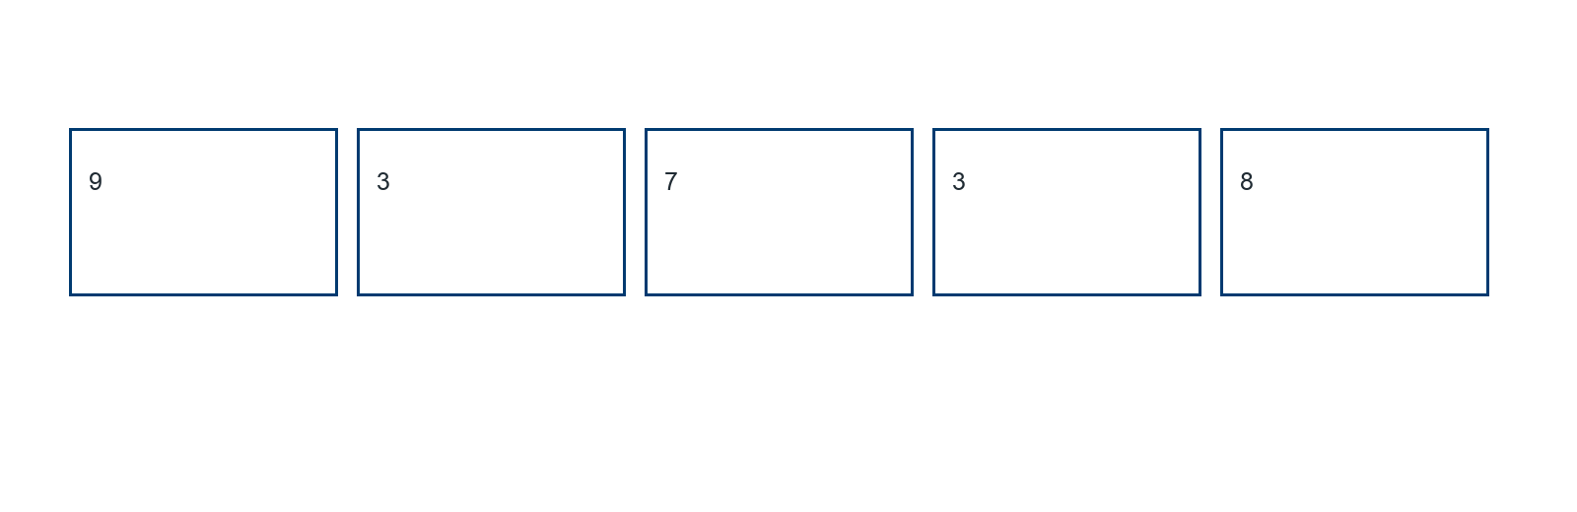
________________________________________________________________
________________________________________________________________
________________________________________________________________

Extend your reasoning
Change the greatest value to 90. Does the median change? Explain using positions.
________________________________________________________________
________________________________________________________________
Self-check: Did my model, calculation, explanation, and units agree?

Session 2 · Model, reason, and explain
Median of an Even Data Set · 6.SP.B.5c
Success: represent the quantities, justify the relationship, and check the result with the correct units.
Order 8, 3, 12, 5. Locate the two middle values on a number line and mark their midpoint. Must the median be one of the observed values?
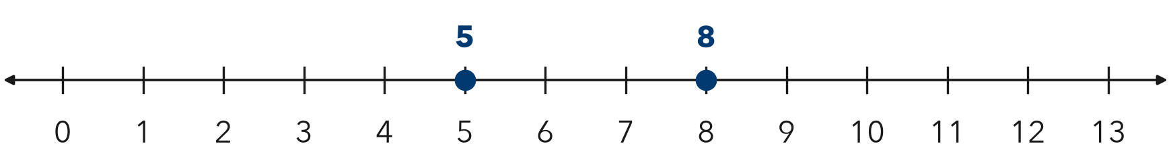
________________________________________________________________
________________________________________________________________
________________________________________________________________

Extend your reasoning
Create four whole-number observations with median 6.5 and verify your set.
________________________________________________________________
________________________________________________________________
Self-check: Did my model, calculation, explanation, and units agree?

