Lesson 2.6 Guided Notes

Session 1 · Median and Outliers
I can explain why the median is a better measure of center than the mean when a data set has an outlier. · 6.SP.B.5d
Word / Spanish | Meaning — complete the blank | Example
outlier / valor atípico | A value _____ from all the others. | 120 in 39, 41, 43, 44, 45, 47, 120
median / mediana | The ________ value of the ordered data. | 44
mean / media | The sum of the values _________ by how many values there are. | (2 + 4 + 9) ÷ 3 = 5

Key idea
An outlier pulls the ______ toward it.
The median stays in the ________, so it describes typical data better when there is an outlier.

Worked example
Car counts: 44, 39, 41, 47, 43, 45, 120. What is a typical count?
Order: 39, 41, 43, 44, 45, 47, 120. The outlier is _____.
The median is the 4th value: _____.
Answer: A typical Saturday has about _____ cars.

You try
1. Data: 12, 15, 11, 14, 13, 60, 16.
a. Outlier: ______
b. Median: ______
________________________________________________________________
2. In the data above, 60 changes to 90. What is the new median?
________________________________________________________________
Sum it up: When a data set has an outlier, I use the ___ because ___.
________________________________________________________________

Session 2 · Comparing Distributions
I can compare two distributions using the median and the interquartile range together. · 6.SP.B.5d
Word / Spanish | Meaning — complete the blank | Example
distribution / distribución | How the data values are ________ across their range. | a box plot shows it
center (median) / centro (mediana) | The _________ value of a data set. | median wait 8 min
spread (IQR) / dispersión (rango intercuartil) | How ________________ the middle half is. | IQR 7 min

Key idea
Use the ________ to compare typical values and the IQR to compare consistency.
A higher median does not mean __________; only the IQR shows that.

Worked example
Line 1: median 8 min, IQR 7. Line 2: median 13 min, IQR 12. Which line should you join?
Center: Line 1’s typical wait is _____ min shorter.
Spread: Line 1’s IQR is _________, so its waits are steadier.
Answer: Join Line _____.

You try
1. Group 1: median 80, IQR 4. Group 2: median 84, IQR 22.
a. Higher typical score: ______
b. More consistent: ______
________________________________________________________________
2. Team A: median 30, IQR 8. Team B: median 44, IQR 8. How are they alike? How do they differ?
________________________________________________________________
Sum it up: To compare two distributions, I use the median to ___ and the IQR to ___.
________________________________________________________________

Session 1 · Model, reason, and explain
Median and Outliers · 6.SP.B.5d
Success: represent the quantities, justify the relationship, and check the result with the correct units.
Data A are 4, 5, 6, 7, 8. In data B, replace 8 with 28. Find each mean and median. Which is more resistant to this change, and what does 'typical' mean in your explanation?
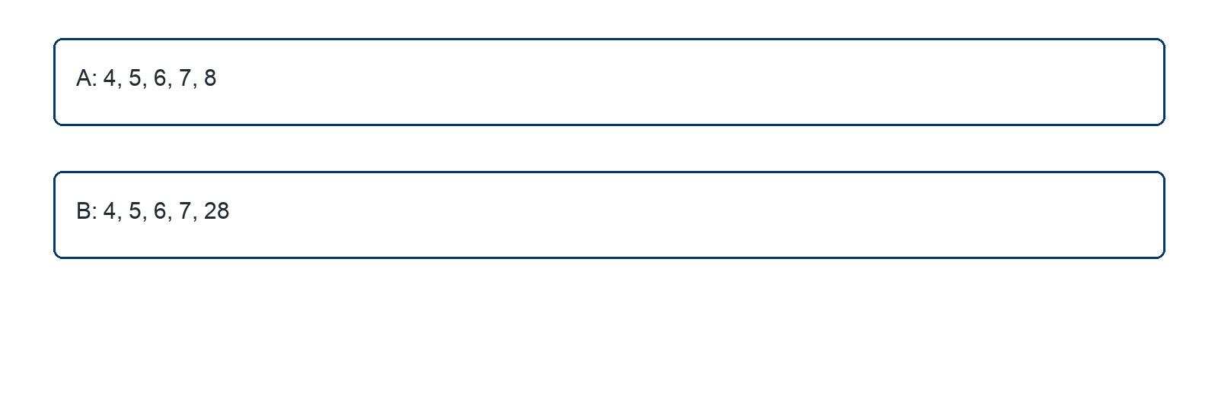
________________________________________________________________
________________________________________________________________
________________________________________________________________

Extend your reasoning
When would the mean of B still be useful?
________________________________________________________________
________________________________________________________________
Self-check: Did my model, calculation, explanation, and units agree?

Session 2 · Model, reason, and explain
Comparing Distributions · 6.SP.B.5d
Success: represent the quantities, justify the relationship, and check the result with the correct units.
Queue A has median 7 minutes and IQR 8 minutes. Queue B has median 10 minutes and IQR 2 minutes. Recommend a queue for a person who values a shorter typical wait, then for a person who values consistent waits.
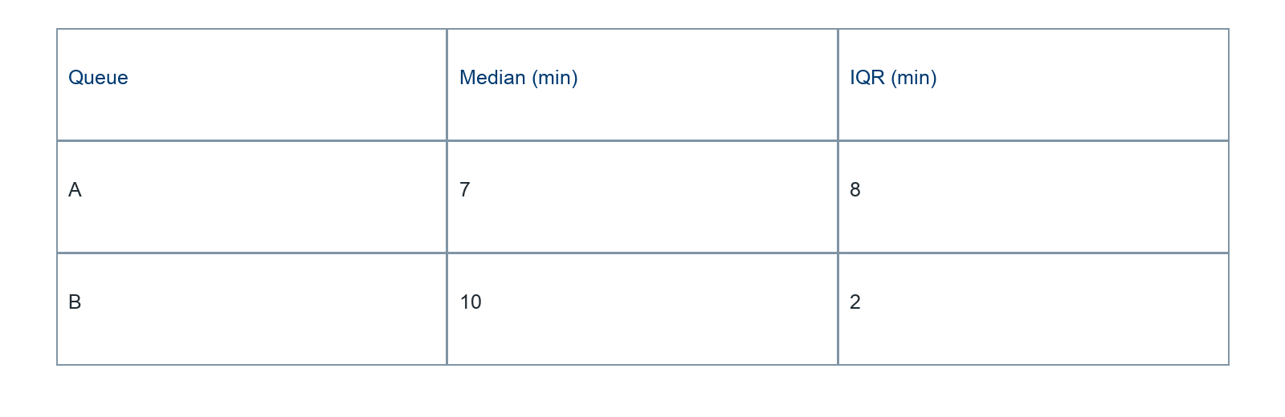
________________________________________________________________
________________________________________________________________
________________________________________________________________

Extend your reasoning
What additional information would help someone who must never wait longer than 15 minutes?
________________________________________________________________
________________________________________________________________
Self-check: Did my model, calculation, explanation, and units agree?

