Name Date Period
Lesson 2-4 · Session 2 · Guided Steps · Form A
Comparing Box Plots
Learning target — I can compare two groups by reading the medians and box widths of their box plots. · 6.SP.B.4
REMEMBER
• Put both box plots on the same scale.
• Compare medians for center: which group is typically higher, and by how much?
• Compare box widths (Q3 − Q1) for spread: the narrower box is more consistent.
GUIDED PRACTICE fill in each blank — problems 1–4
1. Two Quizzes. The box plots show scores on two quizzes.
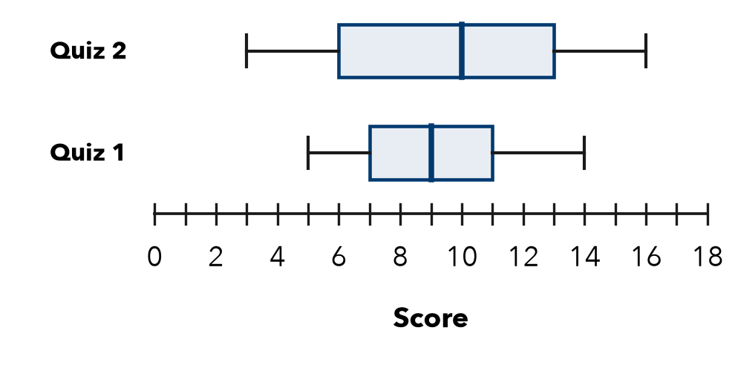
Step 1 Quiz 1: median =
Step 2 Quiz 2: median =
Step 3 Difference: − =
Step 4 Quiz 1 box: Q3 − Q1 = − =
Step 5 Quiz 2 box: Q3 − Q1 = − =
a. Higher median:
b. By how many points:
c. Wider box:

2. Two Teams. Team Red points: 42, 50, 46, 54, 48, 56, 52. Team Blue points: 41, 45, 49, 43, 55, 37, 58. Complete the table. Which team was more consistent?
Step 1 Order Red:
Step 2 Order Blue:
Step 3 Median is the 4th value; Q1 the 2nd; Q3 the 6th
Step 4 Width = Q3 − Q1 for each team: and
Step 5 The narrower box is the more consistent team.
Team | Min | Q1 | Median | Q3 | Max
Red
Blue
More consistent

3. Same Median. Two plots have a median of 30. Box C runs from 27 to 33. Box D runs from 18 to 42.  Step 1 Width = Q3 − Q1  Step 2 Box C: − =  Step 3 Box D: − =  a. Width of box C:  b. Width of box D: | 4. More Consistent? Plot P has Q1 = 22 and Q3 = 30. Plot Q has Q1 = 18 and Q3 = 36. Which middle half is more consistent?  Step 1 Plot P: − =  Step 2 Plot Q: − =  Step 3 The narrower box is plot  □ P □ Q  Widths P Q

ON YOUR OWN use the open space · show your work · label units
5. Equal Spread? Plot M runs from 20 to 90 with a box from 45 to 65. Plot N runs from 50 to 70 with a box from 55 to 60. Jamal says they are equally spread. Is he right? Compare the spans and the boxes.
□ Yes, equal spread □ No, M is more spread out □ No, N is more spread out
Show your work.

6. Two Groups. Which group has the higher median, and by how much?  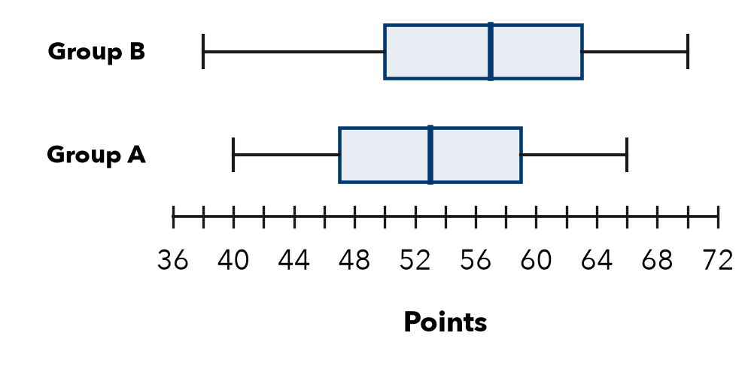  Group; difference ; | 7. Matching Boxes. Plot W runs from 10 to 60. Plot Z runs from 28 to 44. Both boxes run from 30 to 40. Omar says they show the same spread.  a. Whole span of W (max − min):  b. Whole span of Z:  c. Is Omar right? Explain.  Show your work.

8. Two Bus Routes. Travel times (minutes) for two routes.
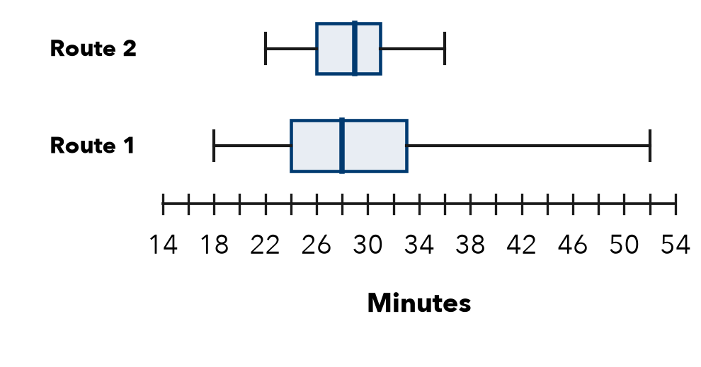
a. Higher median:
b. More predictable (use box widths):
c. A rider must not be late. Which route? Why?
Show your work.

FIND THE ERROR explain the mistake, then fix it
9. Bianca’s Work. Comparing two box plots, Bianca wrote: “Plot E has a longer right whisker, so Plot E has the greater median.” Explain the mistake.
Show your work.

TEST PRACTICE choose the best answer
10. The line inside a box plot’s box shows the —
A mean B median C range D Q1

11. Group A’s median is 50 and Group B’s is 62. Group B’s center is higher by —
A 12 B 112 C 62 D 10

CHECK YOURSELF
□ I can do this on my own □ I need a little help □ I have a question about #

