Name Date Period
Lesson 2-5 · Session 1 · Guided Steps · Form A
Range and IQR
Learning target — I can find the range and the interquartile range of a data set. · 6.SP.B.5c
REMEMBER
• Range = greatest − least. It uses only the two extreme values.
• IQR = Q3 − Q1. It is the spread of the middle half of the data.
GUIDED PRACTICE fill in each blank — problems 1–4
1. Camp Hikes. Seven hikes covered 5, 12, 8, 20, 15, 10, 18 km.
Step 1 Order:
Step 2 Range = − =
Step 3 Q1 = Q3 =
Step 4 IQR = − =
a. Range: b. Q1: c. Q3: d. IQR:

2. Bake Sale. Seven sales earned 48, 62, 55, 70, 51, 64, 59 dollars.  Step 1 Order:  Step 2 Range = − =  Step 3 Q1 = Q3 =  Step 4 IQR = − =  a. Range:  b. IQR: | 3. Chorus Rehearsals. Seven lasted 55, 72, 61, 88, 66, 79, 70 minutes.  Step 1 Order:  Step 2 Range = − =  Step 3 Q1 = Q3 =  Step 4 IQR = − =  a. Range:  b. IQR:

4. Swapped Value. A data set is 12, 14, 18, 22, 24, 29, 33. Someone replaces 33 with 95. Priscilla says both the range and the IQR grow.
Step 1 Before: range = − =
Step 2 Before: IQR = Q3 − Q1 = − =
Step 3 After: order the new set, then range = − =
Step 4 After: Q1 = , Q3 = , IQR =
a. Range before; after: ;
b. IQR before; after: ;
c. Is she right? Explain.
Show your work.

ON YOUR OWN use the open space · show your work · label units
5. Missing Maximum. Seven values have min 7, range 38, Q1 = 15 and Q3 = 32.  Show your work.  a. Maximum: b. IQR: | 6. Same Range? Set C: 20, 24, 28, 32, 36, 40, 44. Set D: 20, 22, 23, 32, 41, 42, 44.  Show your work.  a. Range of C: b. IQR of C:  c. Range of D: d. IQR of D:

7. Which Spread? Hourly wages: min $11, Q1 $14, median $16, Q3 $19, max $62.  Show your work.  a. Range: b. IQR:  c. Better for typical spread: | 8. Two Snack Bars. The box plots show daily sales.  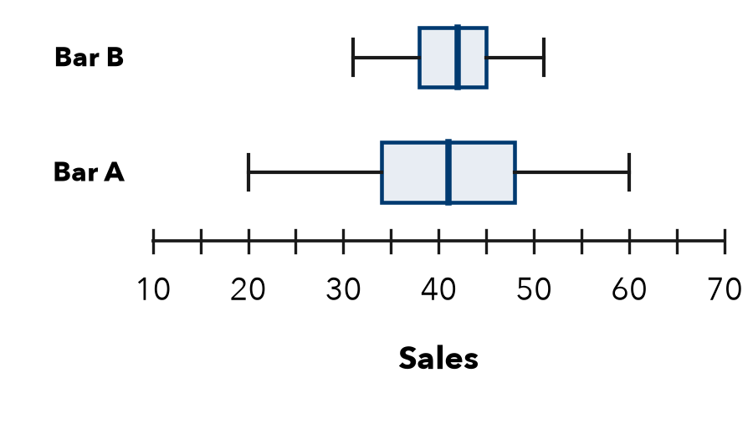  a. Range and IQR of each bar:  b. Which bar has the steadier middle half?  c. Why could the ranges mislead if one day had unusual weather?  Show your work.

FIND THE ERROR explain the mistake, then fix it
9. Tobias’s Work. For 6, 10, 13, 19, 24, 30, 36, Tobias wrote: “The IQR is 30, the greatest value minus the least.” Explain the mistake and find the IQR.
Show your work.

TEST PRACTICE choose the best answer
10. The range of a data set is found by —
A Q3 − Q1 B greatest − least C adding all values D finding the middle

11. For min 18, Q1 25, median 30, Q3 39, max 52, the IQR is —
A 34 B 14 C 9 D 21

CHECK YOURSELF
□ I can do this on my own □ I need a little help □ I have a question about #

