Name Date Period
Lesson 2-5 · Session 1 · Guided Steps · Form B
Range and IQR
Learning target — I can find the range and the interquartile range of a data set. · 6.SP.B.5c
REMEMBER
• Range = greatest − least. It uses only the two extreme values.
• IQR = Q3 − Q1. It is the spread of the middle half of the data.
GUIDED PRACTICE fill in each blank — problems 1–4
1. Bike Rides. Seven rides covered 6, 14, 9, 22, 17, 11, 19 miles.
Step 1 Order:
Step 2 Range = − =
Step 3 Q1 = Q3 =
Step 4 IQR = − =
a. Range: b. Q1: c. Q3: d. IQR:

2. Car Wash. Seven sales earned 52, 66, 58, 74, 55, 69, 62 dollars.  Step 1 Order:  Step 2 Range = − =  Step 3 Q1 = Q3 =  Step 4 IQR = − =  a. Range:  b. IQR: | 3. Band Rehearsals. Seven lasted 50, 68, 58, 84, 62, 75, 66 minutes.  Step 1 Order:  Step 2 Range = − =  Step 3 Q1 = Q3 =  Step 4 IQR = − =  a. Range:  b. IQR:

4. Swapped Value. A data set is 10, 15, 17, 21, 26, 28, 34. Someone replaces 34 with 90. Darnell says both the range and the IQR grow.
Step 1 Before: range = − =
Step 2 Before: IQR = Q3 − Q1 = − =
Step 3 After: order the new set, then range = − =
Step 4 After: Q1 = , Q3 = , IQR =
a. Range before; after: ;
b. IQR before; after: ;
c. Is he right? Explain.
Show your work.

ON YOUR OWN use the open space · show your work · label units
5. Missing Maximum. Seven values have min 9, range 41, Q1 = 18 and Q3 = 37.  Show your work.  a. Maximum: b. IQR: | 6. Same Range? Set C: 10, 15, 20, 25, 30, 35, 40. Set D: 10, 11, 13, 25, 37, 39, 40.  Show your work.  a. Range of C: b. IQR of C:  c. Range of D: d. IQR of D:

7. Which Spread? Hourly wages: min $12, Q1 $15, median $18, Q3 $21, max $70.  Show your work.  a. Range: b. IQR:  c. Better for typical spread: | 8. Two Snack Bars. The box plots show daily sales.  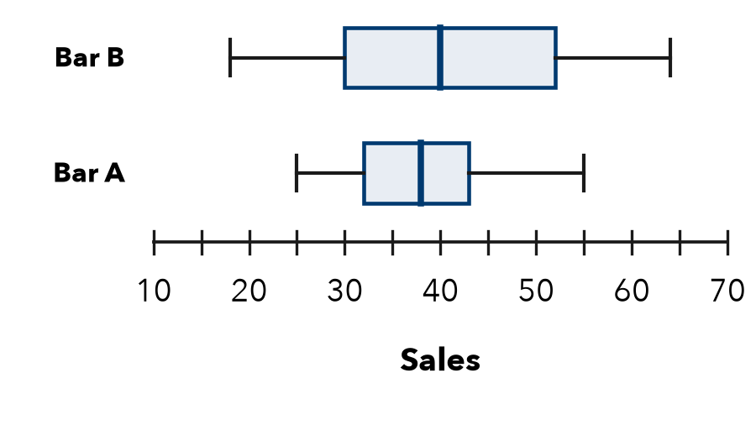  a. Range and IQR of each bar:  b. Which bar has the steadier middle half?  c. Why could the ranges mislead if one day had unusual weather?  Show your work.

FIND THE ERROR explain the mistake, then fix it
9. Marisol’s Work. For 5, 9, 14, 18, 25, 31, 40, Marisol wrote: “The IQR is 35, the greatest value minus the least.” Explain the mistake and find the IQR.
Show your work.

TEST PRACTICE choose the best answer
10. The IQR describes the spread of the —
A whole data set B middle half C lowest values D highest values

11. What is the range of 12, 19, 8, 25, 16?
A 17 B 13 C 8 D 25

CHECK YOURSELF
□ I can do this on my own □ I need a little help □ I have a question about #

