Name Date Period
Lesson 2-5 · Session 2 · Guided Steps · Form A
Comparing Variability
Learning target — I can compare the variability of two data sets using range and IQR. · 6.SP.B.5c
REMEMBER
• More consistent = less spread out = smaller range or smaller IQR.
• Compare the same measure for both groups. Equal ranges can hide different IQRs.
• With one far-out value, trust the IQR more than the range.
GUIDED PRACTICE fill in each blank — problems 1–4
1. Two Classes. Class R scores: 70, 82, 76, 88, 73, 85, 79. Class S scores: 60, 90, 75, 95, 65, 80, 72. Complete the table.
Step 1 Order Class R:
Step 2 Order Class S:
Step 3 Range = greatest − least, for each: and
Step 4 Q1 = 2nd value, Q3 = 6th value; IQR = Q3 − Q1
Step 5 The smaller range and smaller IQR is more consistent.
 | Range | Q1 | Q3 | IQR
Class R
Class S
More consistent

2. Vending Machines. Machine 1 daily sales: 30, 42, 35, 50, 38, 46, 33. Machine 2: 34, 39, 41, 37, 43, 40, 45.
Step 1 Order Machine 1:
Step 2 Order Machine 2:
Step 3 Range 1 = − = ; Range 2 = − =
Step 4 IQR 1 = − = ; IQR 2 = − =
a. Range 1: b. IQR 1: c. Range 2: d. IQR 2:

3. Devi’s Claim. Sets V and W both have a range of 40. V has Q1 = 15 and Q3 = 35; W has Q1 = 25 and Q3 = 30. Devi says they vary the same amount.  Step 1 IQR of V = − =  Step 2 IQR of W = − =  Step 3 Equal ranges, but the IQRs are .  □ Right □ Not right  IQRs V W | 4. Hugo’s Claim. Sets T and U both have an IQR of 12. T runs from 30 to 54; U runs from 8 to 96. Hugo says they are equally spread out.  Step 1 Range of T = − =  Step 2 Range of U = − =  Step 3 Equal IQRs, but the ranges are .  □ Right □ Not right  Ranges T U

ON YOUR OWN use the open space · show your work · label units
5. Choosing a Measure. A list of home prices has one house priced far above all the others. Which measure of spread fits better, the range or the IQR? Explain.
Show your work.

6. Different Stories. Set M has range 40 and IQR 6. Set N has range 24 and IQR 18.  a. Wider middle half:  b. Likely has one unusual value:  Show your work. | 7. Phone Batteries. Phone 1 hours: 16, 20, 18, 24, 22, 26, 14. Phone 2 hours: 19, 21, 20, 23, 18, 24, 17.  Show your work.  a. Range 1: b. IQR 1:  c. Range 2: d. IQR 2:

8. Choosing a Bus. The box plots show how many minutes late each bus was.
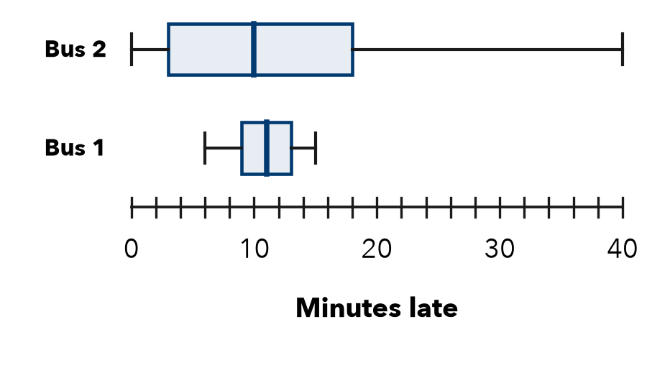
a. IQR of Bus 1:
b. IQR of Bus 2:
c. More predictable:
d. Bus 2 is sometimes almost on time. Why might you still choose Bus 1?
Show your work.

FIND THE ERROR explain the mistake, then fix it
9. Harlan’s Work. Harlan wrote: “Set A has the greater IQR, so Set A must have the greater range too.” Explain the mistake.
Show your work.

TEST PRACTICE choose the best answer
10. A smaller IQR means the middle half of the data is —
A more spread out B closer together C greater D missing values

11. A range much larger than the IQR suggests —
A an extreme value B no variability C equal quartiles D a small data set

CHECK YOURSELF
□ I can do this on my own □ I need a little help □ I have a question about #

