Name Date Period
Lesson 2-5 · Session 2 · Guided Steps · Form B
Comparing Variability
Learning target — I can compare the variability of two data sets using range and IQR. · 6.SP.B.5c
REMEMBER
• More consistent = less spread out = smaller range or smaller IQR.
• Compare the same measure for both groups. Equal ranges can hide different IQRs.
• With one far-out value, trust the IQR more than the range.
GUIDED PRACTICE fill in each blank — problems 1–4
1. Two Teams. Team J scores: 64, 78, 71, 83, 67, 80, 74. Team K scores: 55, 92, 70, 88, 60, 81, 66. Complete the table.
Step 1 Order Team J:
Step 2 Order Team K:
Step 3 Range = greatest − least, for each: and
Step 4 Q1 = 2nd value, Q3 = 6th value; IQR = Q3 − Q1
Step 5 The smaller range and smaller IQR is more consistent.
 | Range | Q1 | Q3 | IQR
Team J
Team K
More consistent

2. Vending Machines. Machine 1 daily sales: 28, 45, 33, 52, 36, 48, 31. Machine 2: 38, 42, 44, 40, 47, 43, 49.
Step 1 Order Machine 1:
Step 2 Order Machine 2:
Step 3 Range 1 = − = ; Range 2 = − =
Step 4 IQR 1 = − = ; IQR 2 = − =
a. Range 1: b. IQR 1: c. Range 2: d. IQR 2:

3. Aaliyah’s Claim. Sets V and W both have a range of 50. V has Q1 = 20 and Q3 = 45; W has Q1 = 30 and Q3 = 36. Aaliyah says they vary the same amount.  Step 1 IQR of V = − =  Step 2 IQR of W = − =  Step 3 Equal ranges, but the IQRs are .  □ Right □ Not right  IQRs V W | 4. Mateo’s Claim. Sets T and U both have an IQR of 10. T runs from 40 to 62; U runs from 12 to 95. Mateo says they are equally spread out.  Step 1 Range of T = − =  Step 2 Range of U = − =  Step 3 Equal IQRs, but the ranges are .  □ Right □ Not right  Ranges T U

ON YOUR OWN use the open space · show your work · label units
5. Choosing a Measure. A list of monthly phone bills has one bill far above all the others. Which measure of spread fits better, the range or the IQR? Explain.
Show your work.

6. Different Stories. Set M has range 36 and IQR 20. Set N has range 50 and IQR 5.  a. Wider middle half:  b. Likely has one unusual value:  Show your work. | 7. Tablet Batteries. Tablet 1 hours: 10, 15, 12, 19, 17, 21, 8. Tablet 2 hours: 13, 15, 14, 17, 12, 18, 16.  Show your work.  a. Range 1: b. IQR 1:  c. Range 2: d. IQR 2:

8. Choosing a Bus. The box plots show how many minutes late each bus was.
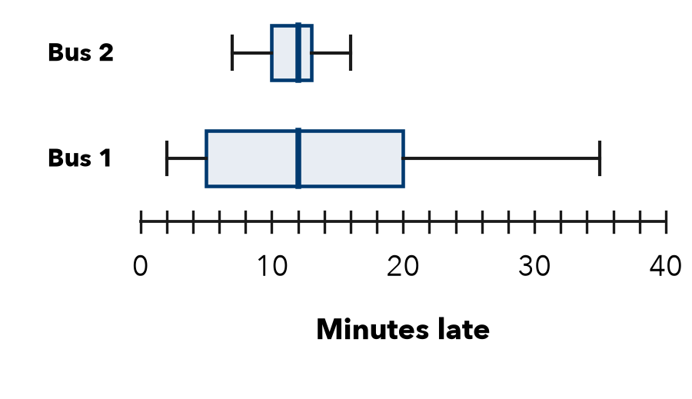
a. IQR of Bus 1:
b. IQR of Bus 2:
c. More predictable:
d. Bus 1 is sometimes almost on time. Why might you still choose Bus 2?
Show your work.

FIND THE ERROR explain the mistake, then fix it
9. Nadia’s Work. Nadia wrote: “Set A has the greater IQR, so Set A must have the greater range too.” Explain the mistake.
Show your work.

TEST PRACTICE choose the best answer
10. Set X has range 12; Set Y has range 30. Which is more spread out overall?
A Set X B Set Y C They are equal D Cannot tell

11. Two sets have the same median but different IQRs. They differ in —
A center B spread of the middle half C number of values D median

CHECK YOURSELF
□ I can do this on my own □ I need a little help □ I have a question about #

