Lesson 2.5 Guided Notes

Session 1 · Range and IQR
I can find the range and the interquartile range of a data set. · 6.SP.B.5c
Word / Spanish | Meaning — complete the blank | Example
range / rango | The greatest value _______ the least value. | 20 − 5 = 15
interquartile range (IQR) / rango intercuartil | Q3 minus Q1; the spread of the _____________. | 18 − 8 = 10
extreme value / valor extremo | A value far from the others; it changes the _______ a lot. | 62 in 11, 14, 16, 19, 62

Key idea
Range and IQR both measure ________, or variability.
For this seven-value example, increasing the maximum leaves the _____ unchanged. Recompute quartiles for a different set.

Worked example
Hikes (km): 5, 12, 8, 20, 15, 10, 18. Find the range and the IQR.
Order: 5, 8, 10, 12, 15, 18, 20. Range = 20 − 5 = _____.
Q1 = _____ and Q3 = _____.
Answer: IQR = 18 − 8 = _____ km

You try
1. Data: 4, 9, 6, 15, 11, 7, 13.
a. Range: ______
b. IQR: ______
________________________________________________________________
2. A set has min 12 and range 25. Find the max.
________________________________________________________________
Sum it up: The IQR is often better than the range when ___ because ___.
________________________________________________________________

Session 2 · Comparing Variability
I can compare the variability of two data sets using range and IQR. · 6.SP.B.5c
Word / Spanish | Meaning — complete the blank | Example
consistent / constante | Values are close together; the spread is _______. | IQR 4 vs. IQR 12
measure of variability / medida de variabilidad | A number that tells how ____________ data are. | range, IQR
extreme value / valor extremo | A value far from the rest; it stretches the _______. | 40 in 0, 3, 10, 18, 40

Key idea
Compare the ______ measure for both groups. The smaller value means more consistent.
When one value is far from the rest, trust the _____ more than the range.

Worked example
Class R: range 18, IQR 12. Class S: range 35, IQR 25. Which class is more consistent?
Ranges: 18 < 35, so R is ______ spread overall.
IQRs: 12 < 25, so R’s _____________ is closer together.
Answer: Class _____ is more consistent.

You try
1. Find each IQR. Circle the more consistent set.
a. P: Q1 = 30, Q3 = 42 ______
b. Q: Q1 = 33, Q3 = 39 ______
________________________________________________________________
2. Set A: range 50, IQR 8. Set B: range 22, IQR 16. Which set likely has one unusual value?
________________________________________________________________
Sum it up: To decide which group is more consistent, I compare ___ because ___.
________________________________________________________________

Session 1 · Model, reason, and explain
Range and IQR · 6.SP.B.5c
Success: represent the quantities, justify the relationship, and check the result with the correct units.
Use the medians of the lower and upper halves. Compare A: 1, 2, 3, 4 and B: 1, 2, 3, 40. Find each range and IQR. Is changing a maximum guaranteed to leave IQR unchanged?
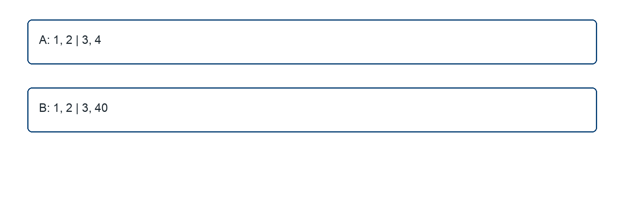
________________________________________________________________
________________________________________________________________
________________________________________________________________

Extend your reasoning
Explain why replacing 7 by 70 in 1, 2, 3, 4, 5, 6, 7 leaves IQR unchanged under this convention.
________________________________________________________________
________________________________________________________________
Self-check: Did my model, calculation, explanation, and units agree?

Session 2 · Model, reason, and explain
Comparing Variability · 6.SP.B.5c
Success: represent the quantities, justify the relationship, and check the result with the correct units.
Two delivery routes have five-number summaries A: 2, 8, 10, 12, 40 and B: 5, 7, 11, 17, 25 minutes. Compare overall spread and middle-half spread. Which route is more consistent depends on which measure?
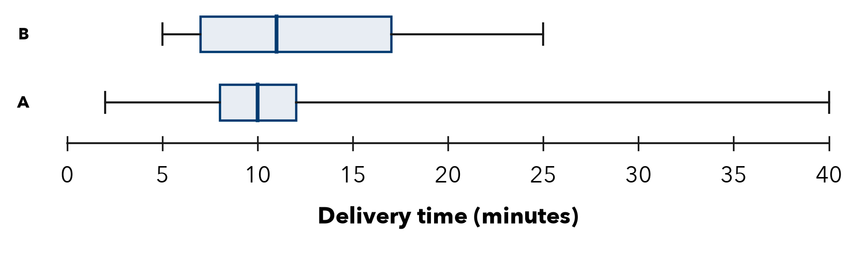
________________________________________________________________
________________________________________________________________
________________________________________________________________

Extend your reasoning
Recommend a route for someone who prioritizes a predictable typical trip, then explain what risk your choice does not capture.
________________________________________________________________
________________________________________________________________
Self-check: Did my model, calculation, explanation, and units agree?

