Lesson 2.7 Guided Notes

Session 1 · Dividing a Decimal by a Whole Number
I can divide a decimal by a whole number and place the decimal point correctly. · 6.NS.B.3
Word / Spanish | Meaning — complete the blank | Example
dividend / dividendo | The number being _________; the amount you share. | In 84.6 ÷ 6, it is 84.6
divisor / divisor | The number you ________ by. | In 84.6 ÷ 6, it is 6
quotient / cociente | The ________ to a division problem. | 84.6 ÷ 6 = 14.1
annex a zero / agregar un cero | Write a 0 at the end of a decimal; the _______ stays the same. | 7.2 = 7.20

Key idea
Put the decimal point in the quotient straight _______ the point in the dividend.
If an amount is left over, _______ a zero and keep dividing.
Check: quotient × divisor = __________.

Worked example
A rope 25.2 meters long is cut into 6 equal pieces. How long is each piece?
Write 25.2 ÷ 6 and put the point in the quotient straight _______ the point in 25.2.
6 goes into 25 _____ times with 1 left over. Bring down the 2 to make 12.
12 ÷ 6 = _____, so the quotient is 4.2.
Answer: Each piece is _____ m. Check: 4.2 × 6 = 25.2

You try
1. Find each quotient.
a. 8.4 ÷ 4 = ______
b. 13.5 ÷ 5 = ______
c. 7.5 ÷ 2 = ______
________________________________________________________________
2. Four friends share a $9.60 bill equally. How much does each pay?
________________________________________________________________
Sum it up: To divide a decimal by a whole number, I place the decimal point ___ because ___.
________________________________________________________________

Session 2 · Dividing by a Decimal
I can divide by a decimal by making the divisor a whole number first. · 6.NS.B.3
Word / Spanish | Meaning — complete the blank | Example
divisor / divisor | The number you ________ by. | In 8.4 ÷ 0.2, it is 0.2
equivalent division / división equivalente | A new division problem with the ______ quotient. | 8.4 ÷ 0.2 = 84 ÷ 2
power of ten / potencia de diez | 10, 100, 1,000 and so on; each one is 10 times the ______. | 0.25 × 100 = 25

Key idea
Multiply the divisor and the dividend by the ______ power of 10 until the divisor is a _______ number.
The quotient does not ________: 5 ÷ 0.25 = 500 ÷ 25 = 20.

Worked example
How many 0.7-liter bottles can be filled from 8.4 liters?
Write 8.4 ÷ 0.7. The divisor has _____ decimal place.
Multiply both by 10: 0.7 becomes _____ and 8.4 becomes _____.
84 ÷ 7 = 12. Check: 12 × 0.7 = 8.4
Answer: _____ bottles

You try
1. Rewrite with a whole-number divisor. Then divide.
a. 6.4 ÷ 0.8 = ______
b. 2.7 ÷ 0.3 = ______
c. 1.8 ÷ 0.06 = ______
________________________________________________________________
2. How many 0.4-liter cups can be filled from 9.6 liters of juice?
________________________________________________________________
Sum it up: To divide by a decimal, I multiply both numbers by ___ because ___.
________________________________________________________________

Session 1 · Model, reason, and explain
Dividing a Decimal by a Whole Number · 6.NS.B.3
Success: represent the quantities, justify the relationship, and check the result with the correct units.
Share 7.2 meters of ribbon equally among 3 groups. Represent 7.2 as 72 tenths, divide, then connect that model to 7.2 ÷ 3. Estimate the answer and check by multiplication.
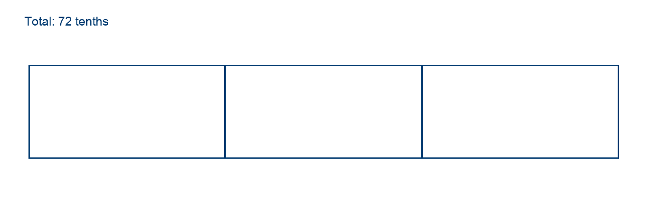
________________________________________________________________
________________________________________________________________
________________________________________________________________

Extend your reasoning
Explain why an answer of 24 meters is unreasonable before calculating exactly.
________________________________________________________________
________________________________________________________________
Self-check: Did my model, calculation, explanation, and units agree?

Session 2 · Model, reason, and explain
Dividing by a Decimal · 6.NS.B.3
Success: represent the quantities, justify the relationship, and check the result with the correct units.
How many 0.6-liter bottles can be filled from 4.8 liters? Rename both measures in tenths of a liter. Explain why scaling only the divisor would change the question.
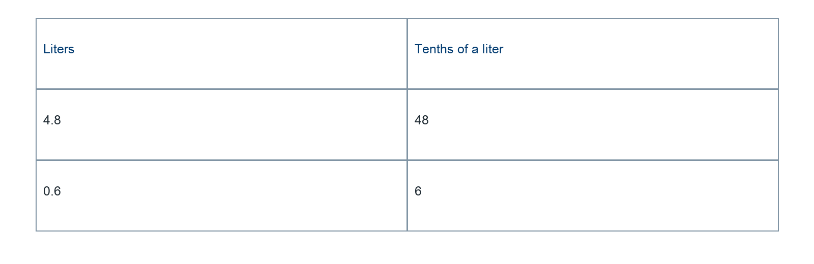
________________________________________________________________
________________________________________________________________
________________________________________________________________

Extend your reasoning
Why is the quotient 8 larger than the numerical value 4.8?
________________________________________________________________
________________________________________________________________
Self-check: Did my model, calculation, explanation, and units agree?

