Name Date Period
Lesson 2-8 · Session 1 · Guided Steps · Form B
Finding the Mean
Learning target — I can find the mean of a data set by sharing the total equally among the values. · 6.SP.B.5c
REMEMBER
• The mean is a fair share: add all the values, then divide by how many values there are.
• Count every value, even a 0.
• The mean is always between the least and greatest values.
GUIDED PRACTICE fill in each blank — problems 1–4
1. Find the mean of each data set.
a. 6, 9, 7, 10, 13  Step 1 Add all:  Step 2 How many values:  Step 3 ÷ = | b. 5, 8, 6, 9, 12  Step 1 Add all:  Step 2 How many values:  Step 3 ÷ = | c. 14, 19, 21, 17, 24, 25  Step 1 Add all:  Step 2 How many values:  Step 3 ÷ =

d. 10, 26, 22, 30, 34, 28 Mean =

2. Bird Feeder. The dot plot shows the number of birds that visited a feeder on six mornings.
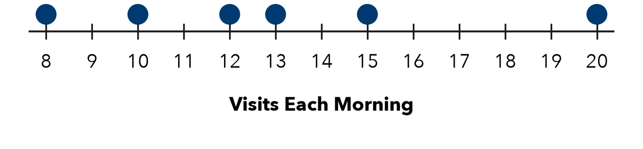
a. Total visits:
Step 1 Read the six values: , , , , ,
Step 2 Add them: total =
b. Mean visits per morning:
Step 3 Share among mornings: ÷ =

3. Seedling Growth. Five seedlings grew 14, 10, 18, 12 and 16 cm. Find the mean growth.
Step 1 Total of the growths:
Step 2 Number of seedlings:
Step 3 ÷ = cm

4. Repeated Values. For 20, 20, 20, 60, Leo says the mean is 20 because most values are 20. Is he right? Find the mean.
Step 1 Add all four values:
Step 2 Share: ÷ 4 =
Step 3 Is Leo right?

ON YOUR OWN use the open space · show your work · label units
5. Sticker Swap. Four friends have 4, 9, 6 and 13 stickers. They share them evenly. How many does each get?  Show your work.  Answer stickers | 6. Dog Walking. Five afternoons of dog walking earned $16, $22, $18, $20 and $29. Find the mean earnings.  Show your work.  Answer dollars

7. The Zero Day. A student earned $13, $0, $16, $8 and $18 recycling cans on five days. Omar says to leave out the $0 day. Is he right? Find the mean.  Show your work.  Answer dollars | 8. Class Fundraiser. Six students raised $35, $40, $30, $55, $45 and $47.  a. Find the mean amount raised. dollars  Show your work.  b. A seventh student raises $98. Will the mean rise or fall? Find the new mean. dollars  Show your work.

FIND THE ERROR explain the mistake, then fix it
9. Keisha’s Work. For 7, 11, 9, 13, Keisha added the values and wrote that the mean is 40. Explain her mistake and find the mean.
Show your work.

TEST PRACTICE choose the best answer
10. Find the mean of 4, 4, 4, 8.
A 4 B 8 C 5 D 20

11. The mean is found by dividing the sum by the —
A greatest value B number of values C least value D median

CHECK YOURSELF
□ I can do this on my own □ I need a little help □ I have a question about #

